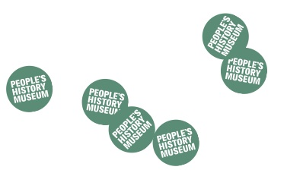
Programming at the People’s History Museum (PHM)
Expression of Interest Form

Your name
Pronouns
(e.g. she/her, he/him, they/their, etc)
Organisation name
(if applicable)
Address
Telephone number
Email address
Have you previously visited the People’s History Museum?
Title of project
How would you like to work with us? (max 100 words)
Why People’s History Museum? How does your story fit with ours? (max 100 words)
Who are the audience for your project? (be specific, i.e. not just ‘adults’)
How will you reach this audience? (max 100 words)

Your proposal will be assessed on a clear, defined target audience and a clear plan on how to reach this audience. PHM has a commitment to diversifying our audiences.
Is there anything else we need to know? (e.g. technical requirements, limitation on dates, funding etc)

Please attach visuals relating to the specific event or of previous work to assist us in considering your proposal.

FOR OFFICE USE ONLY
Date application considered:
Individuals present:
Application successful: Y/N Staff member assigned………………………………………………
If not, why?
 | Relevance to PHM |  | Timetabling
 | Audience |  | Repeats other recent projects
 | Other (please state)
 | Comments

