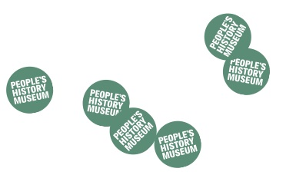
Programming at the People’s History Museum (PHM)
Expression of Interest Form (community exhibitions)

Your name
Pronouns
(e.g. she/her, he/him, they/their, etc)
Organisation name
(if applicable)
Address
Telephone number
Email address
Have you previously visited the People’s History Museum?
Title of exhibition
Explain your exhibition? (max 100 words)
Explain how your exhibition fits in with the theme of protest? (max 50 words)
Why People’s History Museum? How does your story fit with ours? (max 100 words)
Who are the audience for your exhibition? (be specific, i.e. not just ‘adults’)
How will you reach this audience? (max 100 words)

Your proposal will be assessed on a clear, defined target audience and a clear plan on how to reach this audience. PHM has a commitment to diversifying our audiences.
Is the exhibition dependant on funding or other issues that could prevent it from going ahead?

Although PHM is unable to fully fund community exhibitions, we have a small budget available to help support the 2019 community exhibition programme. Please outline below what support you might require.
Please tick your preferred display space and dates:
Engine Hall |  |  | Main Gallery Two display area
Please tick your preferred Engine Hall slot (please tick all dates you are available).  Exhibitions will run for one month and slots available are: |  |  | Please specify preferred Main Gallery Two display area slot.  Exhibitions will run for three months and slots available are between January 2019 and January 2020.
Fri 5 April – Sun 5 May 2019
Fri 9 August – Sun 8 September 2019
Fri 6 December – Sun 5 January 2020

