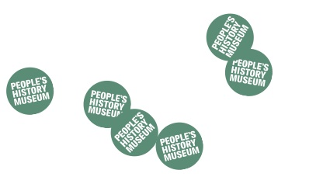
Programming at the People’s History Museum (PHM)
Expression of Interest Form (Events)

Your name
Pronouns
(e.g. she/her, he/him, they/their, etc)
Organisation name
(if applicable)
Address
Telephone number
Email address
Have you previously visited the People’s History Museum?
Title of event
Explain your event? (max 100 words)
Explain how your event fits in with the theme of protest? (max 50 words)
Why People’s History Museum? How does your story fit with ours? (max 100 words)
Who are the audience for your event? (be specific, i.e. not just ‘adults’)
How will you reach this audience? (max 100 words)

(Please include how many people you estimate may come to this event to help us determine which space might be appropriate to programme the event in).

Your proposal will be assessed on a clear, defined target audience and a clear plan on how to reach this audience. PHM has a commitment to diversifying our audiences.
Is the event dependant on funding or other issues that could prevent it from going ahead?

Although PHM is unable to fully fund events, we have a small budget available to help support the 2019 events programme, particularly in relation to travel expenses, material costs and artist fees. Please outline below what support you might require.
Please could you let us know if there are any preferred dates/times for your event to take place?

We will try to accommodate this where possible, dependent on the scheduling of the wider public programme as a whole.

