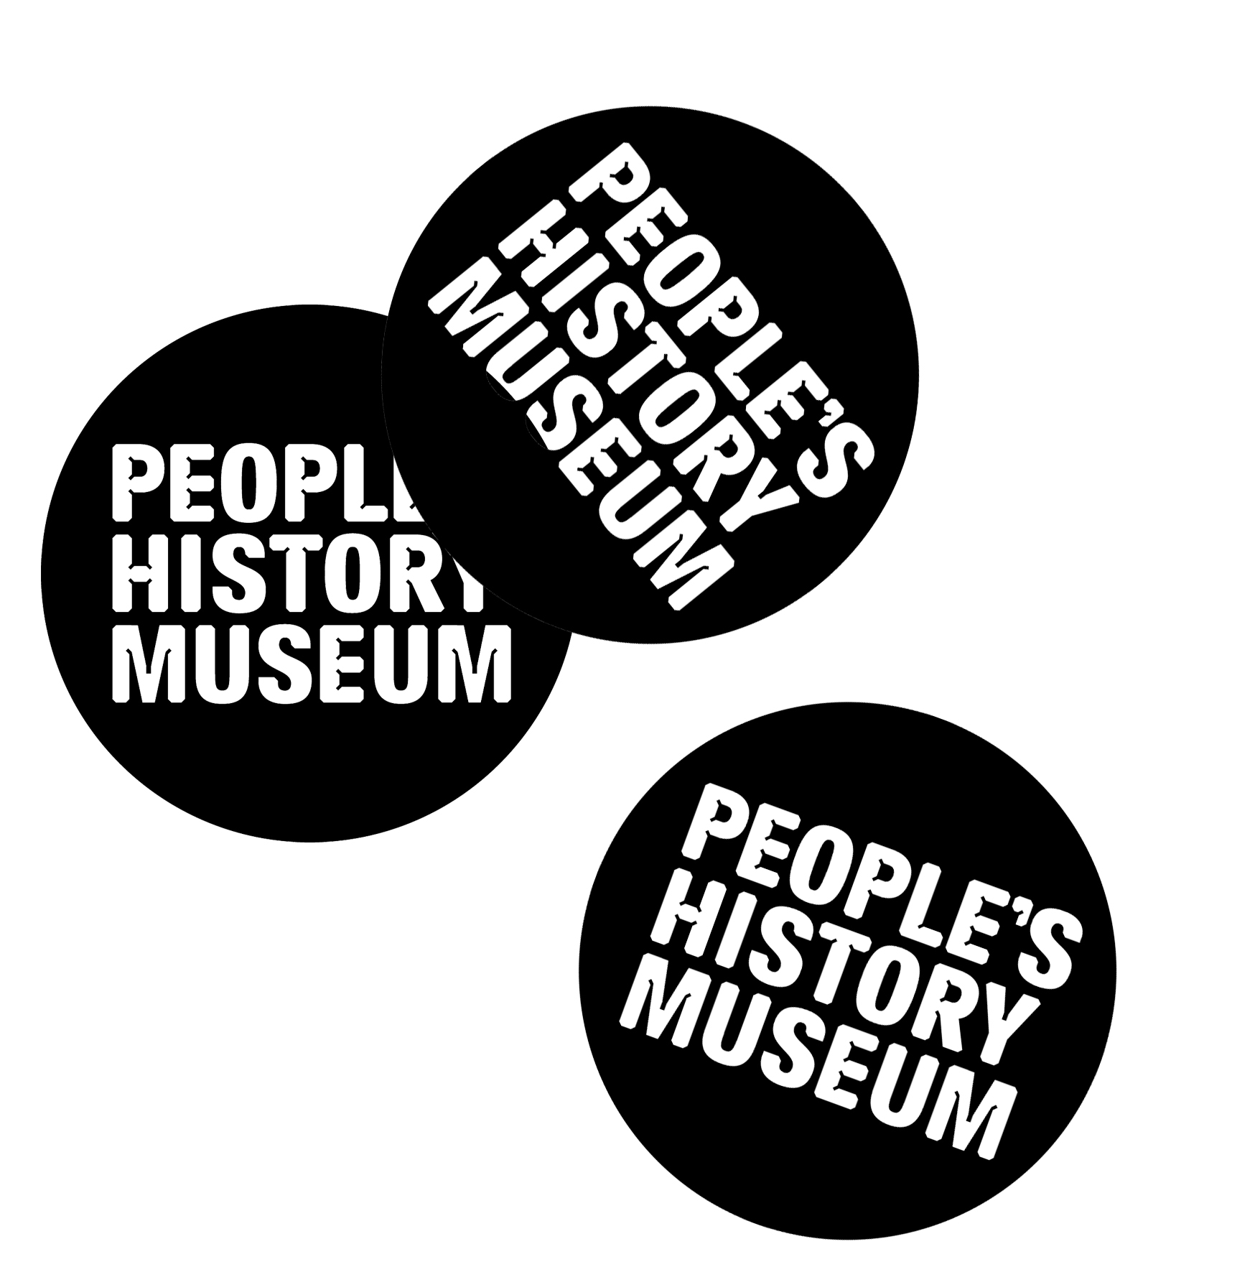
People’s History Museum’s (PHM) 2020 programme, exploring theme of migration

Community Programme Team opportunity

People’s History Museum (PHM) is the national museum of democracy and the home of ideas worth fighting for. In 2020 the museum will launch a year long programme of new exhibitions, events, learning sessions and creative collaborations that will explore the theme of migration. As a museum that is leading the way with co-creation, integrating campaigning into its approach and working with international partners, this programme will be curated in partnership with the communities whose lives have been shaped by migration. The stories the museum tells will be re-examined through their eyes, creating a rich visitor experience with gallery takeovers, new exhibits, digital installations, banner displays, artistic responses and collaborations.

2020 will mark the tenth birthday of PHM being in its current home and we will be marking this milestone by taking our most radical approach yet to co-creation, and to do this we need your help.
We want to ensure PHM’s programme of activity, exhibitions and events for 2020 are created with and by people whose lives have been shaped by migration. We are looking for five people to form a Community Programme Team who will lead a project finding new ways of highlighting the story of migration within PHM’s main galleries. You will also have the opportunity to shape PHM’s public programme of exhibitions and events. You don’t need any prior experience of working with a museum, just an enthusiasm for bringing people and communities together. To find out more about PHM’s ethos please read the PHM Story.
We are looking for a diverse group of people; which reflects the diversity of Greater Manchester residents.
What is involved?
Throughout the project, you will share creative control and decision making working alongside museum staff.
This process will include but is not limited to:
- Research into migration stories in PHM’s collection
- Finding and developing ideas for new and exciting ways to highlight the history of migration in PHM’s main galleries
- Helping select community exhibitions and events for PHM’s 2020 public programme
- Writing blog posts about the project to be published on PHM’s blog
- Promoting PHM’s programmes within your own networks and community
- Feeding into the evaluation of the project.
Approximately 10 to 15 hours per month between August 2019 and July 2020. This will be a combination of meetings and independent research and planning. Members may want to volunteer more time in between meetings or attend additional training. After this period, the group are invited to continue meeting to evaluate the project and decide what happens next.
To begin with, meetings will take place on the first and third Friday of each month from 1.00pm – 3.30pm. This is open to change depending on the preference of the group.

We are looking for people who have any of these skills and/or experience (you don’t need to have all of them to apply!):
- Personal experience of migration
- Enthusiasm for bringing people and communities together
- Creativity
- Experience in decision making
- An understanding of migration history
- Connections to black, Asian and minority ethic (BAME) community groups and networks
- Research skills
- Experience of community engagement
- Digital skills
- Current knowledge of migration laws / the legal system
- Ability to speak a language other than English
We expect everyone to be able to commit to the project for at least 12 months. This role requires a good level of understanding of spoken English.

What we can provide in return for your commitment:
- Opportunities to meet new people and take part in new experiences
- Access to archives and object collections at PHM
- Full support during the whole process; if you have any questions we’re at the end of the phone / email
- Office space at PHM on a hot-desk basis
- Access to spaces for meetings and events
- Access to equipment and tools
- 10% discount in the shop and café
The museum will offer a range of training and opportunities tailored to your personal interests and ambitions. As well as reimbursing you for your expenses, we are committed to acknowledging the time, skills and expertise that you will be sharing with the museum. We will discuss with each applicant how best to show our gratitude based on their individual circumstances.
If you think PHM can offer you something else that is not listed above, please let us know when you get in touch.

How to get involved
As there are limited spaces available within the Community Programme Team, we want to get to know you a bit better and put together a group with a variety of backgrounds and experiences.
To express an interest in this opportunity please send a short email, video message or sound recording to Zofia Kufeldt, Programme Officer on zofia.kufeldt@phm.org.uk and tell us a bit about yourself by answering the following questions:
- Why you are interested in joining the Community Programme Team at PHM?
- What skills and/or knowledge will you contribute to the group?
- Which skills and/or experience you would like to develop during the project?
If you are unable to send an email, video message or sound recording you can call 0161 838 9190 and ask to speak with a member of the Programme Team.
You can also send the above information by post to:

Zofia Kufeldt, Programme Officer

People’s History Museum

Left Bank

Spinningfields

Manchester

M3 3ER

The deadline for expressing an interest in this role is Wednesday 31 July at 5.00pm
An informal interview will take place on Thursday 8 August 2019, 5.00 – 7.00pm. This will involve the chance to find out more about the museum and an opportunity to meet others interested in the Community Programme Team opportunity. Please let us know when you get in touch if you are unavailable on this date.
If you are invited to be part of the Community Programme Team you will be asked to provide the details of someone who has known you for more than 3 years who can provide a reference for you.
We would encourage people in full time employment, who are interested in this opportunity, to discuss the project with their employer as a Continuing Professional Development (CPD) opportunity. We would be happy to discuss with your employer opportunities to include the project as part of their diversity, widening participation or Corporate Social Responsibility (CSR) strategies and to help raise their profile as an inclusive employer.

Where a member of the group is disabled, every effort will be made to supply all necessary aids, adaptations or equipment to allow them to participate fully in all aspects of the opportunity.

There are a number of other opportunities to get involved in PHM’s 2020 programme on the theme of migration, further details can be found here.
If you have any questions please email Zofia Kufeldt, Programme Officer on zofia.kufeldt@phm.org.uk or phone 0161 838 9190.

