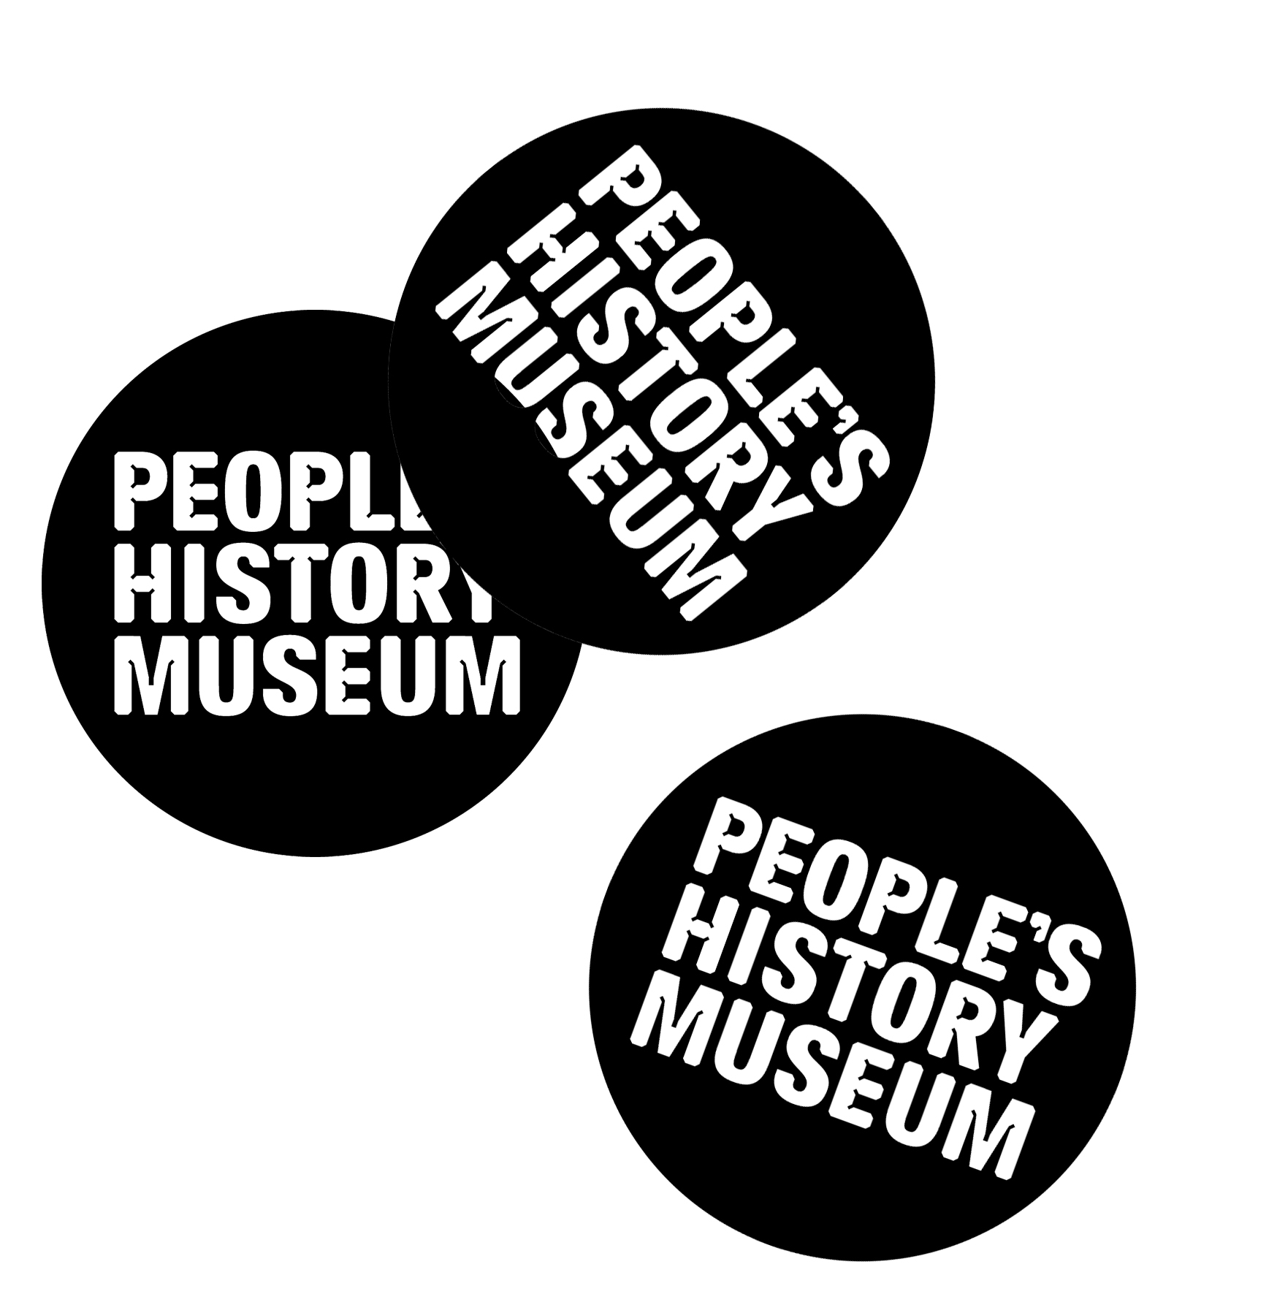
Opportunities for involvement in People’s History Museum’s (PHM) 2020 programme exploring the theme of migration
In 2020 People’s History Museum (PHM) will launch a year long programme of new exhibitions, events, learning activities and creative collaborations that will explore the theme of migration. As a museum that is leading the way with co-creation, integrating campaigning into its approach and working with international partners, this programme will be curated in partnership with the communities whose lives have been shaped by migration. The stories the museum tells will be re-examined through their eyes, creating a rich visitor experience with gallery takeovers, new exhibits, digital installations, banner displays, artistic responses and collaborations.

There are a number of ways to get involved in PHM’s 2020 programme. If you have any questions or would like more information please email Zofia Kufeldt, Programme Officer on zofia.kufeldt@phm.org.uk or phone 0161 838 9190.

Create with us
We want to ensure PHM’s programme of activity, exhibitions and events for 2020 are created with and by people whose lives have been shaped by migration. We are looking for a group of five people to form a Community Programme Team who will lead a project finding new ways of highlighting the story of migration within PHM’s main galleries. You will also have the opportunity to shape PHM’s public programme of exhibitions and events. You don’t need any prior experience working with museums, just an enthusiasm for bringing people and communities together.
More information on what the role entails and what PHM can offer in return can be found here. The deadline for expressing an interest in this role is Wednesday 31 July 2019 at 5.00pm.
We expect the Community Programme Team will work with or invite other members of their community to get involved. Watch this space for future opportunities.

Share your story
2020 will mark the tenth birthday of PHM being in its current home. During this time the story of migration has evolved. We plan to create a temporary display documenting recent experience of migration and collect new material to enrich our collection. If you have a story, photograph or object you would like to be considered for inclusion please email Mark Wilson, Exhibitions Officer on exhibitions@phm.org.uk or phone 0161 838 9190 before Saturday 31 August 2019.

Put on an exhibition
If you have an idea for an exhibition to display or produce linked to the theme of migration, please get in touch. We are looking for proposals, big or small, from community groups or individuals, in all media. We are particularly interested in submissions which link to contemporary campaigns and migration issues and/or highlight societal issues surrounding the topic of migration. The 2020 community exhibition programme will be selected by a panel of museum staff and members of a cross section of community groups.
There will be two rounds for applications:
The first deadline is Sunday 15 September 2019 at 5.00pm for exhibitions slots between March 2020 and August 2020
The second deadline is Sunday 16 February 2020 at 5.00pm for exhibitions slots between September 2020 and February 2021
PHM is committed to paying professional artists. If you are a professional artist, please make this clear when you get in touch.
Please see our Community Exhibition Guidance Notes and how to apply. For further information please contact Mark Wilson, Exhibitions Officer on exhibitions@phm.org.uk or phone 0161 838 9190.

Organise an event
One of our aims for 2020 is to bring people together and use the museum as a space for sharing ideas, skills and learning from each other. We are looking for a variety of public events to programme at weekends or on one of our monthly Radical Lates on the second Thursday each month when the whole museum, shop and cafe are open until 8.00pm. Previous Radical Lates have included music, dance, film and talks.

If you are interested in having an event at the museum please complete this form. Alternatively send a short email, video message or sound recording to Zofia Kufeldt, Programme Officer on zofia.kufeldt@phm.org.uk, answering the following questions:
- Who are you?
- What is your idea?
- Does your idea need money to do it and if so, roughly how much?
- When would you like your idea to happen?
If you are unable to send an email, video message or sound recording you can call 0161 838 9190 and ask to speak with a member of the Programme Team.
You can also send the above information by post to:

Zofia Kufeldt, Programme Officer

People’s History Museum

Left Bank

Spinningfields

Manchester

M3 3ER
PHM is committed to paying professional artists. If you are a professional artist, please make this clear when you get in touch.
There are four deadlines for getting in touch with an event proposal:
Tuesday 1 October 2019 at 5.00pm for events in PHM’s spring programme between March 2020 and May 2020
Wednesday 1 January 2020 at 5.00pm for events in PHM’s summer programme between June 2020 and August 2020
Wednesday 1 April 2020 at 5.00pm for events in PHM’s autumn programme between September 2020 and November 2020
Wednesday 1 July 2020 at 5.00pm for events in PHM’s winter programme between December 2020 and February 2021.
Please note we will consider proposals for all seasons at each deadline.
The public events programme will be selected by a panel of museum staff and members of a cross section of community groups.

Use our space
We are keen to support local community organisations and charities that support our programme aims and operate on low income to use our spaces. As part of our 2020 programme exploring the theme of migration, we will be providing a dedicated space for regular or one off informal events, private meetings and other activities. Events could be as varied as discussions and debates, English for Speakers of Other Languages (ESOL) courses, singing sessions, textile workshops or campaign meetings.
Where possible we will offer this space at no cost during museum opening hours. We cannot support everyone who approaches us as we have limited space and capacity but we will try to help. Bookings will be open for this space from February 2020.

