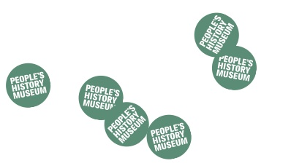
Community Exhibitions Guidance Notes

In 2020 People’s History Museum (PHM) will launch a year long programme of new exhibitions, events, learning sessions and creative collaborations that will explore the theme of migration. As a museum that is leading the way with co-creation, integrating campaigning into its approach and working with international partners, this programme will be curated in partnership with the communities whose lives have been shaped by migration.

If you have an idea for an exhibition to display or produce linked to the theme of migration, please get in touch. We are looking for proposals, big or small, from community groups or individuals, in all media. We are particularly interested in submissions which link to contemporary campaigns and migration issues and/or highlight societal issues surrounding the topic of migration.

What type of exhibitions will be displayed?

- Exhibitions allowing community groups or individuals a chance to tell and examine their story

- Exhibitions that are accessible to a wide range of people

- Exhibitions that are likely to attract new visitors to the museum

- Exhibitions that help to raise the profile of the museum locally, nationally and internationally

- Exhibitions must adhere to the concept of equal opportunities taking into account physical and intellectual access.

- The museum will not display items:
  - that are dangerous to the public e.g. knives and blades or anything with sharp edges, live creatures, strobe lights, naked flames
  - that can be a health hazard e.g. food and drink, nuts and seeds
  - too big or heavy to carry into the building
  - anything deemed to show hostility towards individuals or groups, including those with protected characteristics and those facing persecution.

- The museum does not provide opportunities for commercial exhibitions. Prices should not be put on any items included in the exhibition.

Sending us your idea

If community groups or individuals have an idea for an exhibition, please send a short email, video message or sound recording for the attention of Mark Wilson, Exhibitions Officer to exhibitions@phm.org.uk and answer these questions:

- Who are you?
- What is your exhibition about? (Include supporting images if you have them)
- Does your idea need money to do it and if so, roughly how much?
- Do you have preferred dates for the exhibition?

If you are unable to put your idea into an email, video message or sound recording you can call 0161 838 9190 and ask to discuss your idea with a member of the Programme Team.

You can also send us your idea by post to:

Mark Wilson, Exhibitions Officer

People’s History Museum

Left Bank

Spinningfields

Manchester

M3 3ER

The successful exhibitions will be selected by a panel of museum staff and members of a cross section of community groups.

There will be two rounds for applications:
The first deadline is Sunday 15 September 2019 at 5.00pm for exhibitions slots between March 2020 and August 2020
The second deadline is Sunday 16 February 2020 at 5.00pm for exhibitions slots between September 2020 and February 2021

The exhibition

Exhibitions will take place in part of the museum’s Changing Exhibition Gallery on the ground floor; the space is climate controlled and exhibitors will have access to a selection of museum standard display cases and various audio visual equipment.

- Display details must be approved by PHM staff in advance of installation.

- All community exhibitions need to include at least one text panel (minimum size A3) introducing the group or individuals involved / the story or subject being explored.

- Wall mounted information should be word processed at a minimum size of 16 point.

- PHM reserves the right to ask for artwork or information to be withdrawn or amended if it does not meet the criteria set out above.

- PHM supports community exhibitions in a substantial manner through professional staff support, heating, lighting, staffing the building during opening hours and providing display equipment. Although PHM is unable to fully fund large scale community exhibitions, we have a small budget available to help support the 2020 community exhibition programme.

- PHM is committed to paying professional artists. If you are a professional artist, please make this clear when you get in touch.

- PHM can provide the services of a member of museum staff to advise on display methods and assist with installation according to an agreed plan.

- Installation and derig of exhibitions should take place on pre-arranged dates (access to PHM is strictly between 8.30am and 5.00pm).

- Exhibitions cannot be installed after or derigged prior to the arranged days.

- The exhibition must not prevent the museum remaining fully accessible to all visitors and must ensure that other museum activities can continue.

- A full list of exhibition content should be provided to PHM staff before the exhibition is due to open. The list should in particular detail:
  - any textiles to be included as they may need treatment before they can be displayed
  - a list of any freestanding material which should number no more than three items
  - any high value items with details of how they are to be secured

- Loan material is the responsibility of the external exhibition organiser.

- The museum is unable to store material relating to the exhibition after the derig.

The floor plan below shows the available space within the Changing Exhibition Gallery highlighted in green. Exhibitions can use all or part of this space. Below the plan are photographs of the Changing Exhibition Gallery.

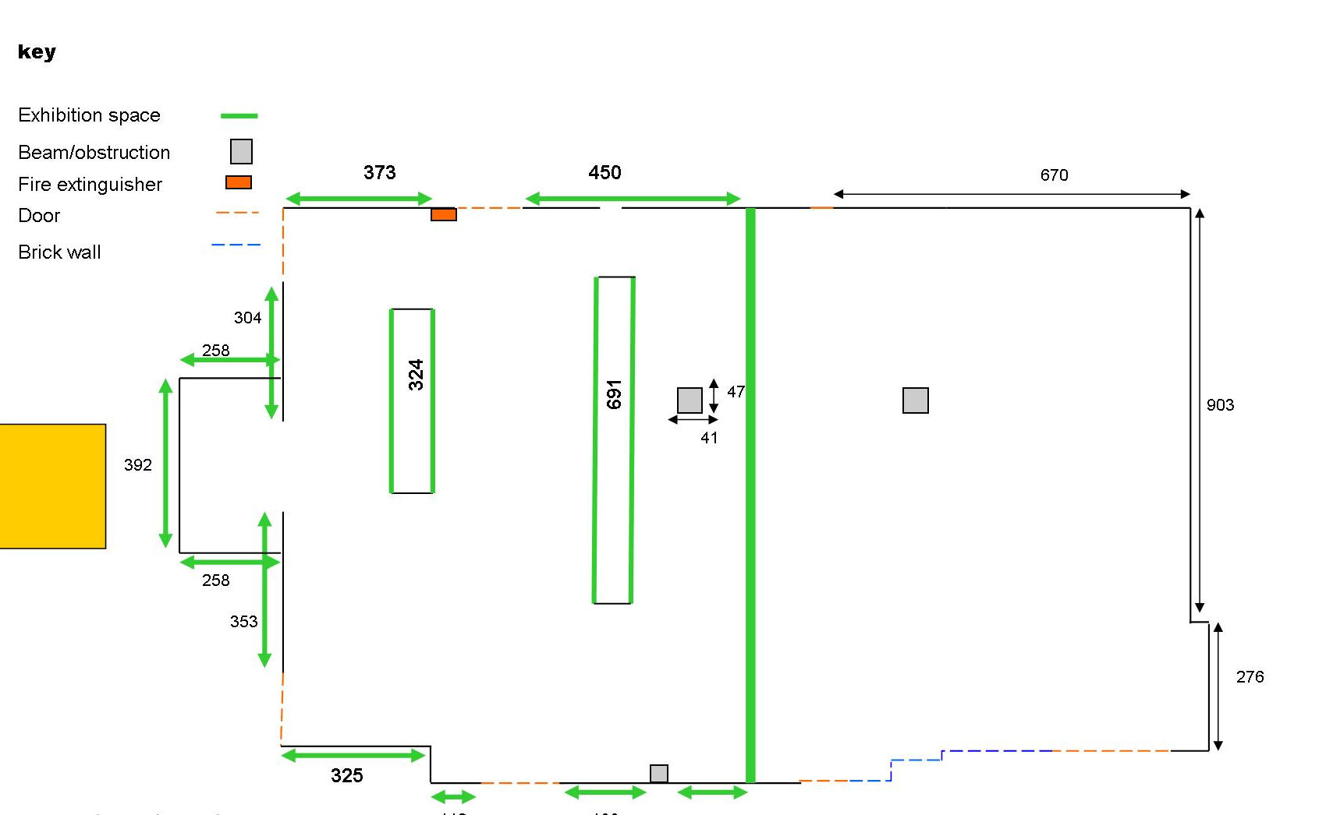

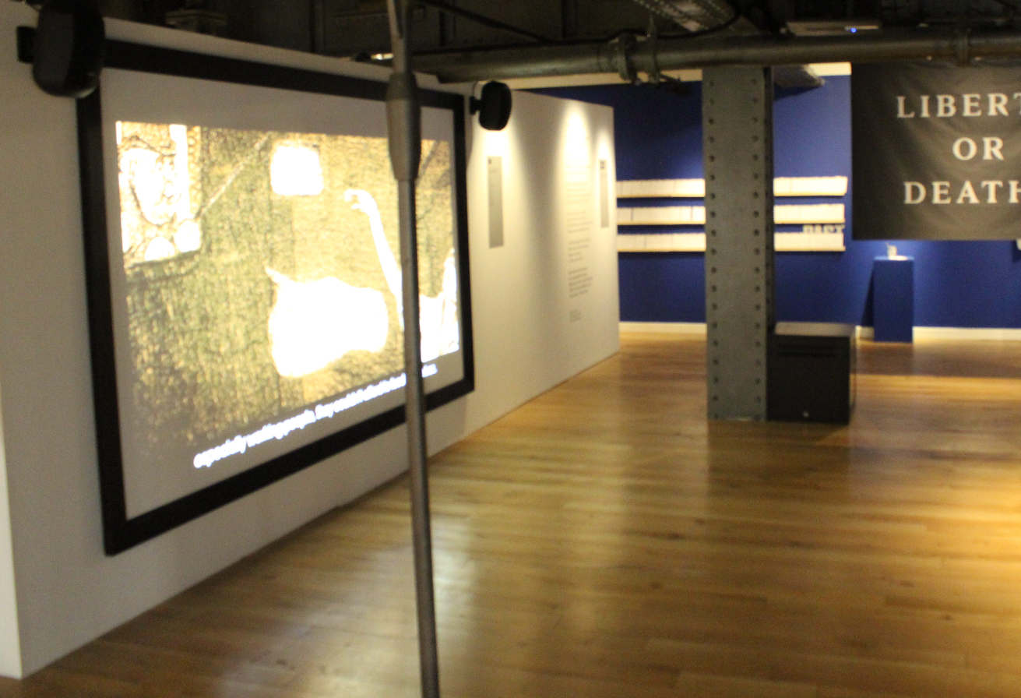

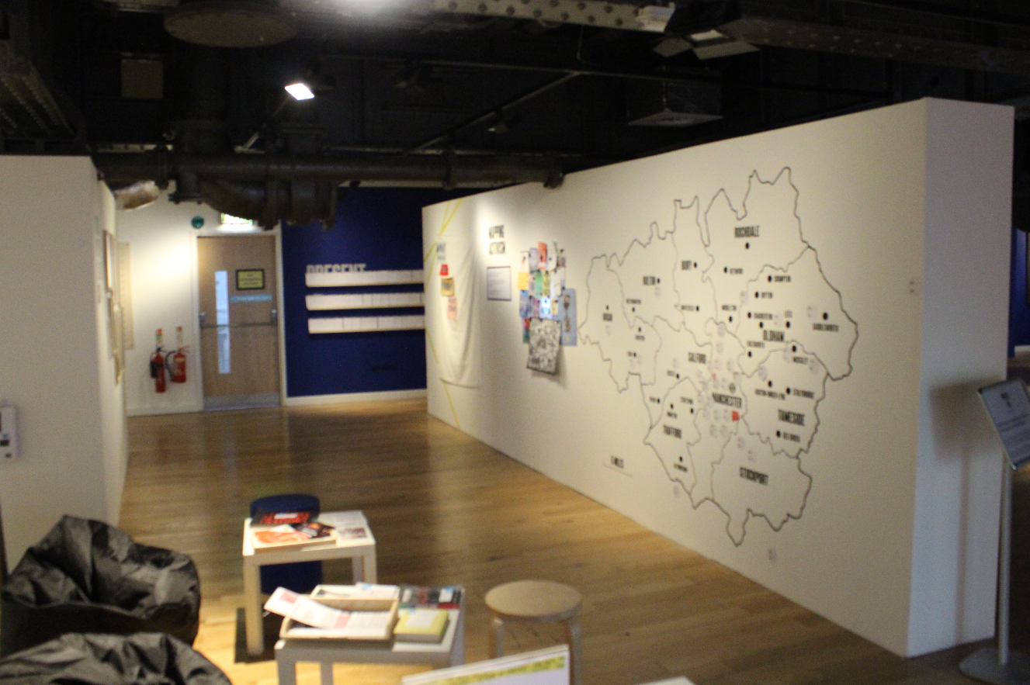

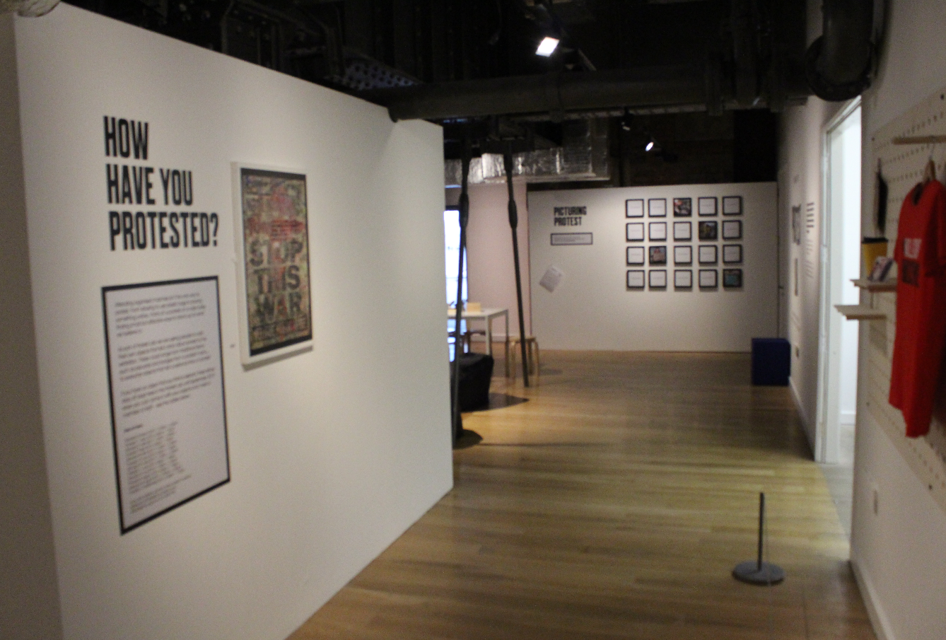

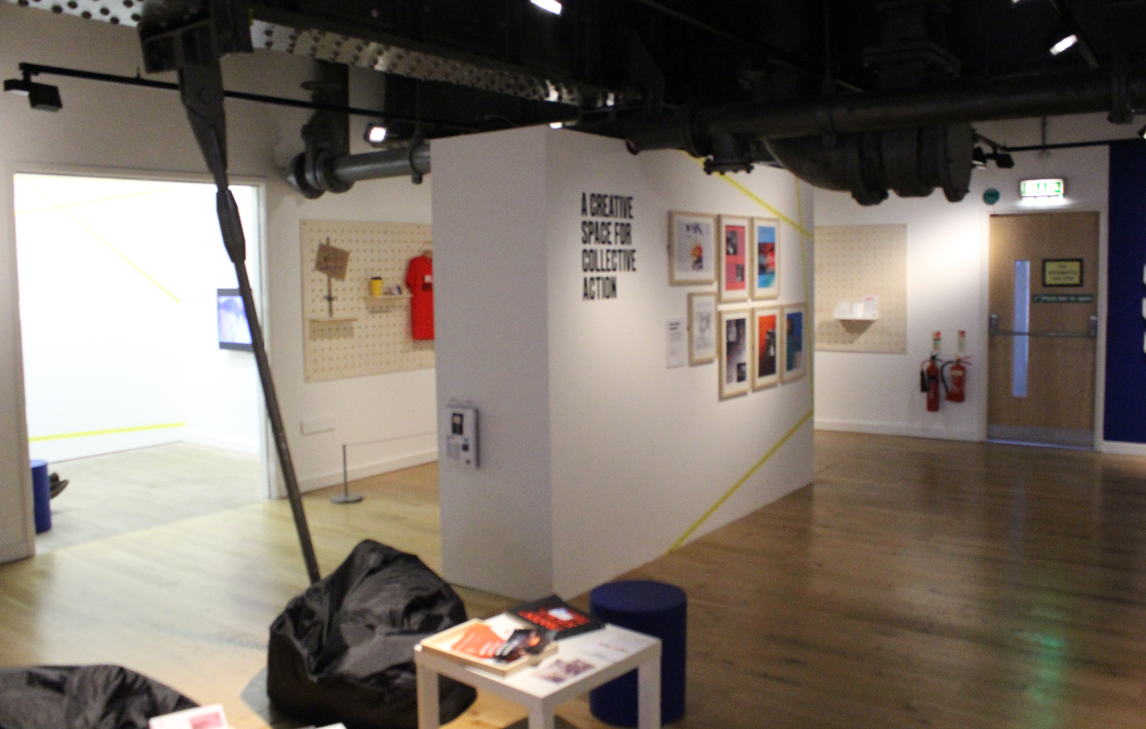

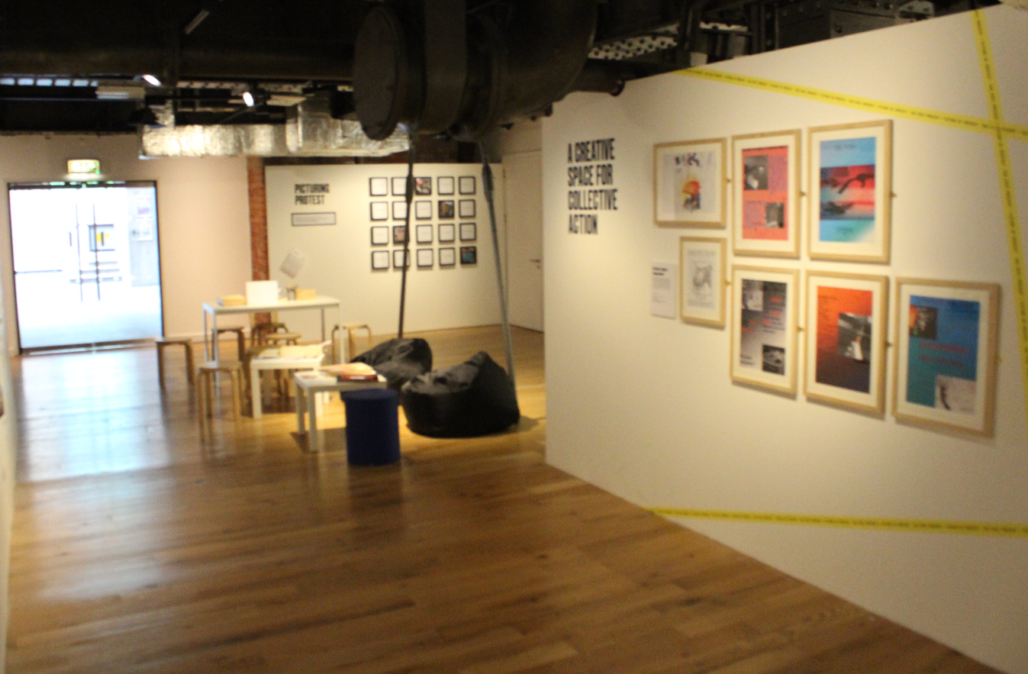

Marketing community exhibitions and events in PHM’s public programme

- PHM’s Communications & Marketing Team will assist in promoting the exhibition to the public where possible.

- All promotional material (exhibition preview invites, flyers, postcards, posters, press releases etc.) using the museum name must be approved by PHM’s Communications & Marketing Team before going to print/being circulated.

- If you wish to have an opening event for your exhibition this can be organised in advance through your PHM Programme Team contact. All events at PHM requiring catering use the services of our in house caterers CH&Co who manage The Left Bank cafe bar and support the museum’s Venue Hire service, a vital source of income generation for the museum. No other catering can be used as this breaches the museum’s contract with the caterers. External exhibition organisers will be required to pay for any catering before the event takes place.

- If you wish to run public events such as talks or workshops as part of the exhibition, these can be arranged with PHM’s Programme Team. If your event proposals are feasible and fit within PHM’s public programme, the Communications & Marketing Team will assist in promoting your event to the public where possible.

