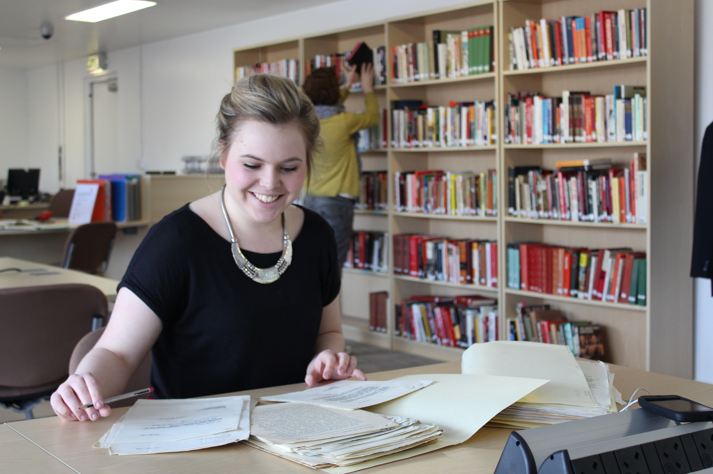**Introduction to Archives**

**Teacher’s Notes**

**Summary**

In this session discover what an archive is and look behind the scenes. Students will develop research skills by analysing primary sources using The Labour History Archive and Study Centre’s (LHASC) unique collections relating to the political wing of the labour movement.

Citizenship, History, Politics, Sociology

**Suitable for**

Key Stage 3 & 4, FE, HE & adult groups

**Objectives**

* Learn about how archives can be used to enhance understanding of a historic theme
* Use observation and analysis skills to interpret source material
* To physically handle archive material/primary sources
* To learn about the archive collections of the People’s History Museum

**Themes**

To be chosen by teacher prior to visit in discussion with the archivist

Material is mainly from 19th century to the present day although the oldest item we have is a Levellers pamphlet dating from 1649.

* Radicalism and reform
* Single issue campaigning
* National and international social and political movements
* Labour Party archive
* Communist Party of Great Britain archive

**Session itinerary**

The session will begin with an introduction from an archivist, followed by a teacher led research activity. Worksheets are provided by LHASC and will also be sent to group leaders prior to their visit.

|  |  |
| --- | --- |
| Activity | Led by |
| **Introduction to archives**   * What is an archive and how do you access one? * What material does LHASC collect? * What material will you be looking at today? | Archivist |
| ***Should we believe everything we see and read?* Research activity**  Four source materials will be provided by the archive.  In small groups analyse one source material each and complete the research questions on the worksheet provided.  After 20 minutes swap with another group so each participant has the opportunity to analyse two different sources. | Group leader |
| **Tour of the strong room**  During the research activity there will be opportunity for students to take a tour of the strong room and see where material is stored.  Due to space limitations these will be carried out in small groups. | Archivist  Accompanied by at least one group leader |
| **Group discussion and evaluation**   * What were the source materials? * What can we learn about the time period from them? * Was anybody surprised by what they found? | Group leader |

