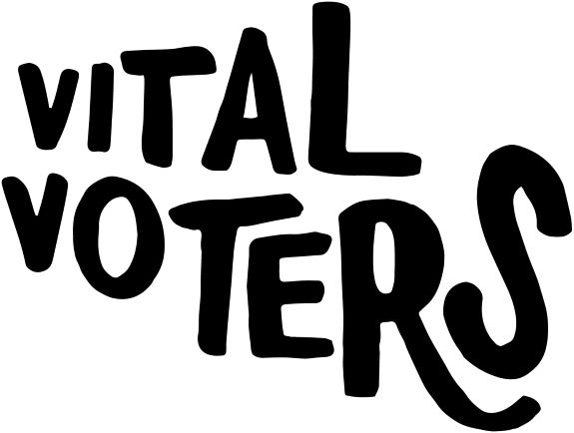
Group Leader Notes
Vital Voters: Your Voice Counts
Summary
The history of democracy is dotted not only with tales of struggle and inequality but also with the actions that ordinary people have taken to make the world a fairer place. After exploring our exhibitions, young people are invited to take action on an issue that matters to them by filming their own campaign video. They learn about what it takes to make an effective campaign video before producing their own short films to be uploaded on People’s History Museum’s (PHM) website as part of our Vital Voters project.

Suitable for
Year 5 to Year 11

National Curriculum links
Democracy, government and the rights and responsibilities of citizens.

Session itinerary
We recommend using PHM’s Your Voice Counts presentation to prepare your group for the workshop.
- Arrival at museum. Self-guided tour of galleries looking at examples of campaigns and active citizenship. A quiz sheet has been prepared to focus young people’s exploration of the galleries.
- Meet your facilitator and move to the Learning Studio. What makes an effective campaign video? Young people work in groups to watch examples of videos and identify what makes them successful before reporting back to class.
- Explore what is meant by fake news and how campaigns can be used to bring about negative as well as positive change.
- Young people are given tips on how to get the most out of iMovie before working in their groups to storyboard their own campaign videos.
- Young people film and edit their video adding titles, sound effects, clips and music and design a campaign logo. Review all films as a class and identify what worked well.

Post visit activity suggestion
- After the workshop, suitable videos will be uploaded and available to view on PHM’s website.
- It is important that the young people see the influence their voice has had. For this reason, we recommend that you show the completed videos to the rest of the school and arrange either a ballot for them to vote for their favourite video or petitions to sign to show their support of the individual campaigns. People’s History Museum would love for you to send any data from such activities to us as it will help evidence the wider impact of the Vital Voters project.

Objectives
- To explore how campaigns use persuasive techniques to inspire people to take action.
- To consider how campaigns can be used for negative purposes as well as good.
- To develop creative and digital skills.
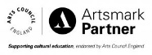
- To increase young people’s sense that their voice and opinion counts.

