1945
Winston Churchill - Conservative
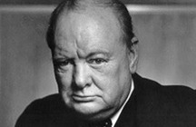
- Mobilised and inspired UK to victory in World War II
- Inspirational leadership skills and vast military experience
- Wanted to maintain links to the British Empire and Commonwealth
- Set up alliance with USA and Russia
1945
Clement Attlee -Labour
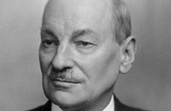
- Wanted to set up National Health Service (free healthcare for all)
- Wanted to nationalise and reform industries , giving workers higher pay and better working hours
- Encouraged immigration into the UK
- Promoted free education for all

1945
Henry Campbell-Bannerman - Liberal
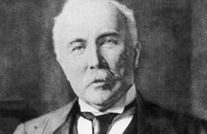
- Wanted local authorities to provide free school meals
- Against taxing foreign goods that would make them more expensive – he believed in free trade.
- Wanted to improve working conditions in factories and reduce unemployment
1945
Arthur Balfour – Conservative and Liberal Unionist
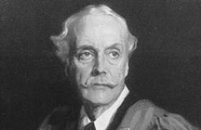
- Wanted to tax foreign goods and make them more expensive to protect British industry
- Keen to strength the Empire in the face of the growing economic power of Germany and the USA

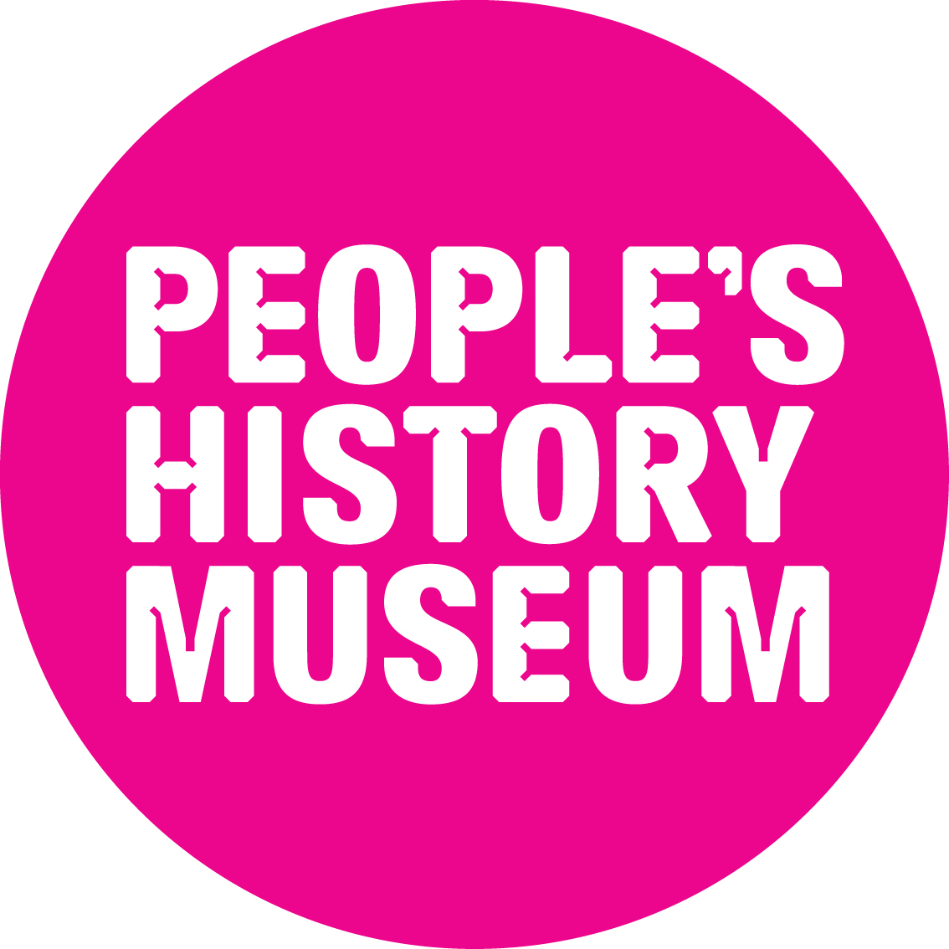

1959
Harold Macmillan – Conservative
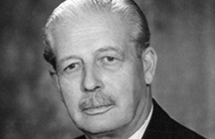
- Military experience – junior minister to Churchill and took over as PM after Suez crisis of1956.
- Standard of living amongst people rose under his leadership and promised to double standard of living again within 10 years
- Proposed to cut taxes in 7 budgets
- Promised to double standard of living
1959
Hugh Gaitskell – Labour

- Wanted to remove Purchase Tax on essential goods (food etc.)
- Wanted to reduce gap between richest and poorest people
- Identified mass unemployment and pensioners having a lack of retirement income as key problems and sought to solve them

1997
John Major - Conservative

- Conservatives had already spent 18 years in office.
- Helped country to recover from recession in the early 1990s.
- Wanted to develop private investment sector to regenerate cities and areas of decline.
1997
Tony Blair - Labour


- Promised not to raise income tax
- Vowed to cut class sizes in schools and put education at the top of its priority list.
- Wanted to reduce NHS waiting lists

1979
Margaret Thatcher - Conservative
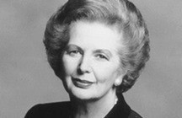
- Cuts in income taxes
- Wanted to privatise some industry to relieve pressure on government spending
- First woman running for Prime Minister represented huge social change
1979
James Callaghan - Labour
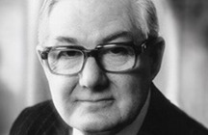
- Wanted to stop inflation (prices going up)
- Close links to trade Unions
- Vastly experienced other government positions: home secretary, foreign secretary and chancellor of the exchequer.

Election Top Trumps – Rules
1) Split students into groups of 3. Explain the rules to the group before they start.
2) One player will act as the ‘public’ while the other two players will be representing a political party presenting arguments to get their vote.
3) Public’ player gives out the two cards from the same election year. Give party players a minute to read through the information card of the party/leader they have been given.
4) Each player will state why they think the ‘public’ player should vote for them and at the end, the public player will decide who they would vote for.
5) Check to see if the result you picked was the result in real life. If not, why not?

