Russell Brand Image/quote

Russell Brand Image/quote

logo

logo

Activity 2
The Votes Close – The Amazing Journey of Your Vote

Activity 2
The Votes Close – The Amazing Journey of Your Vote

Logo

logo

Activity 2
The Votes Close – The Amazing Journey of Your Vote

Activity 2
The Votes Close – The Amazing Journey of Your Vote

Logo

Logo

Activity 2
The Votes Close – The Amazing Journey of Your Vote

Activity 2
The Votes Close – The Amazing Journey of Your Vote

Logo

Logo

Candidate
An electoral district represented by a politician or politicians.

Democracy
Usually a member of a political party that stands in an election.

Constituency
Constituents
Representative
People who live in a particular electoral district.

A person who wants or holds an elected position within the government.

A person who represents others views and opinions.

Politician
The opportunity to vote or have your say on an issue.

Coalition
Government
Cabinet of a parliamentary government in which several political parties cooperate, reducing the dominance of any one party.

Minority Government
A cabinet formed when a political party does not have a majority of overall seats in parliament.

House of Commons
A body with 659 MPs who have been elected by local residents to represent an area in parliament.

House of Lords
A body made up of people with titles. There is no limit on the number of these members. Their job is to double check new laws.

Majority Government
A government formed by a governing party that has an absolute majority of seats in parliament.

Manifesto
A declaration of policy and aims issued before an election by a political party or candidate.

Activity 5 – 1945 Hot-seating
Following World War II, an election was called in 1945 which saw the hugely popular conservative Winston Churchill come up against Labour’s Clement Atlee. In small groups discuss how an undecided voter might have felt about who to vote for in the 1945 election.
Undecided voter, 1940 election
- Winston Churchill (Conservative) had just played a key role in leading the United Kingdom to victory in World War II
- Labour Party wanted to introduce the welfare state (National Health Service, free education for all, council housing) and nationalisation of rail and coal industries
- Public worry that under a Conservative government, a welfare state would not be introduced and UK would return to mass unemployment of 1930s.
- The 1945 election was the first to be fought in Britain for ten years, due to the war.
Have one person play the role of the voter, with the rest of the group asking this person questions about how they feel and what they plan to do.

Activity 5 – 1945 Hot-seating
Following World War II, an election was called in 1945 which saw the hugely popular conservative Winston Churchill come up against Labour’s Clement Atlee. In small groups discuss how an undecided voter might have felt about who to vote for in the 1945 election.
Undecided voter, 1940 election
- Winston Churchill (Conservative) had just played a key role in leading the United Kingdom to victory in World War II
- Labour Party wanted to introduce the welfare state (National Health Service, free education for all, council housing) and nationalisation of rail and coal industries
- Public worry that under a Conservative government, a welfare state would not be introduced and UK would return to mass unemployment of 1930s.
- The 1945 election was the first to be fought in Britain for ten years, due to the war.
Have one person play the role of the voter, with the rest of the group asking this person questions about how they feel and what they plan to do.

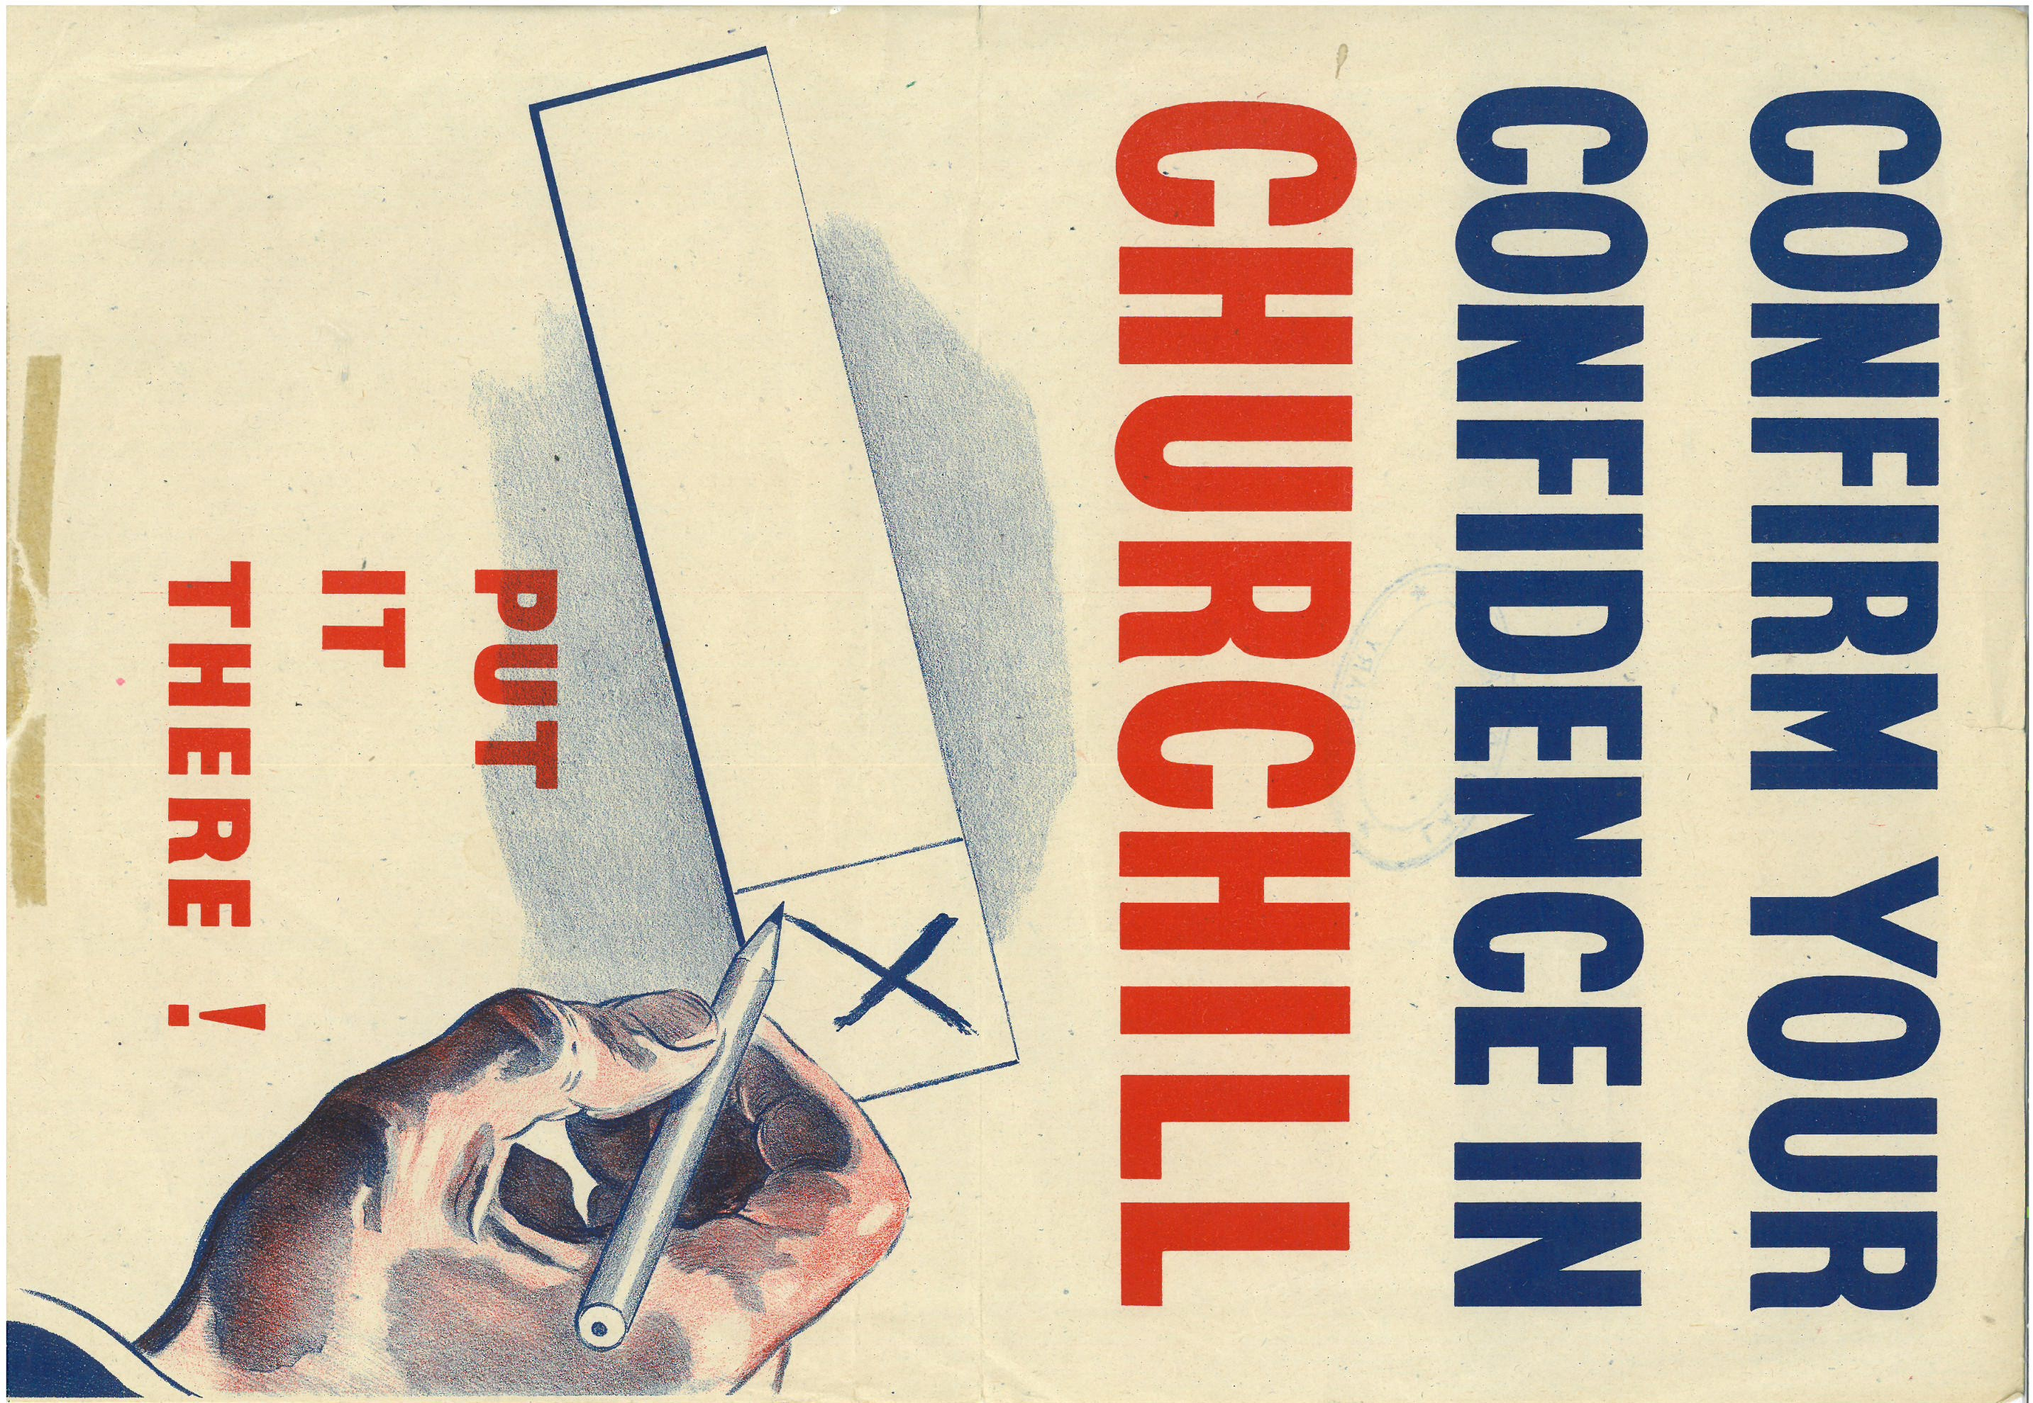

Activity 7 – Tableau/Frozen Pictures
In the nineteenth century women had no place in national politics. They could not stand as candidates for Parliament. It was not until 1928 that all women had equality with men in their right to vote.
Create 4 freeze frames using your body to express how a person supporting women’s right to vote would feel at each of these stages:
- 1867 - John Stuart Mill proposed an amendment that would have given the vote to women on the same terms as men but it was rejected.

- 1903 - The Women's Social and Political Union (WSPU) is founded in Manchester by Emmeline Pankhurst. Soon after, suffragette protests for the voting rights of women began.

- 1918 - The Representation of the People Act is passed giving women the vote, but only if they are aged over 30 and either they, or their husband, meet a property qualification. The Parliament (Qualification of Women) Act is passed on 21 November allowing women to stand for Parliament.

- 1928 - The Equal Franchise Act is passed giving women equal voting rights with men. All women aged over 21 can now vote in elections.

Activity 7 – Tableau/Frozen Pictures
In the nineteenth century women had no place in national politics. They could not stand as candidates for Parliament. It was not until 1928 that all women had equality with men in their right to vote.
Create 4 freeze frames using your body to express how a person supporting women’s right to vote would feel at each of these stages:
- 1867 - John Stuart Mill proposed an amendment that would have given the vote to women on the same terms as men but it was rejected.

- 1903 - The Women's Social and Political Union (WSPU) is founded in Manchester by Emmeline Pankhurst. Soon after, suffragette protests for the voting rights of women began.

- 1918 - The Representation of the People Act is passed giving women the vote, but only if they are aged over 30 and either they, or their husband, meet a property qualification. The Parliament (Qualification of Women) Act is passed on 21 November allowing women to stand for Parliament.

- 1928 - The Equal Franchise Act is passed giving women equal voting rights with men. All women aged over 21 can now vote in elections.

