Activity 1
Russell Brand Image/quote

Activity 1
Russell Brand Image/quote

logo

logo

‘If 16 year olds could vote, they might become more interested in politics. Then, they would be more likely to vote during their lifetime.’

‘16 year olds have a right to vote. An important reason behind democracy was “no taxation without representation.” At 16 you can get a job and pay taxes so it is undemocratic that you don’t get a say in how those taxes are set and spent. You should have a say in those policies’

‘16 year olds can get married and join the army. If they can do this, they should be allowed to vote.’

‘There has to be some limits. Otherwise, why not let 14 year olds vote and so on. I’m sure there are some 16 year olds who are mature enough to vote, but the majority are not.’

‘Scientific studies have shown our brains are not fully formed until we are about 21 years of age. With this in mind, it doesn’t make sense to lower the voting age further.’

‘There are better ways of getting young people involved in politics without lowering the voting age. Having more citizenship lessons in school would help students get more involved in parliament.’

‘Voter turnout is most significant in the 18-21 age bracket. If we offered 16 year olds the chance to sign up to voting in school, maybe voter interest would increase.’

‘If 16 year olds could vote, they might become more interested in politics. Then, they would be more likely to vote during their lifetime.’

‘16 year olds have a right to vote. An important reason behind democracy was “no taxation without representation.” At 16 you can get a job and pay taxes so it is undemocratic that you don’t get a say in how those taxes are set and spent. You should have a say in those policies’

‘16 year olds can get married and join the army. If they can do this, they should be allowed to vote.’

‘There has to be some limits. Otherwise, why not let 14 year olds vote and so on. I’m sure there are some 16 year olds who are mature enough to vote, but the majority are not.’

‘Scientific studies have shown our brains are not fully formed until we are about 21 years of age. With this in mind, it doesn’t make sense to lower the voting age further.’

‘There are better ways of getting young people involved in politics without lowering the voting age. Having more citizenship lessons in school would help students get more involved in parliament.’

‘Voter turnout is most significant in the 18-21 age bracket. If we offered 16 year olds the chance to sign up to voting in school, maybe voter interest would increase.’

Activity 4 – Howard Wilson’s letter

To whom it may concern,
As the leader of the Labour party, I have set you the task of creating a political party advert that will encourage people to vote for us during upcoming 1974 election. Have a look at some examples of propaganda artwork to help you in your task.
How do parties depict the opposition in these pictures? How do they try to persuade the voter to vote for them?
I know I can rely on you to do a good job!
Kind regards
Howard Wilson

Activity 4 – Howard Wilson’s letter

logo

Logo

Activity 4: February 1974 Election
Here is some background information to help you in the production of your advert:
- Industrial relations between the Conservative government and the unions turned sour when Edward Heath's attempted to calm the economy's troubles with government-enforced pay freezes and calls for pay restraint failed.
- As demand for coal increased the miners sensed an advantage and pressed asked for higher wages.
- With the miners rejected a 13% pay rise and an overtime ban followed.
- January 1974 saw Heath declare a three-day working week where electricity supplies were cut to just three consecutive days per week to conserve coal stocks, which was threatened by a strike by mineworkers.
- Heath had taken the UK into Europe Common market after a vote in parliament, leaving many people feeling they had not been properly consulted over what was a major change.
- We will offer people an opportunity to vote on our membership to the European Common market.

Activity 4: February 1974 Election
Here is some background information to help you in the production of your advert:
- Industrial relations between the Conservative government and the unions turned sour when Edward Heath's attempted to calm the economy's troubles with government-enforced pay freezes and calls for pay restraint failed.
- As demand for coal increased the miners sensed an advantage and pressed asked for higher wages.
- With the miners rejected a 13% pay rise and an overtime ban followed.
- January 1974 saw Heath declare a three-day working week where electricity supplies were cut to just three consecutive days per week to conserve coal stocks, which was threatened by a strike by mineworkers.
- Heath had taken the UK into Europe Common market after a vote in parliament, leaving many people feeling they had not been properly consulted over what was a major change.
- We will offer people an opportunity to vote on our membership to the European Common market.

Logo

Logo

Activity 5 – Hot-seating
Following World War II, an election was called in 1945 which saw the hugely popular conservative Winston Churchill come up against Labour’s Clement Atlee. In small groups discuss how an undecided voter might have felt about who to vote for in the 1945 election.
Undecided voter, 1940 election
- Winston Churchill (Conservative) had just played a key role in leading the United Kingdom to victory in World War II
- Labour Party wanted to introduce the welfare state (National Health Service, free education for all, council housing) and nationalisation of rail and coal industries
- Public worry that under a Conservative government, a welfare state would not be introduced and UK would return to mass unemployment of 1930s.
- The 1945 election was the first to be fought in Britain for ten years, due to the war.
Have one person play the role of the voter, with the rest of the group asking this person questions about how they feel and what they plan to do.

Activity 5 – Hot-seating
Following World War II, an election was called in 1945 which saw the hugely popular conservative Winston Churchill come up against Labour’s Clement Atlee. In small groups discuss how an undecided voter might have felt about who to vote for in the 1945 election.
Undecided voter, 1950 election
- Winston Churchill (Conservative) had just played a key role in leading the United Kingdom to victory in World War II
- Labour Party wanted to introduce the welfare state (National Health Service, free education for all, council housing) and nationalisation of rail and coal industries
- Public worry that under a Conservative government, a welfare state would not be introduced and UK would return to mass unemployment of 1930s.
- The 1945 election was the first to be fought in Britain for ten years, due to the war.
Have one person play the role of the voter, with the rest of the group asking this person questions about how they feel and what they plan to do.

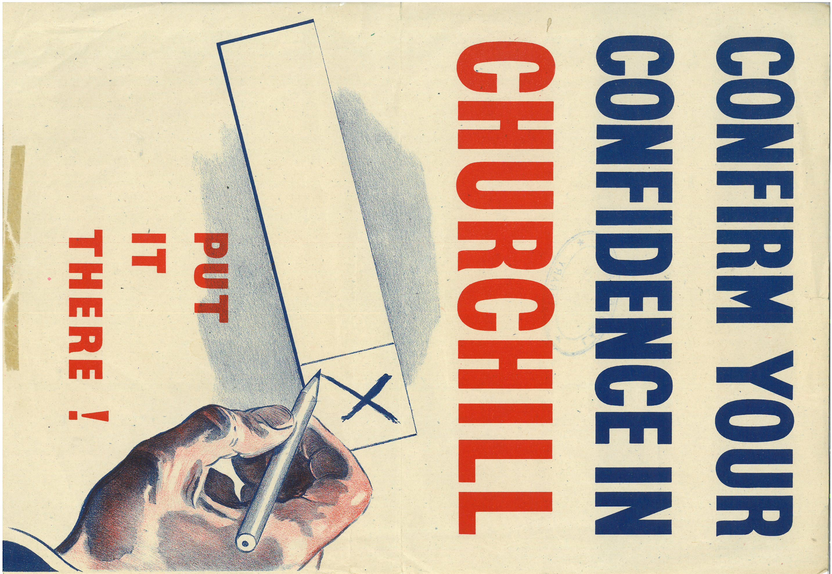
.

.

Curator’s Comment

Logo

logo

Activity 6 – Tableau/Frozen Picture
In the nineteenth century women had no place in national politics. They could not stand as candidates for Parliament. It was not until 1928 that all women had equality with men in their right to vote.
Create 4 freeze frames using your body to express how a person supporting women’s right to vote would feel at each of these stages:
- 1867 - John Stuart Mill proposed an amendment that would have given the vote to women on the same terms as men but it was rejected.

- 1903 - The Women's Social and Political Union (WSPU) is founded in Manchester by Emmeline Pankhurst. Soon after, suffragette protests for the voting rights of women began.

- 1918 - The Representation of the People Act is passed giving women the vote, but only if they are aged over 30 and either they, or their husband, meet a property qualification. The Parliament (Qualification of Women) Act is passed on 21 November allowing women to stand for Parliament.

- 1928 - The Equal Franchise Act is passed giving women equal voting rights with men. All women aged over 21 can now vote in elections.

Activity 6 – Tableau/Frozen Picture
In the nineteenth century women had no place in national politics. They could not stand as candidates for Parliament. It was not until 1928 that all women had equality with men in their right to vote.
Create 4 freeze frames using your body to express how a person supporting women’s right to vote would feel at each of these stages:
- 1867 - John Stuart Mill proposed an amendment that would have given the vote to women on the same terms as men but it was rejected.

- 1903 - The Women's Social and Political Union (WSPU) is founded in Manchester by Emmeline Pankhurst. Soon after, suffragette protests for the voting rights of women began.

- 1918 - The Representation of the People Act is passed giving women the vote, but only if they are aged over 30 and either they, or their husband, meet a property qualification. The Parliament (Qualification of Women) Act is passed on 21 November allowing women to stand for Parliament.

- 1928 - The Equal Franchise Act is passed giving women equal voting rights with men. All women aged over 21 can now vote in elections.

Conservative
Eight years ago was a turning point in British history. The Labour government had failed in grappling with the problems of a post-war world. Under Conservative leadership this country set out upon a new path. It is leading to prosperity and opportunity for all. The British economy is sounder today than at any time since the First World War. Our exports have reached the highest peak ever. We have cut taxes in seven budgets, whilst continuing to develop the social services. We have provided over two million new homes and over two million new school places, a better health service and a modern pensions plan. We have shown that Conservative freedom works. Life is better with the Conservatives.
- Cut taxes in seven budgets
- Highest exports ever
- Continued development of social services
- Modern pensions plan
- Two million new homes built
- Two million new school places.

Labour
We welcome this election; it gives us, at last, the chance to end eight years of Tory rule. Macmillan told us that the old division of Britain into two nations, the Haves and the Have Nots, has disappeared. In fact, the contrast between the extremes of wealth and poverty is sharper today than eight years ago. The business man with a tax-free expense account, the speculator with tax-free capital gains, and the retiring company director with a tax-free redundancy payment have indeed ‘never had it so good’. It is not so good for the widowed mother with children, the chronic sick, the 400,000 unemployed, and the millions of old age pensioners who have no adequate retirement income. Instead of recognising this problem as the greates social challenge of our time, the Prime Minister blandly denies it exists.
- Wanted to remove Purchase tax on essential goods like food.
- Vowed to reduce gap between the rich and the poor
- Identified mass unemployment as an area to improve
- Sought to solve the problem of pensioners with a lack of retirement income.

Logo

Logo

Liberal
We must have more Liberals in Parliament for the sake of honest, above-board politics. The Conservative party is clearly identified with employers and big business and they cannot deal with the problems continually arising between employer and employee. The Labour party is in the hands of the Trade Union leaders. The whole nation is the loser from this crazy line up of power politics. A Liberal vote is a protest against the British political system being divided up between two powerful party machines, one largely financed by the employers and the other by the Trade Unions.

- Believed Conservatives were bad for working people’s rights and fought for the employers
- Believed Labour were effectively ‘in the hands of’ the Trade Unions
- An alternative to both Labour and the Conservatives who were not going to be influenced by either employers nor Trade Unions.
- Offered permanent prices and incomes policies, better pensions and a minimum earnings level.

Logo

