More in Common:
in memory of Jo Cox

Large Print Text
24pt

Contents

Our Yorkshire Rose banner 3
Jo Cox 4
Introduction panel 4
Jo’s birth and growing up 6
A passion for politics 8
Labour MP 10
Family Life 12
International interests 14
22 June 1974 - 16 June 2016 15
Jo Cox – continued 17
Jo Cox - In her own words - Memorial Film 17
Jo Cox’s mountain hat 18
More in common Group 21
Collective values 23
Quotes from participants 25
Adapting to a global pandemic 27
Our More in Common Journey 29
Looking for ‘More in Common’ 29
Threads That Bind Us 36
A Day in the Life 40
Voices of Manchester 41
In memory of Jo 44
Memorials 45
In the UK and beyond 48
Donations 50
Objects in the case 51
Jo Cox Memorial Wall 54
The Wall of Hope 55
Quotes from Jo’s family 56
Jo’s Legacy 57
The Jo Cox Foundation 59
Building a fairer world 61
A better public life 63
Objects in the case 66
The More in Common Network film 68
The people of More in Common 69
Acknowledgment 71

Located outside the entrance to the exhibition, in the Engine Hall

Our Yorkshire Rose banner, 2016
Courtesy of Jo Cox’s family
The mooring where Jo lived is a close community full of friends. When Jo died many of the artists on the mooring worked together to design and make this banner. It was designed in the style of an old trade union banner, a nod to her politics and also her strength. It was carried by her neighbours to the vigil in Trafalgar Square, London. Her neighbours have been a huge support to her family and remain a close knit community.

Jo Cox

Introduction panel
Inspired by the legacy of Jo Cox MP, the More in Common project involves a group of over 30 people from different backgrounds who made Manchester their home, coming together to share knowledge, experiences, and conversations.
Co-created by the project group, this exhibition explores Jo’s life and legacy and follows the group on their journey in celebrating our commonality and challenging discrimination.
Join us in championing Jo’s words: ‘We are far more united and have far more in common than that which divides us’. Now more than ever, Britain needs to embrace, celebrate and find strength in what connects us.
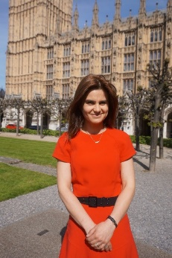
Jo Cox on College Green, Westminster, London, 2015
Courtesy of The Jo Cox Foundation
Jo is pictured here on one of her first days as an MP.

‘One of the reasons I am entering politics is because only 23% of the House of Commons is female. If women don’t make that 50/50 then the people taking decisions about our communities are never going to be reflective of the needs.’
Jo Cox, 2015

Jo’s birth and growing up

Jo was born Helen Joanne Leadbeater, in Dewsbury, West Yorkshire on 22 June 1974.

Jo and Kim Leadbeater at Millbridge School, 1978
Courtesy of Jo Cox’s family

Jo grew up in a close working class family and was the first in the family to finish university, gaining a place at Pembroke College at the University of Cambridge.
At first Jo struggled to adjust to life at Cambridge and the loneliness she experienced while studying would inform the work she did later as an MP, combating loneliness and isolation.
During her life Jo Cox made an impact not only as a passionate campaigner, politician and humanitarian but also as a proud mother, wife, daughter, sister and friend. Even after her death her message of love and her belief in a more equal and tolerant world continues to inspire others.

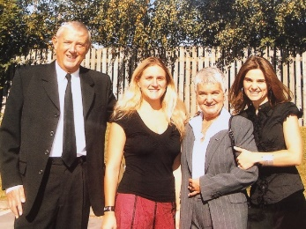
Gordon, Kim, Jean and Jo Leadbeater, 2008
Courtesy of Jo Cox’s family
Jo and her family are pictured here at her paternal Grandad Arthur’s funeral in Heckmondwike.

A passion for politics

Soon after graduating in 1995, Jo became a political adviser for the Labour Party MP Joan Walley. This was followed by move to Brussels where she would live for six years, first working as an assistant to Labour Party Member of the European Parliament (MEP) Glenys Kinnock and then as the Head of Oxfam International’s European Union office. Jo continued in various posts at Oxfam until 2009, roles that would shape her view of international politics.

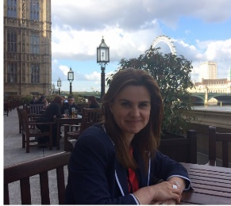
Jo Cox on the House of Commons terrace, 2015
Courtesy of The Jo Cox Foundation

‘I’ve been in some horrific situations where women have been raped repeatedly in Darfur, I’ve been with child soldiers who have been given Kalashnikov and killed members of their own family in Uganda. In Afghanistan I was talking to Afghan elders who were world weary of a lack of sustained attention from their own Government and from the international community to stop problems early. That’s the thing that all of that experience gave me, if you ignore a problem it gets worse’

Jo Cox visiting Gaza, Palestine, 2006
Courtesy of The Jo Cox Foundation
During her time working for Oxfam International Jo visited Gaza. She believed the international community should play a bigger role to protect civilians from armed conflict.

Labour MP

In 2015, Jo got her dream job when she was elected the Labour Party MP for Batley and Spen, representing the place where she was born and grew up.
During her short time in parliament, she made a huge impression campaigning for equality in education and politics, promoting closer communities and setting up a cross party commission to tackle loneliness, with Conservative Party MP Seema Kennedy.

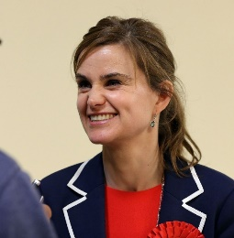
Jo Cox at the general election count in Huddersfield, 2015
Courtesy of The Jo Cox Foundation
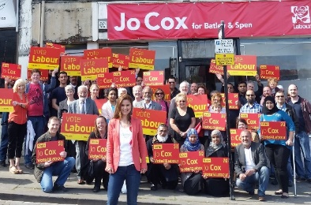
Jo Cox and her campaign team in Batley and Spen, 2015
Courtesy of The Jo Cox Foundation
Jo and her team prepare for a weekend of campaigning in the run up to the 2015 general election. Knocking on doors and talking to people was one of the things Jo loved about politics.

‘We are far more united and have far more in common than that which divides us’
Jo Cox, 2015

Family Life

In 2009, Jo married Brendan Cox. They soon started a family together and had two children, Cuillin and Lejla. Even during her time as an MP, Jo made sure the children came first and would rush back on her bike to make it home in time for bedtime.

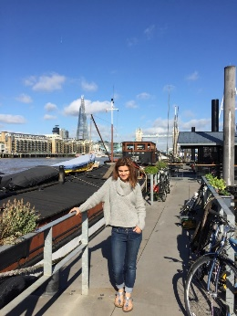
Jo Cox by her mooring, London, 2015
Courtesy of The Jo Cox Foundation
Jo lived with her husband and children on a house boat on the River Thames. Jo and Brendan lived on boats throughout their life together. The community on the mooring has been a bedrock of support for her family since her death.
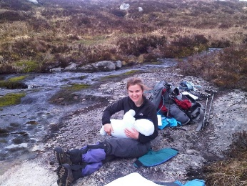
Jo Cox breastfeeding Cuillin Cox, 2011
Photo courtesy of Jo Cox’s family
Jo is pictured here halfway up a Scottish mountain a few months after her son Cuillin was born.

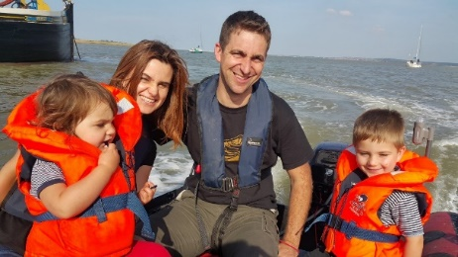
Jo, Brendan, Cuillin and Lejla Cox in their dinghy, 2015
Courtesy of Jo Cox’s family
Jo and her family are pictured here at The Swale, a tidal stream near the mouth of the River Thames. The Swale was a regular destination with their boat. They would anchor in the channel, swim to the shore and play on the mudflats.

International interests

As well as local and national issues, Jo was particularly interested in foreign policy. She was especially concerned with the conflict in Syria and launched the all party parliamentary group ‘Friends of Syria’ with Conservative Party MP Andrew Mitchell, to promote better understanding of the crisis among politicians and to find policy solutions.

22 June 1974 - 16 June 2016

On 16 June 2016, Jo’s life was tragically cut short.
During this period society had become increasingly divided and the politics of hate was on the rise.
On her way to a constituency surgery at Birstall Library, Jo was attacked and murdered.

‘The killing of Jo was a political act, in my view, an act of terrorism but in the history of such acts it was perhaps the most incompetent and self defeating. An act driven by hatred which instead has created an outpouring of love. An act designed to drive communities apart which has instead pulled them together. An act designed to silence a voice which instead allowed millions of others to hear it.’
Brendan Cox, 2016

Jo Cox – continued

On the screen:

Jo Cox - In her own words - Memorial Film, 2016
This film was shown in Trafalgar Square, London on 22 June 2016 as part of events to remember Jo Cox.
Made by Sarah Hamilton, Zara Hayes and Emma Lysaght with support from Minnow Films and Envy post production. Special thanks to Nancy Nigro, Morgan Matthews, Jane Neville, Chris Rayner, Jonathan Stewart and Hannah Wythe.

In the case:

Jo Cox’s mountain hat
Courtesy of Jo Cox’s family
Jo‘s trusty hat has accompanied her on every major expedition. From Pyrenean peaks to the rapids of the Delaware. Her husband and children now take it with them on their own adventures and it is on course to make it to the top of every Munro in her stead.

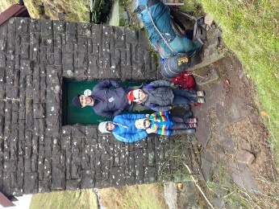
Jo Cox and family in the Black Mountains, Wales, 2016
Courtesy of Jo Cox’s family
Jo loved adventures and visiting bothies was high on that list. Bothies are often old shepherds’ huts, left open for walkers to use free of charge. This is one of the smallest bothies in the country and this photograph was taken on the children’s first bothy visit.

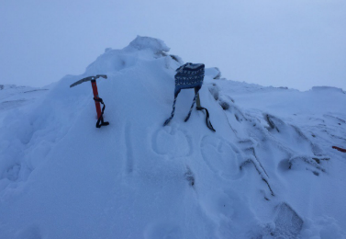
Jo Cox’s hat on Munro mountain summit, 2016
Courtesy of Jo Cox’s family
When Jo and Brendan met they decided to climb all 282 Munros together. Munros are Scottish mountains over 3,000 ft. The plan was to finish on Jo’s 70th birthday. Before Jo died they had climbed 98 together. Since then Brendan, Cuillin and Lejla have climbed them in her stead, carrying her hat to every summit. This was the 100th Munro in full winter conditions. The family are currently up to 148.

More in common Group

Do you believe that we can live together in a multicultural society without labels?
Are you looking for a space to meet a diverse range of people?

With this message PHM launched the More in Common project in early 2020, as an opportunity for the residents and communities of Greater Manchester, who shared Jo Cox’s beliefs and values to meet and work together.
After a positive response we started fortnightly gatherings for two groups, one in the morning and one in the evening

We were complete strangers but we knew that we had all signed up for something we believed in. It was encouraging to see people’s commitment, despite the pouring rain on every single Monday evening, as we gathered at the museum.
Through lots of conversation we got to know each other.
What makes us feel safe?
What do we care about?
What do we have in common?
Be part of a group getting together at People’s History Museum every fortnight to meet, discuss, and explore what you have in common. You can choose what you want to do and how you will spend the time together.

Collective values

We developed ‘values of working’ that we all agreed to:
- We respect and value our diverse and different opinions and beliefs.
- We will not judge anyone based on their status or background.
- We will not use offensive language or expressions.
- We will use clear language. Many of us are non-native English speakers.
- We will ask for clarification if we need to. Everyone has an equal opportunity to follow the conversation and contribute.
- We will ensure that everyone has an opportunity to speak during sessions, especially when meeting online.
- We will work as a team not individuals and we will try to have fun and learn new things as much as possible.
- We will communicate in a professional manner for the project purpose. If we choose to socialise and make friendships outside the project frame, we will take responsibility for our own actions.
- We will not take photographs and screenshots or make video or sound recordings without having the consent of all participants.
- We will not share sensitive information such as personal stories outside of the group unless we have unanimous agreement.

Quotes from participants

‘I was pleasantly surprised when I went to the first session. Almost all of the arts and cultural events in Manchester that I had been to were overwhelmingly white, despite the city having a diverse population. I loved being in a room with people from different walks of life. I thought 'I've found my gang’.’
‘I don’t want to identify as a gender, colour or religion. I am me.’
‘Now more than ever, we need to celebrate what we have in common and develop a better understanding of people with different lifestyles/perspectives. People are all we’ve got, so we’d better stick together!’
‘I am increasingly concerned at the hate and lies dominating our politics.’
‘I want to work with people from our different communities to improve our city and our world.’
‘I feel everyone should be able to be a part of society and lead full active lives without discrimination. At the end of the day, whatever differences people may think they have, we are all humans and have the same wants, needs and hopes.’
‘I believe we’re all citizens of the world.’

Adapting to a global pandemic

Like everyone across the globe, we had to change our plans when the Covid-19 pandemic hit.
The very essence of our project is about social interaction and we found ourselves isolated and connected only by a computer screen.
We continued the project online, though not everyone could join us.
We had to meet in smaller groups. So far, we have had over 50 gatherings! Check out what we’ve been working on.

Quote from participant:
‘We started working on mini projects, but none of us knew that Covid-19 was just around the corner. After a short pause, we restarted our projects online. My group works well together and we have become quite close. The experience has taught me to be more patient and empathetic. For example, it can take longer to make decisions as a group, but the end results are usually better.’

Our More in Common Journey

Looking for ‘More in Common’

More in Common is a personal journey. A connection with yourself and those around you.
It is to strip away fear, think without restriction and create without regulation.
We spoke and discussed.
2020 had just happened and we still were/are in the aftermath of it.
There is an air of urgency and a raw flame that has burnt everyone.
In sessions we visited places further out than we would normally venture, critically analysing why we see things the way we do. Why they are presented to us in the way they are and what we can do with them.
More in Common is a personal journey and to even start looking for ‘More in Common’ is a personal act of revolution.
More in Common continues to be a work in progress as does every artist involved in the process.
This display was created by a group of five women with the support of artist Shaheda Choudhury.

Top right
Eastern Europeans, by aleKSandra, 2021
British media representation of Eastern Europeans is rarely positive. The first image is a comment on harmful and classist stereotypes depicting a very large and diverse group of people as drunk, backward and servile.
The second image aims to capture the complexity of Eastern Europe’s relationship with Britain and includes the artist’s own family’s migration stories. People are more than the stereotypes enforced by the media and each of us has a very personal link with the place they migrated to.

Centre
Covid Time, by Julie Clare, 2021
We all experience time in the same way. A minute is 60 seconds no matter who or where you are. But Covid-19 has changed our perceptions of time and how we've all experienced time in the last year. For some, time has flown by, for others it has slowed down. For many it has become precious. This is a reflection on my Covid year.

Middle left
The Flower, by Julie Clare, 2021
As our lockdown world became smaller, nature was an escape. Freedom. The house was filled with flowers and plants. Chorlton Ees, Sale Water Park and the River Mersey on my doorstep but previously unexplored. Day after day for a year but it never looked the same. Seasons. Wildlife. Nature. Fusion.

Top left
From Poor to Posh!, by Sue Richardson, 2021
This collage shows the progress of a family over the years and highlights some strong women, especially my grandma:
My grandma’s family in the 19th century (top left); Grandad (top row, centre image) died of tetanus from a mining accident aged 39, she brought up six children, two became nurses; my mother married a middle class man from Bath (bottom right, first photograph) and their son was a director of British Aerospace.
Once I heard my grandma say to my steel-worker uncles when they were in their 50s, ‘If you’re as tall as a house, you won’t rule me’. Who said women’s liberation was a modern thing?

Bottom left
More Sky, by Tandrima, 2021

Far right
Sanam Collage, by Sanam, 2021
SanamSwans, by Sanam, 2021
Sanam Offering, by Sanam, 2021

Threads That Bind Us

This display consists of a collection of four costumes which explore the past, present and future through the eyes of Manchester’s diverse population, and its roots in colonialism through the cotton trade and fashion industries. Gathering inspiration from the heritage found in our cultural clothing and our hopes for the future as a gathered people, the costumes take us on a journey through the negative effects of colonialism, coming together as a diverse people from all over the world, growing, learning and launching into a colourful new future as a unified people.
This display is created by a group of four artists with the support of artist Ibukun Baldwin.

For Whose Common Wealth? by Chandanpreet Shergill, 2021
For this piece, I used patchwork to symbolise the complex and shifting relationship of an identity that lies between two countries and cultures. The bright colours, patterns and embellishments celebrate my Indian heritage, and the patches show the friction of the ties between the commonwealth countries and Britain’s colonial past. It is both looking back to empire and the textile industry of Manchester, as well as forward to a more hopeful and sustainable fashion future.

Pirates of the Colonial Empire, by Brett Dearden, 2021
This shirt style represents colonialism, which from my perspective was just shameful national piracy conducted with a flag and a tailored uniform. The belt represents taken resources and the colour reflects the bloodshed caused. The fabric was a gift from my friend, Ruth Jones, and was produced and purchased in India.

Thriving Flamboyance, by Anuarita Morel, 2021
This coat represents the idea of flourishing from a devastating past. The main shape seems to be falling apart, however all of its ornaments help to reconnect the piece together in order to create a thriving future. The golden armour is the strength that emerges from the power of growth and unity.

Celebration! By Mei Yuk Wong, 2021
This flamboyant headpiece celebrates the amazing diversity of our communities and the wider world. We are different and yet we share the same humanity. Why should we just be content with one culture when we can enjoy a variety? We are here to celebrate our diversity and it is for all to enjoy.

A Day in the Life

We worked on the theme of ‘More in Common’ through telling individual stories of our lives in lockdown, as well as our varied pasts. Generally, we focussed on experiences which are relatable and universal, such as music, family, and the outdoors. We wanted to show a mix of past and present, of similarities and differences, to highlight that we are all sharing space, and our stories are linked in all different ways. As well as writing about key events in our personal histories, we have also tried to give space to the small pleasures we have experienced over the past year.
This display was created by a group of five participants with the support of artist Lydia Allison.

Voices of Manchester
Greater Manchester is home to nearly three million people. There are many things that make us different but what do we have in common with each other?
The Voices of Manchester project was led by four volunteers and was inspired by Jo Cox’s words: ‘We have more in common than that which divides us’. We wanted to know if this was true.
The project team invited local people to step forward for an experiment. We matched strangers from different backgrounds and asked them to take part in a recorded conversation.
Watch this animation and hear highlights from those conversations. Visit moreincommon.phm.org.uk for more details.
This display and project were developed and implemented by a group of four participants: Asma Begum, Catherine Chan, Joseph Timan, and Roger Rendell. The animation was created by Woven Ink.

Quotes from volunteers:

‘Once we had recorded a few conversations, I wished we had hundreds.’
Roger, Voices of Manchester project volunteer
‘I loved getting to know the volunteers who were all from different backgrounds – it was the most diverse group I’ve ever been in. I wanted to replicate this type of experience for others.’
Joseph, Voices of Manchester project volunteer
‘I enjoyed hearing about different people’s lives. I was pleasantly surprised many of the pairs found common ground so easily.’
Cat, Voices of Manchester project volunteer
‘Some of these conversations were pleasant chats; some of them were intense, thought provoking and challenging.’
Roger, Voices of Manchester project volunteer
‘I have thoroughly enjoyed the team I worked with on this project. Despite being from separate backgrounds, we were able to find common ground to work together well.’
Asma, Voices of Manchester project volunteer

In memory of Jo

The impact of Jo’s death was felt across the world not just in Britain.
The public reaction to the tragedy showed that Jo’s values of respect, unity and compassion were widely shared.
It was the first time since 1990 that a serving British MP had been murdered and campaigning in the EU referendum was suspended in light of the tragedy.

Memorials

Memorial events took place in cities across the globe.
An outpouring of genuine grief swept the country.
In Birstall, the site of the attack, the floral tributes grew daily.
In Jo’s home town of Batley, candles were lit, songs sung, poetry read, and a minute’s silence held in respect of the proud Yorkshire MP.

Fascism will never win placard left at Birstall, 2016
Courtesy of Jo Cox’s family

Tributes to Jo Cox from Warwick Road Primary School, Batley, 2016
Courtesy of Jo Cox’s family

‘I remember being so shocked and saddened at the murder of Jo Cox. I went to her memorial in Trafalgar Square. I wanted to stand shoulder –to shoulder with others against hate’
Cat, More in Common project participant

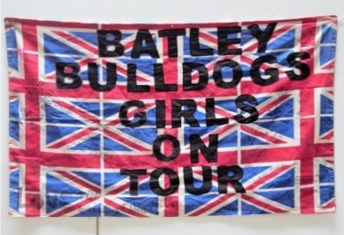
Batley Bulldogs Girls On Tour flag, 2016
Courtesy of Jo Cox’s family
Jo worked with the Batley Bulldogs girls’ rugby league team. She felt passionately about young women in sport and championed the team. The team left this flag and various other tributes to Jo in Birstall.
Placard left at Birstall, 2016
Courtesy of Jo Cox’s family.

In the UK and beyond

In Parliament Square, London thousands of people visited a memorial which included the wall you see in this exhibition. A week later, thousands more gathered for the ‘More in Common’ vigil in Trafalgar Square, London on what would have been Jo’s 42nd birthday.
In Manchester, another vigil took place in Piccadilly Gardens to honour Jo’s memory and similar international events took place as far away as Nairobi, Washington and Buenos Aires.

The crowd during the rally in Trafalgar Square, London to celebrate what would have been Jo's 42nd birthday, 2016
Credit: Daniel Leal-Olivas/PA Wire.
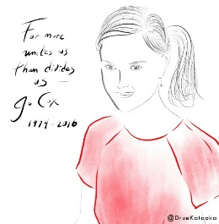
#LoveLikeJo artwork, 2016
By Drue Kataoka
‘So I painted Jo’s face in ink on paper, to best capture her bright and soulful eyes. But given the time crunch, I sketched her body as an iPad painting. Late at night, I emailed Jo’s friends the artwork. When I woke up a day later, countless photos of people gathering for Jo were flooding in on social media, newswires, TV. Thousands of people in Trafalgar Square were holding up the portrait of Jo on posters, boards and pledge cards. The image had taken on a life of its own as part of this larger movement, it was being carried by love, with people building their own meanings on top of it, all of them resolving to #LoveLikeJo. Tears arose in my eyes.’
Drue Kataoka, artist, CEO Drue Kataoka Studios

Donations

In the days that followed nearly £2m was donated to the Jo Cox Fund. This was divided into grants for charities that Jo supported.

Objects in the case

Silver cross blessed by the Pope, 2016
Courtesy of Jo Cox’s family
This beautiful cross, blessed by Pope Francis, was presented to Jo's family by Father Eamonn O'Higgins and senior representatives from the Vatican and the Vatican's St Peter's Cricket Team at a private meeting in September 2016. The team were visiting Yorkshire to play against a local cricket team at Mount Cricket Club in Batley as part of their 'Light of Faith' tour of England.

Batley Bulldogs rugby ball signed by the girls’ rugby league team, 2016
Courtesy of Jo Cox’s family
Jo was a good friend to the Batley Bulldogs. She had visited the club on a number of occasions and met the chairman, chief executive, coaches, players and cheerleaders. The girls’ team left this rugby ball and various other tributes to Jo in Birstall. The club now holds an annual memorial game in Jo's honour as part of The Great Get Together weekend in June.

The Brownies 'Tributes to Jo' book, 2016
Courtesy of Jo Cox’s family
This book of tributes to Jo is from the 1st Roberttown & Norristhorpe Brownie group in Jo's constituency and the village where her parents and sister live. Jo attended their 'pack holiday' one Friday night and told them all about her travels around the world and her job as an MP. She told them that they could be anything that they wanted to be and they ate hotdogs together. After the camp the Brownies wrote letters to Jo and she replied to them all individually. After her murder the Brownies planted a rose bush in her memory, they call it the 'hot dog rose’.

Jo Cox Memorial Wall, 2016
Following Jo Cox’s death, a memorial was erected in Parliament Square in conjunction with the campaign group Avaaz*. The focus of the memorial was a wall on which hundreds of people from the UK and overseas left written tributes expressing their condolences and sympathies. Flowers, candles and flags were also left.
* Avaaz means voice in several European, Middle Eastern and Asian languages

The Wall of Hope

Like many people across the globe, we were inspired by Jo’s life and the ideas she fought for. Tell us what she means to you.
Use the tablet provided to add your message. You can also use your smartphone to scan this QR code or visit
moreincommon.phm.org.uk/send-a-message and add your message to the Wall of Hope.

Quotes from Jo’s family

‘Jo would not want to rest in peace but forever be an activist and passionate force for good in the world.’
Brendan Cox, 2016

‘My mum was one of the most amazing people, she meant so much to me. I’d love to know what she meant to other people.’
Cuillin Cox, 2021

‘My mum would not want us to be sad. She’d want us to make a difference in the world.’
Lejla Cox, 2021

Jo’s Legacy
In the aftermath of Jo’s murder, many worked to build something positive from the tragedy.

#MoreInCommon free community fun day poster, 2016
Courtesy of Jo Cox’s family
This poster was for one of a series of events organised across the country and led by Hope Not Hate, one of the charities that benefited from the Jo Cox Fund. It was the first event arranged by the group of local volunteers who went on to form the More in Common, Batley & Spen group. Jo's family were also heavily involved in planning the day and her sister Kim spoke at the event.
Les Misérables School Edition poster, 2017
Courtesy of Jo Cox’s family
Les Misérables was Jo’s favourite musical. This production was staged by the Batley & Spen Youth Theatre Company and included a cast of 100 young people from the local area. The company was formed in 2017, in memory Jo Cox and all she believed in.

The Jo Cox Foundation

In September 2016, Jo’s friends and family established The Jo Cox Foundation to honour her memory and spread her ‘More in Common’ message.
The following year the Foundation organised the first Great Get Together. It took place on the first anniversary of Jo’s murder. People from across the country came together to celebrate their communities. The event proved to be a huge success with over 10 million people taking part. The Great Get Together has become an annual event and 2019 saw 11,000 events held across the UK.

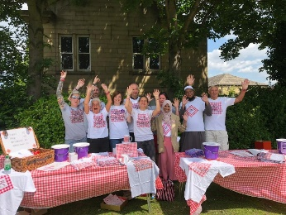
Iftar event, Batley, 2017
Courtesy of The Jo Cox Foundation
This event is organised by More in Common, Batley & Spen and takes place as part of the Muslim holy month of Ramadan. It brings together all sections of the community for an open air get together which includes breaking the fast when the sun goes down.

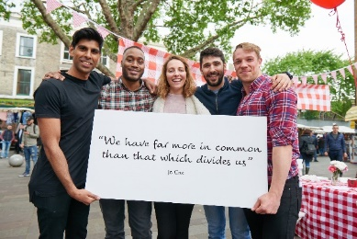
The Great Get Together, Portobello, Edinburgh, 2017
Courtesy of The Jo Cox Foundation

Building a fairer world

As well as working locally and nationally, the Foundation works internationally too, inspiring and championing the humanitarian work and campaigns that were so important to Jo.
In February 2017, the Foundation supported the completion of ‘The Cost of Doing Nothing Report’. Jo had been working on this report before her death with Conservative Party MP Tom Tugendhat, who would go on to finish it with Labour Party MP Alison McGovern. The report made a case for action to protect civilians from atrocities in conflicts around the world. It received strong cross party support.

Combatting loneliness one conversation at a time’ report, 2017
Continuing the work Jo started on loneliness whilst an MP, this report was published at the end of 2017. Led by Rachel Reeves MP and Seema Kennedy MP, it called for national leadership and a clear structured approach to the issue. By the start of 2018, Tracey Crouch MP was appointed as the world's first minister for loneliness.

A better public life

In January 2019, the Foundation started a national conversation around intimidation in public life following increasing levels of abuse towards MPs. They called for greater civility, respect and compassion in national discourse. Later in May, the Foundation started work with the committee on standards in public life to convene the first joint standard of conduct for political parties.

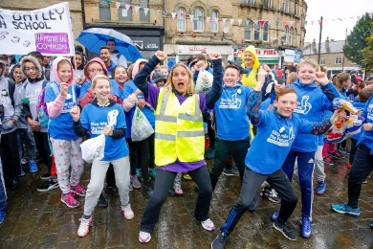
Step Into The Future event, 2019
Courtesy of The Jo Cox Foundation
This event is organised by More in Common, Batley & Spen and the BBEST (Birstall and Batley Excellence in Schools Together) hub. It brings together over 1000 pupils from schools across the region on a march through Batley town centre and up to the Batley Bulldogs rugby league ground where they take part in activities which embody the 'More in Common' ethos.

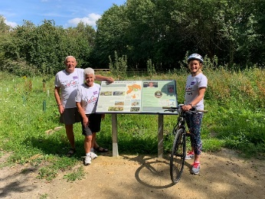
Gordon, Jean and Kim Leadbeater at the Jo Cox Community Wood, Spen Valley, 2020
Courtesy of The Jo Cox Foundation
Spen Valley Civic Society created the community wood in 2019 in Jo’s memory. Jo’s family are pictured here wearing t-shirts for the Jo Cox Way bike ride, which was set up in the Summer of 2016 by a North Yorkshire businessman Sarfraz Mian. The bike ride now takes place every year. In 2018, Jo's sister Kim did the full 280 mile ride from West Yorkshire to London. Sadly, due to lockdown the event could not take place in 2020, but Kim is hoping to join over 50 cyclists to do it again in July 2021.
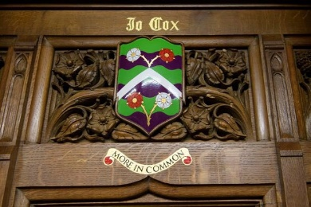
Coat of Arms of Jo Cox in the House of Commons, 2017
Courtesy of Jo Cox’s family
The coat of arms was unveiled in the House of Commons on 24 June 2017, by Jo’s children.

Objects in the case

Coat of Arms of Jo Cox, 2017 from Lejla and Cuillin Cox
Courtesy of Jo Cox’s family
‘This is the coat of arms of Jo Cox (our mum).
Daddy and the two of us designed it. It has the three suffragette colours of green, white and violet.
In the middle is a mountain and the green and blue represent rivers and hills.
The rivers are the River Thames, the River Wye and The Swale. The hills represent the Wye Valley where we spent our holidays.
At the top and the bottom are two roses (white and red). The red rose stands for the Labour Party and the white rose stands for Yorkshire. There are four roses because there are four of us.
It means a lot to us because it is handwritten and because it shows things Mummy cared about.’
On the screen

The More in Common Network film, 2021
This short film is a collaborative effort between staff at The Jo Cox Foundation and members of the More in Common Network. It explains what the More in Common Network is, what More in Common groups do, and calls on ordinary people to get involved in the movement.

Interested in being a part of The More in Common Network? Register your interest using the iPad provided.

The people of More in Common artwork
Mixed media, 2021by artist John Priestley
‘I have created a jigsaw puzzle to illustrate how we have ’more in common’. 42 small squares with 21 portraits of the More in Common participants, grouped around a large Jo Cox portrait showing stages of her life.
I was an amateur artist who used art creation to fight mental wellbeing issues while combating homelessness. I got an art project grant and created ‘Home street home’ for the Museum of Homelessness. I also helped on homeless art sessions in Rochdale before the Covid lockdowns.

The More in Common project is the largest artwork I have ever created. Mixing portraits, keywords and inspirational Jo Cox images, it's been an honour to create this work.’

Acknowledgment
This exhibition has been co-created by the More in Common project group who continue to carry Jo’s banner of love. The ‘People of More in Common’ artwork was commissioned to represent this group.
People’s History Museum would like to thanks Jo Cox’s family and the Jo Cox Foundation for their contribution and continuous support.
Reason Digital – Wall of Hope and online exhibition development
Hannah Warrick – exhibition design and production
DIS – event, sign and graphics specialists

The More in Common project, led by People’s History Museum, has received funding from the European Union’s Horizon 2020 Framework Programme for Research and Innovation under grant agreement no 770158 (project CultureLabs).

