Large Print guide
Nothing about us without us

Section: Introduction

Text size: 18pt

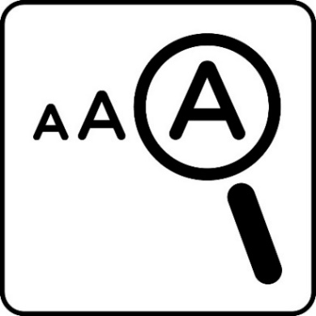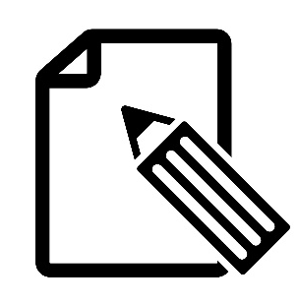
Transcription

This guide contains

- Large print of the wall texts and labels.
- Short descriptions of the objects and images on display.
- Transcripts of the films on show.

Large Print exhibition guides in 14pt and 24pt text versions, magnifiers and colour overlays are also available.

Please ask a staff member if you need any further assistance.

.

Introduction

Contents Page number

Introduction ……………………………...… 4 - 6

Accessibility ………….……………………..….. 6

Language…………….………………………….. 7

Social Model of Disability ……….…….…... 8 - 9

Film transcript ...……………………….. ..10 - 12
– The Social Model of Disability

This guide follows the order of the displays within this section of the exhibition.

When you have finished using this guide, please return it or give it to a member of staff. Thank you.

Please share with us any feedback on this resource. You can email access@phm.org.uk or share your feedback with a member of staff
Introduction

Nothing about us without us
For centuries disabled people have been fighting for rights and inclusion. This exhibition shows how disabled people have come together to demand to be included in society as equals. With huge amounts of creativity and innovative thinking, through self organising, campaigning, educating and protesting, disabled people have fought to take control of their own lives.

This exhibition explores the history of disabled people’s activism and the ongoing battle against oppression, discrimination and injustice, in their own words and images.

Nothing about us without us has been curated by four community curators, who all identify as disabled people and have been working at People’s History Museum (PHM) since August 2021.

The curators are Anis Akhtar, Ruth Malkin, Hannah Ross and Alison Wilde.

This exhibition has been created as part of PHM’s programme exploring the history of disabled people’s rights and activism. It has been guided by a steering group who have been working with the museum on a variety of projects since 2018.
[Object Descriptions]

Photograph of Disabled People Fight Back banner in use at Demonstration Tory Party Conference, October 2015
Colour photograph of two people holding the large banner in the middle of a cordoned off road: Mount Street, Manchester. Three police officers are in front of a yellow barrier in the background. Manchester Town Hall is in the background on the right. The banner in this photo is on display in the Disabled People Fight Back main section.

Photographs of marches for British Sign Language (BSL) recognition, 2000
Colour photograph of a large crowd of protestors behind a metal crowd control barrier. Some of the crowd are facing the camera and smiling. Some are holding up BSL banners. Buildings, some trees, a black cab taxi and a bus are in the background.
Conservative Party Conference protest, 2019
Colour photograph of protesters on a road holding signs, DPAC banners and GMDCP banners on display in this section. There is a person dressed as the grim reaper with a Boris Johnson face mask. A protester holding a megaphone sits on a banner on the floor.

Accessibility

We understand that everyone’s access needs are different please come and tell us about your access requirements.

Panel includes the following symbols

Audio Description
Braille
Seating
Large Print
Captions
Transcription
British Sign Language (BSL)
Quiet Space
Access dogs welcome
Video
Audio format information
Language

Throughout history, the language used to describe disabled people has often been misleading, hurtful and stigmatising.

Overall, the language used to refer to disabled people has usually made people think that disabled people are different to other human beings. Words such as ‘handicapped’, ‘invalid’, ‘vulnerable’, ‘infirm’, and ‘cripple’ have all been used in everyday society. Language such as this suggests that disabled people are ‘less than’ their contemporaries, and that they are weak, inferior and useless.

The move away from such words is recent, and there is much greater recognition of the harm these words do. Harmful words like these tend to emphasise difference. They also contribute to many harmful stereotypes, which lead to feelings such as pity and scorn. In this exhibition, you will find examples of how these words were used in the past and how some disabled people have reclaimed or reused these words creatively or ironically.

The language used in this exhibition has been informed by the Social Model of Disability with guidance from our community curators, steering group members and partners such as
Greater Manchester Coalition of Disabled People (GMCDP).
The Social Model of Disability

This exhibition is underpinned by the Social Model of Disability.

The Social Model focuses on the barriers disabled people face, not their impairments or perceived impairments.

‘Impairment’ means a difference in mind or body to what society expects.

Some people do not view their difference as an impairment. ‘Disability’ means the barriers people with impairments face in society.

These barriers can be because of people’s attitudes, how the world is physically built or how the world is organised and services provided.

The Social Model states that disabled people are disabled by society and not by their impairments and that society is responsible for removing the barriers disabled people face, in order to enable disabled people to be an equal, included and valued part of society.

Social Model of Disability animation (2 minutes 45 seconds), Courtesy of NDACA

[Film description]
A person in a wheelchair holds a placard with
‘I HAVE A DISABILITY’ written on it. A winding path leads from them to the top of the screen. A standing person appears next to them with a straight path above their head.

With the Social Model, the placard changes to
‘I AM DISABLED’ and a steep flight of stairs appears above the word ‘SOCIETY’.

Placards appear from a crowd outline. Three placards are unveiled with Crippen cartoons.
A hand writes demands on another four.

Camera zooms out on five people with a placard stating ‘the majority of disabled people have invisible impairments’ to reveal many people.

The two paths from the beginning merge together to make one and the person in a wheelchair and standing move up it together
Film transcript

The Social Model of Disability _ NDACA animation
[Text]: NDACA National Disability Arts Collection & Archive.
UK DISABILITY HISTORY MONTH (drawn logo)
Social Model: Definition
[Narrator]: According to the Medical Model of disability, the word disabled means less able. Less able to achieve your potential. Less able to have meaningful relationships. Less able to play an active part in the world around you and that this is just your bad luck.
This outdated view of the world puts the responsibility of overcoming disabling barriers on the person with an impairment.
But this idea is changing... The more modern Social Model of disability says that a person doesn't ‘have a disability’ but that they are ‘disabled’. They're disabled by society. It is the attitudes and physical barriers imposed on them by society that prevents them from achieving their potential.

The Social Model was developed by disabled people and their allies to help them take action against discrimination and to empower people to find solutions, remove barriers and campaign together for equality and human rights.
They showed how people with lots of different impairments face many of the same problems. These disabling barriers include prejudiced opinions and attitudes, restricted access, and people being systematically excluded.
The Social Model looks for the ways that society can be planned and organised in order to provide accessibility, independence and opportunity in a way that enables people rather than ‘disables’ them.
What we learn from the Social Model of disability is that disability is a social construct created by social barriers, barriers which can be eliminated.
We learn that it is the responsibility of government, public spaces, businesses and individual people to make the changes to increase the access and build a more equal society where everyone has the opportunity to reach their full potential.
[Text] Artists: Roberto Sitta & Giulia Coppola. Editor: Dan Casswell.
Narrated by Georgia Macqueen Black.
Produced by the National Disability Arts Collection and Archive in collaboration with Disability History Month.
With thanks to those who have deposited work to NDACA, our funders, partner organisations, and the leaders of the Disability Arts Movement.

The end
This is the end of the Large Print guide for the Introduction section of the exhibition. We hope you have found it useful. Please return the guide or give it to a member of staff. Thank you.

Please share with us any feedback on this resource. You can email access@phm.org.uk or share your feedback with a member of staff.

