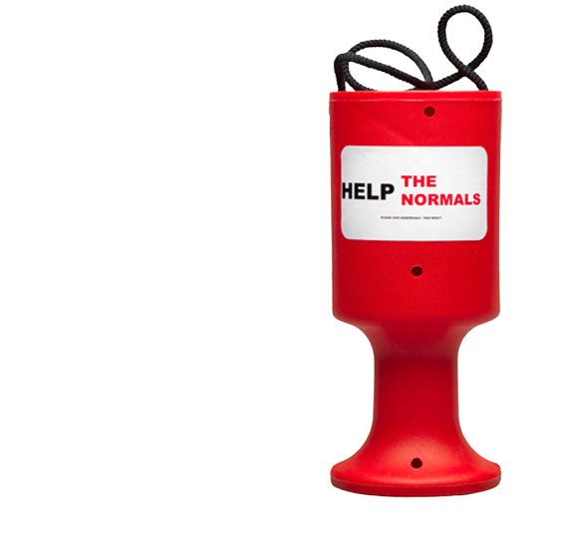
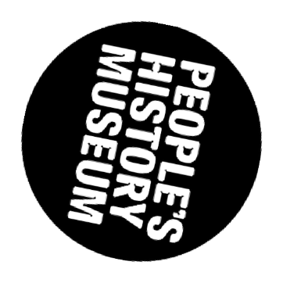
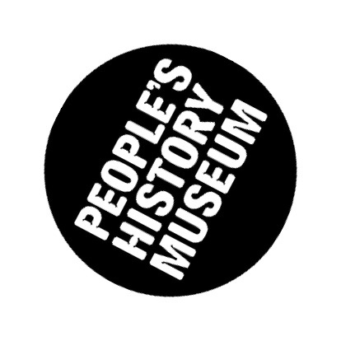
Nothing About Us Without Us exhibition guide for
group leaders

The exhibition and this supporting guide are suitable for ages 12+

We recommend under 12s are accompanied by an adult.

The Nothing About Us Without Us exhibition is on display until Monday 16 October 2023.

Contents

Page 1

Page 2

Page 3

Page 4

Page 5

Pages 6-8

Page 9

Page 10

Page 11
Exhibition summary Sensitive subjects
People's History Museum's values Emotional support
Pre visit activity: the power of words

During your visit activities: find, sketch, discuss Post visit activity: reflections
Accessibility Practical information

Exhibition summary:

Nothing About Us Without Us

For centuries disabled people have been fighting for rights and inclusion. This exhibition shows how disabled people have come together to demand to be included in society as equals.

With your group, explore the history and ongoing battle of disabled people’s activism and reflect on the important role we all play in removing the barriers in society that disable people.

Find out more about the exhibition.

This guide will help to provide guidance for discussing sensitive subjects, activities to engage with the topics explored, and offer space to ask questions.
This exhibition is underpinned by the Social Model of Disability.
The Social Model of Disability states that disabled people are disabled by society and not by their impairments, and that society is responsible for removing the barriers disabled people face, in order to enable disabled people to be an equal, included and valued part of society.
Social Model of Disability animation (2 minutes, 45 seconds) Courtesy of
National Disability Arts Collection & Archive (NDACA)

Page 1 of 11

Sensitive subjects

This exhibition is a celebration of the determination of disabled people in the face of hardship and abuse.

Some of the content shows disabled people in distressing or even life-threatening situations. Stories covered include disabled people's responses to lived experiences of abuse, assaults, suicide and incarceration in hospital and other settings.

There is some use of strong language.

We believe the exhibition is of great value to help us understand different experiences and consider how we can all support the ongoing campaigns for equality.

We advise you to talk to your group about the exhibition ahead of your visit to make them aware of what to expect.

You might also find it useful to ask accompanying adults to reflect on their boundaries so they are confident in how to respond if a member of the group or they themselves are triggered by any of the content:

What personal boundaries might be challenged in this space?
Do you feel prepared if a conversation or action within your group, or within any of the exhibition content crosses a personal boundary?
Who can take the lead if you or a group member needs a break, and how will you communicate this to others?

Page 2 of 11

People's History Museum's values

People's History Museum (PHM) prides itself on being a welcoming and inclusive organisation.

We promote empathy and compassion, and challenge discrimination.
We support people in addressing their own bias and prejudices.
We encourage people to challenge assumptions, seek understanding and ask questions.

We ask for your support in ensuring your group understands and respects our values.

We will be proactive in challenging behaviour that could be offensive, upsetting or discriminatory, and ask group leaders to do the same. If someone in your group displays such behaviour, we ask group leaders to address this.

If museum staff become aware of such behaviour, we will approach the individual or their group leaders and raise concerns. If this behaviour continues, groups may be asked to leave the museum.

Page 3 of 11

Emotional support

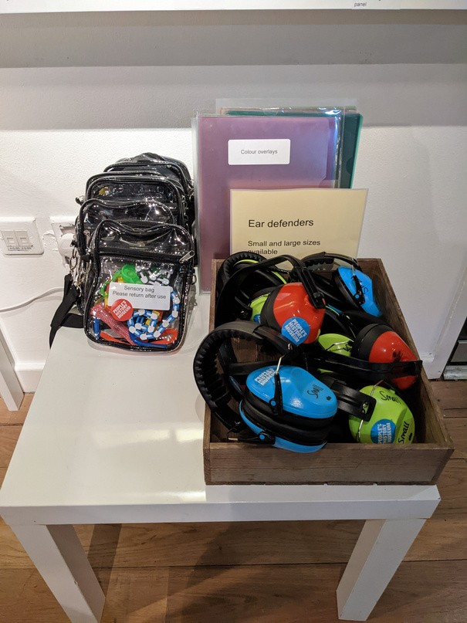
If a member of your group is upset or distressed, these tools and services may help.

Sensory bags and ear defenders
are available to borrow within the exhibition space.

5, 4, 3, 2, 1 calming exercise
While you take slow, deep breaths, name: Five things you can see.
Four things you can feel.

Quiet Room

Three things you can hear.
Two things you can smell. One thing you can taste.

Mental health services
There is a Quiet Room by the Info Desk, or staff can help find a quieter space in the building when it's unavailable.

Samaritans are there for anyone who’s struggling to cope, who needs someone to listen without judgement or pressure.
samaritans.org
116 123. Phones staffed 24 hours a day, 365 days a year.

Mind provide advice and support to empower anyone experiencing a mental health problem.
mind.org.uk
0300 123 3393. Phones staffed 10.00am to 6.00pm, Monday to Friday (except for bank holidays).

Page 4 of 11

Before your visit

Activity idea: the power of words

Throughout history, the language used to describe disabled people has often been misleading, hurtful and stigmatising.

Such language tends to emphasise difference. It also contributes to many harmful stereotypes, which lead to feelings such as pity and scorn.

Step one:
Read this resource with your group on preferred/appropriate language:
Greater Manchester Coalition of Disabled People: Terminology and Language

Additional resources
You can also find resources on UK Disability History Month's website: ukdhm.org/general-resources

Step two:
Create ground rules with your group.

Deciding and agreeing three ground rules together can help promote empathy and respect. This might include:

Treat others as you wish to be treated; it is not okay to tease or make fun of others based on their differences. You can disagree with someone's opinion but you should not attack their character.
You may not know what people are dealing with in private; treat topics sensitively.
Page 5 of 11

During your visit

Activity idea: find, sketch, discuss
Step one:
Together, read the introduction panel to the Disabled people fight back section.

Step two:
Find and sketch the Disabled People Fight Back banner.

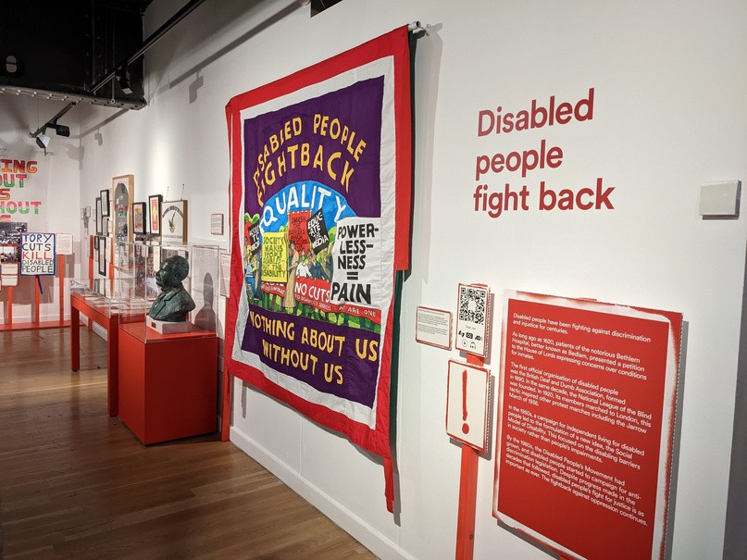
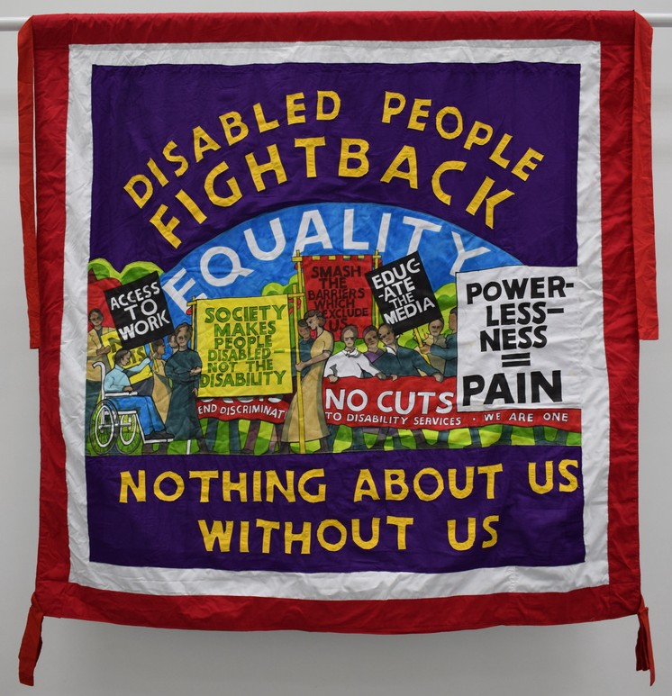
Check the different accessible formats available on page 10.

Step three:
Reflect on these points together and make notes around your sketch:

What do you think is meant by 'Nothing About Us Without Us'?
e.g. No decision should be made without the involvement of those affected by that decision.

What could be an example of a barrier highlighted on the placards in this section?
e.g. 'Access to work' might be wheelchair access to work spaces, flexibility with deadlines or working hours, or challenging bias during the recruitment process, to name a few.

Page 6 of 11

During your visit

Activity idea: find, sketch, discuss
Step one:
Together, read the introduction panel to the Piss on pity section.

Step two:
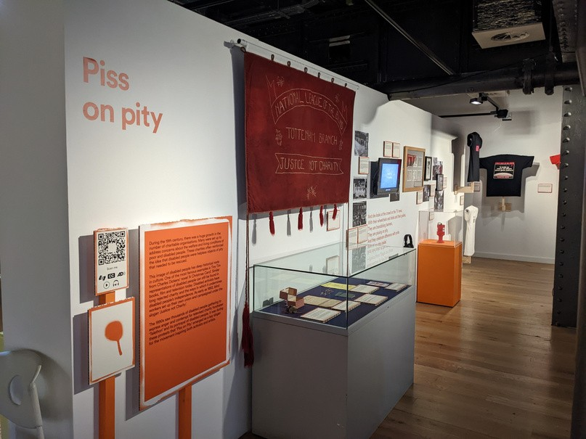
Find and sketch an object that highlights how disabled activists have rejected charity due to the ways in which it undermines disabled people’s independence.
Check the different accessible formats available on page 10.

Step three:
Reflect on these points together and make notes around your sketch:

Why was your chosen object made / how was it used?
e.g. The Children in Need (...OF WHAT?) leaflet explains why some disabled people don't like the show's representation of disabled children as needing charity rather than rights.

Instead of giving to charity, what could you do to help change a society that excludes people?
e.g. Consider a change that could be made in your organisation or local area. What steps could you take to raise this with leaders?

Page 7 of 11

During your visit

Activity idea: find, sketch, discuss
Step one:
Together, read the introduction panel to the
To boldly go where all others have gone before section.

Step two:
Find and sketch an object that highlights disabled people’s demands for a barrier free and inclusive society.
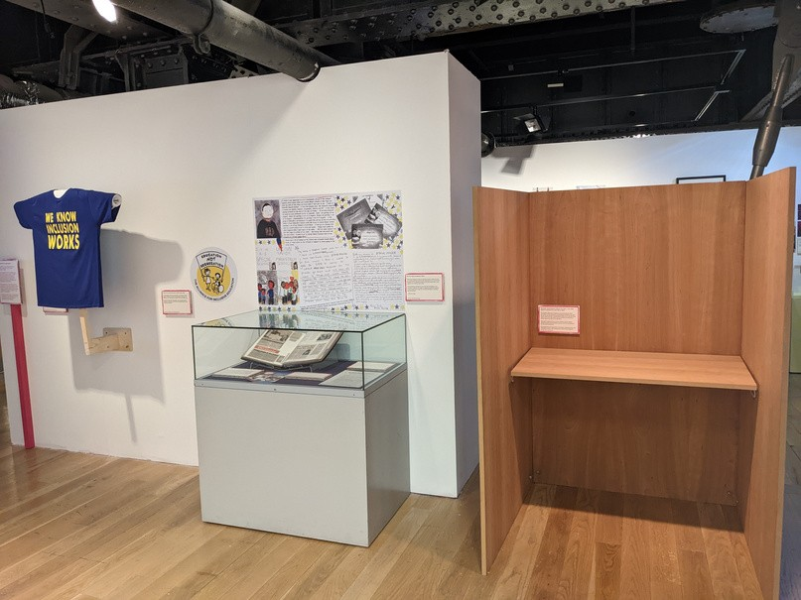
Check the different accessible formats available on page 10.

Step three:
Reflect on these points together and make notes around your sketch:

Why was your chosen object made / how was it used?
e.g. The polling station cartoon by Crippen highlights the physical barriers and social attitudes that prevent disabled people accessing polling stations to exercise their democratic right to vote.

What do the objects in 'Education not segregation' tell us about the value of an inclusive education system?
e.g. Simone Aspis's scrapbook illustrates how an inclusive education allows disabled and non-disabled pupils to '...play, learn, work together and relate to each other.'
Page 8 of 11

After your visit

Activity idea: reflections
Reflecting on the exhibition together is a good opportunity to see how attitudes in your group might have changed, and give you an opportunity to answer any further questions they may have.

Here are some prompts which might lead
to meaningful conversations with your group:

What issues/barriers do disabled people face today? This could be something discussed in the activities, your discussions, or something else.

Were you surprised by anything in the exhibition?
Did you learn anything new? Has your thinking changed as a result of visiting the exhibition?

Is there anything more you want to find out about?
Here are some examples of organisations that can help you continue your learning:
Greater Manchester Coalition of Disabled People publications
Disabled People's Archive films

What could you do to help remove barriers for disabled people?
There are many things we can do ranging from small to big acts.
e.g. Share your learning and promote the Social Model of Disability with others, include disabled people in decisions and planning within your organisation, get involved in local campaigns to improve or protect disabled people's rights.
Page 9 of 11

Accessibility

A range of accessible formats have been created to enable visitors to engage with the exhibition in different ways.

We understand everyone's access needs are different.

Discuss your group's specific access requirements with PHM's Learning Team when booking your visit.

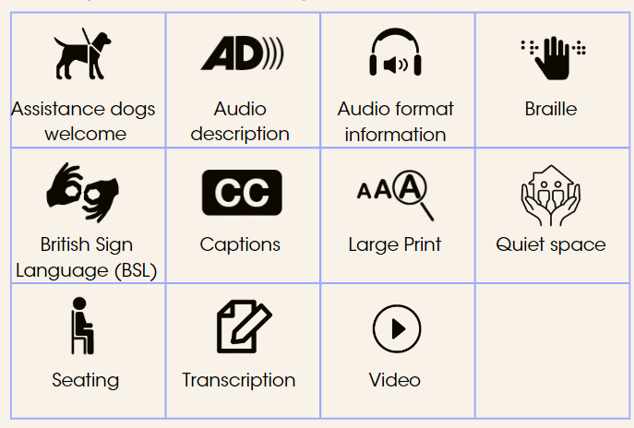

Links to further access information:

Museum access information Visual Story for the museum Visual Story for the exhibition

Page 10 of 11

Practical information

Quieter visiting times
When arriving at the museum, the Info Desk area may be busy with visitors and groups arriving. The Processional Way can also be a busy space. If you’re feeling overwhelmed, please speak to a member of staff.
By pre booking your group's visit on one of our group booking days (Mondays, Wednesdays, and Thursdays) you are helping us to provide one weekday for quieter independent visits for individuals who may find busy places over stimulating.

Protecting objects
We kindly ask you to refrain from touching objects that are on open display to help maintain their condition for the future.

Please use pencil in the exhibition space to prevent permanent marking.

Taking photographs
Photography without flash is allowed in the exhibition. Many of the objects are sensitive to light.

Food and drink
Please store food and drink away while in the exhibition space to prevent bugs and staining.

Picnic tables are available near the Info Desk. Tables for groups larger than six can be reserved in advance of your visit to guarantee a space.

Navigating small spaces
Some areas of the exhibition are narrow. If you have a large group you may find it easier to split people into smaller groups while exploring and completing activities.

Page 11 of 11

