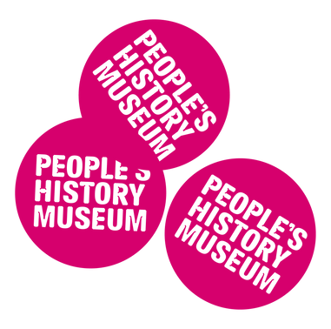
Welcome to the
Nothing About Us Without Us exhibition at
People's History Museum

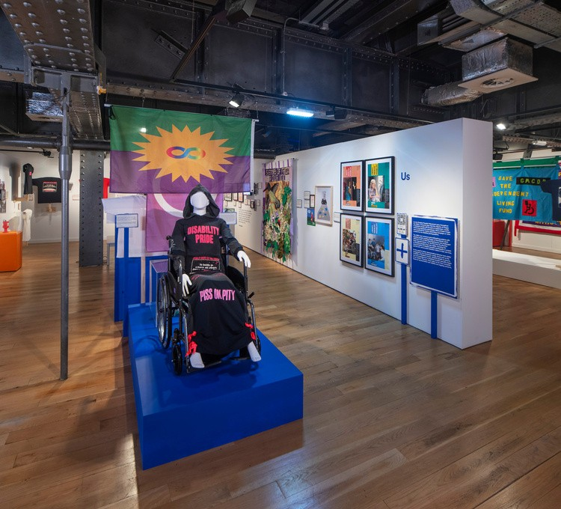
Visual Story
There is sound in the exhibition space coming from the air conditioning, and from a television in the middle section, and from an installation to the left side of the room.
Page 1 of 10

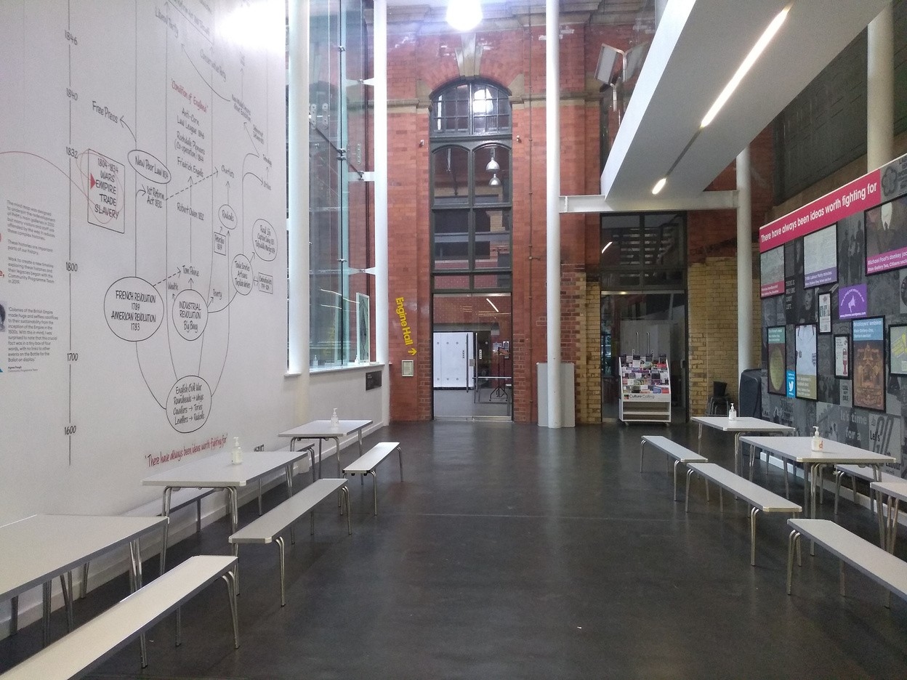

The exhibition space is on the ground floor.

The exhibition space is towards the end of the Processional Way, which is to the left of the Info Desk.

Page 2 of 10

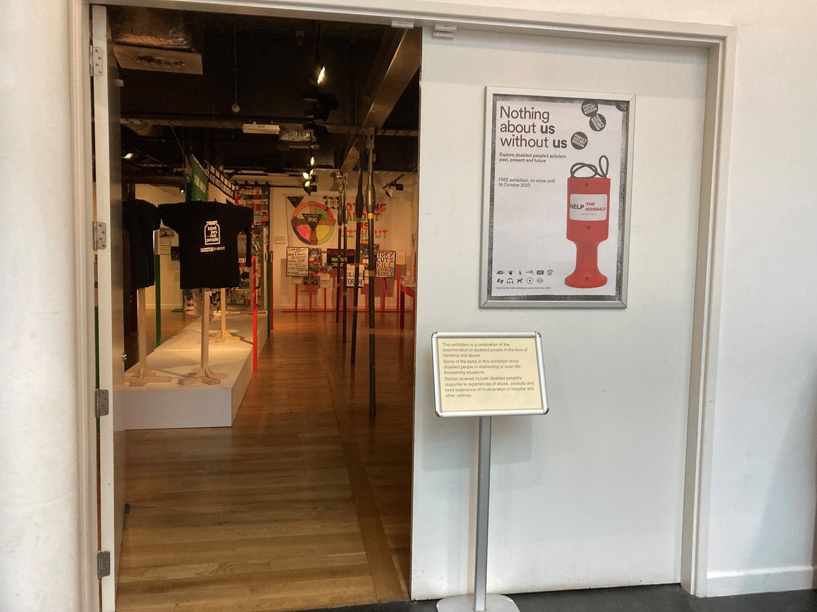

The entrance to the exhibition space is just before the glass doors to the Engine Hall, on the right.

Page 3 of 10

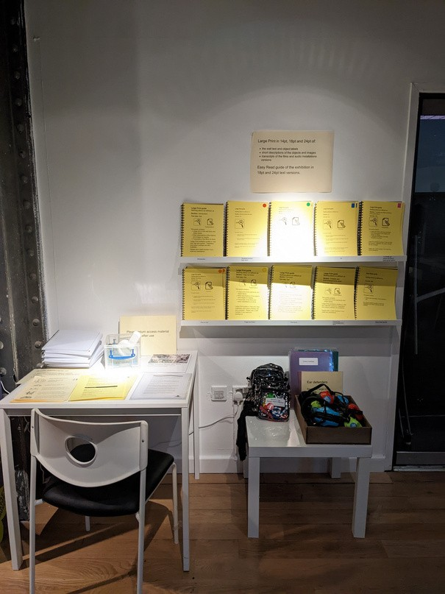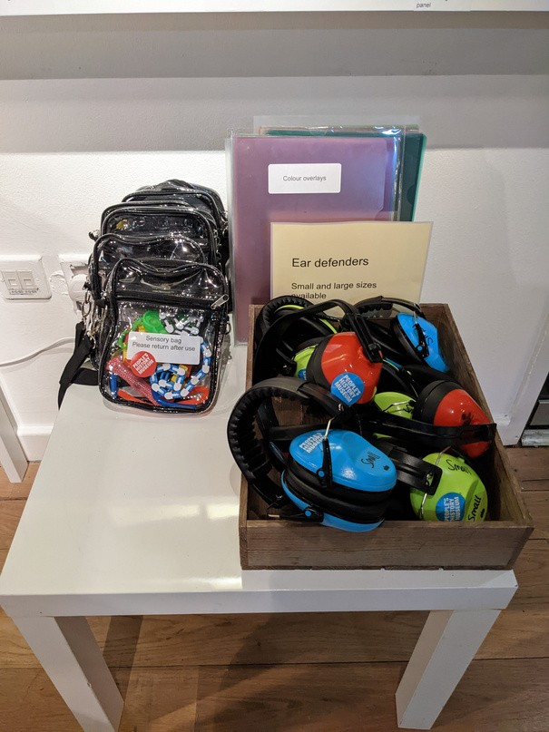

There is a station inside the exhibition space to the left of the entrance, where you can collect access support material.

This includes ear defenders, sensory bags, Large Print guides, colour overlays, magnifiers, and transcripts of the films and audio installations.

Page 4 of 10

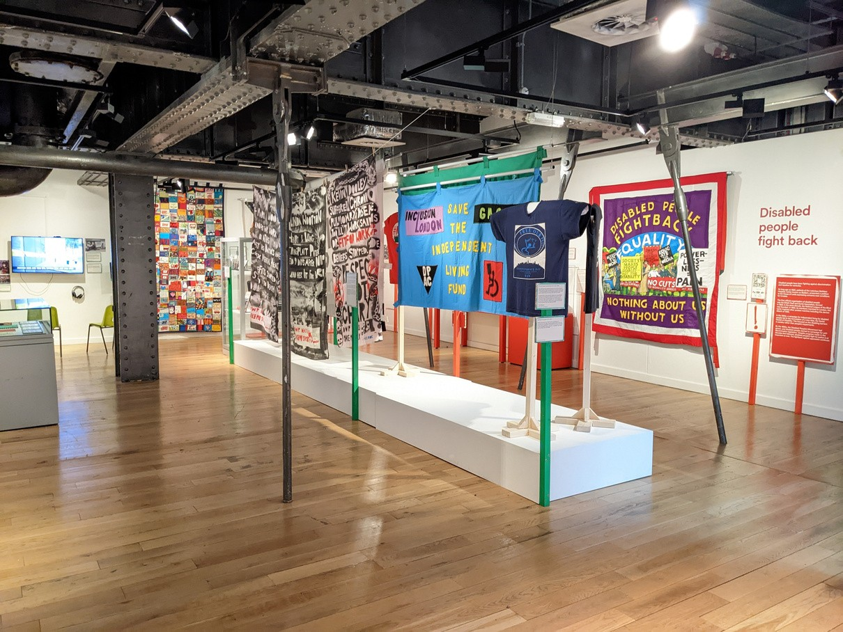

The right side of the exhibition space includes the following sections:

Introduction
Disabled people fight back Free our people

Page 5 of 10

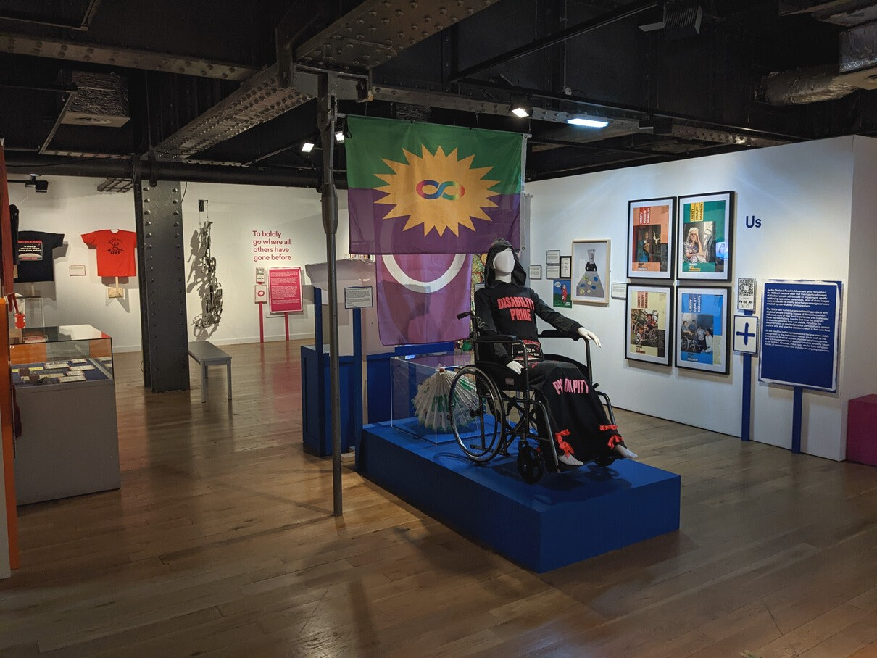

The middle of the exhibition space includes the following sections:

Us
To boldly go where all others have gone before

Page 6 of 10

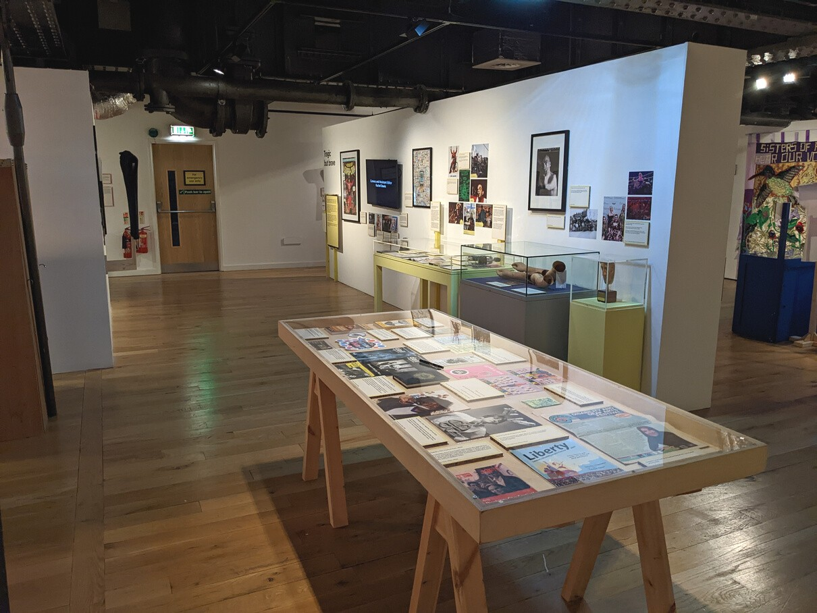

The left side of the exhibition space includes the following sections:

Piss on pity Tragic but brave Timeline

Page 7 of 10

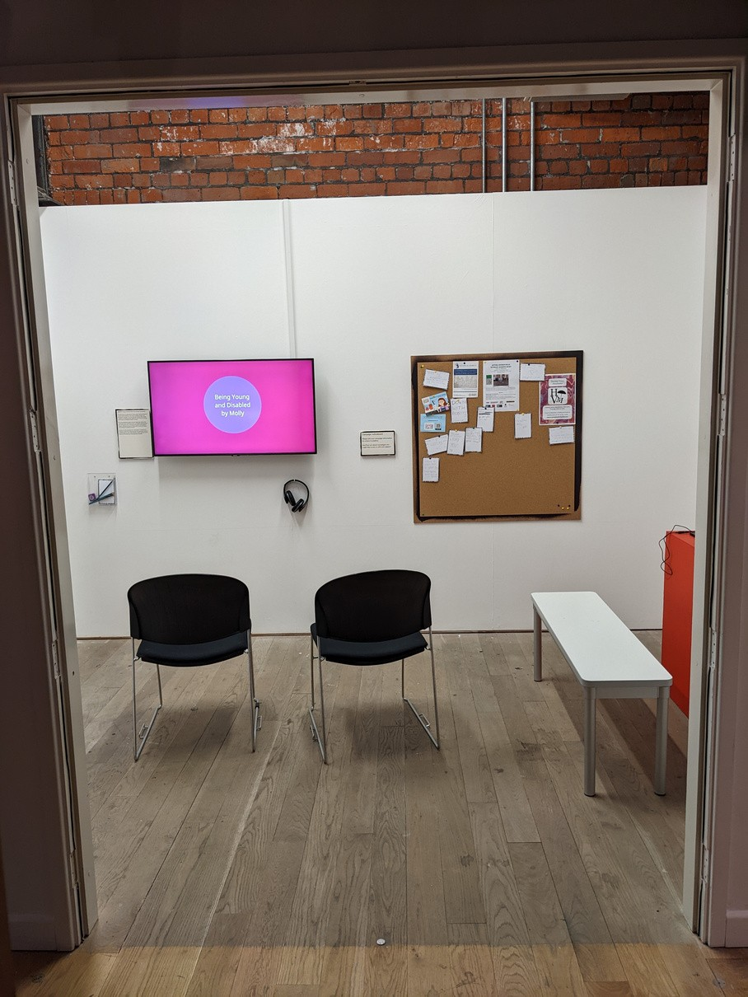

There is a separate room off the
left side of the exhibition space which includes the following section:

The future

Page 8 of 10

Links to further access information:

Nothing About Us Without Us
exhibition information

Museum access information

Visual Story for the museum

Page 9 of 10

Please talk to us if you have queries or require any assistance in advance of your visit by phoning 0161 838 9190, or by emailing access@phm.org.uk.

Phones and emails will be answered Monday to Friday, 10.00am to 5.00pm.

On the day of your visit, our Visitor Experience Team will be available to help.

You can also give us a call on the day of your planned visit if you require assistance.

Page 10 of 10

