People’s

History

Museum

# Early-career Textile Conservator

Job Pack

March 2023

# About the role

This is an exciting opportunity to join People's History Museum (PHM)’s Textile Conservation Studio at a time of development and growth.

The Conservation Team cares for the museum’s collections and also provides a service to external clients which generates income for the museum. The team works in the purpose-built and dedicated Textile Conservation Studio (TCS), is led by an accredited member of ICON (Institution of Conservation) as listed on the Conservation Register.

Working alongside the Conservation Manager and Conservation Officer, large projects will be completed as a team, with individual and collaborative decision making. The Textile Conservator’s primary focus will be conserving objects for external clients and supporting the team with internal work such as Integrated Pest Management (IPM), store improvements and preparing objects for display.

# About People’s History Museum

**People’s History Museum** (PHM) is the **national museum of democracy**, telling the story of its development in Britain: past, present, and future. The museum provides opportunities for all people to learn about, be inspired by and get involved in **ideas worth fighting for**; ideas such as equality, social justice, co-operation, and a fair world for all.

PHM currently welcomes a local, national and international audience, attracting up to 125,000 visitors annually (pre-covid), as well as reaching people online through digital activities. The museum involves audiences and communities in all aspects of its work, using models of co-curation, collaboration and crowd-sourcing when developing and delivering programmes of activity. Engaging people directly in the work of the museum helps to build a passionate and committed audience who become supporters and advocates for PHM, while ensuring we are shaping authentic content representative of diverse audiences, providing an inclusive space for their voices, stories and ideas. PHM’s innovative programme-led approach explores important subjects and issues relevant to us all today.

PHM has an annual turnover of around £1.5 million, employs 36 members of staff and has a team of freelance staff and volunteers. PHM is funded by Arts Council England (ACE) as a National Portfolio Organisation (NPO) and by Greater Manchester Combined Authority (GMCA) Culture and Social Impact Fund. PHM is an independent museum, charitable trust and company limited by guarantee, with a Board of Trustees, a Trading Company Board, and an Audit and Risk Committee.

# Staff structure

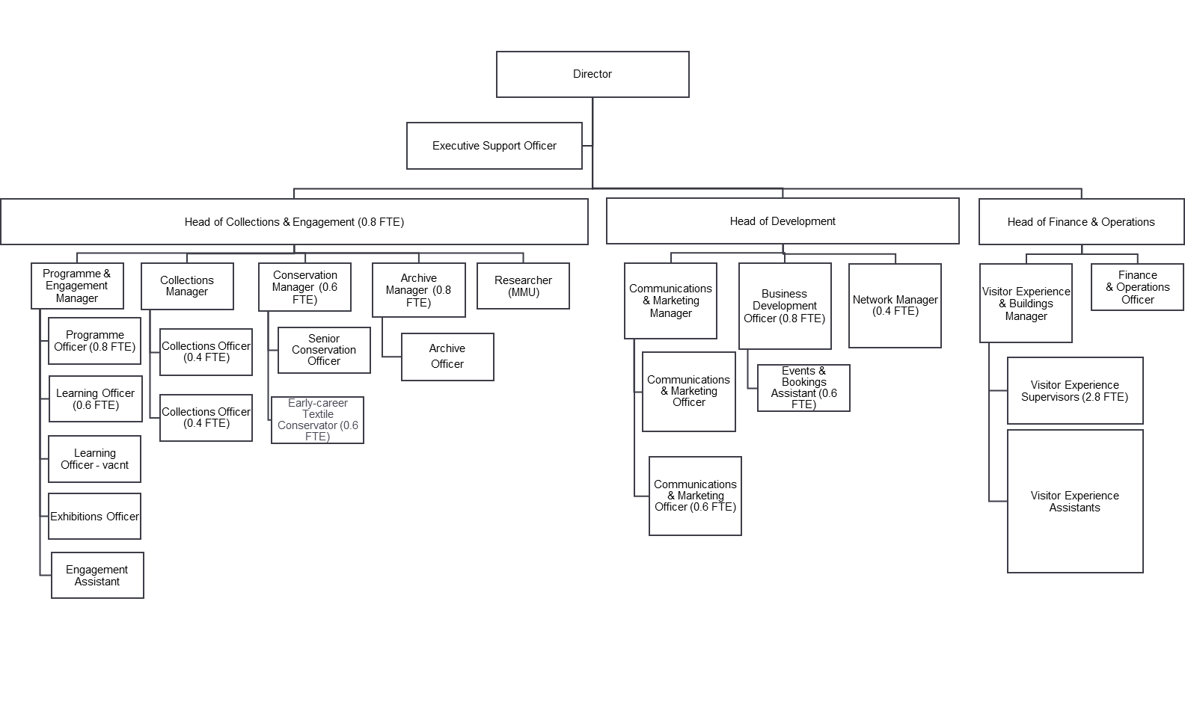

# Job Description

**Early-career Textile Conservator**

**Salary**: £24,948 pro rata (plus pension contribution to the Greater Manchester Pension Fund)

**Hours**: Part time (21 hours a week) with flexible working

**Annual leave:**  24 days plus bank holidays (pro rata)

**Contract**: Fixed term 12 month contract

**Responsible to:**  Conservation Manager/Senior Conservation Officer

**Responsible for:** Supervising volunteers where appropriate

**Location:** People’s History Museum and off-site stores with the opportunity for occasional agile working in line with PHM’s flexible working policy

## Key Responsibilities

### Collections display and access

* Undertaking all aspects of conservation work, including work on the museum’s historic banner and textile collection, including examination, assessment, documentation and photography, and advising on the object collections
* Undertaking handling, storage, display and transport of the museum banner, textiles and object collections to ensure their preservation
* Assisting with the programme of external conservation work including compilation of conservation reports and recommendations for future care, with accurate time estimates and costings
* Maintaining appropriate written, electronic and photographic records, including updating of PHMs Collections Management System (KeEmu)
* Taking responsibility, with colleagues, for the care and conservation of the museum’s collections in storage and on the permanent galleries and in changing exhibition spaces
* Monitoring all collections’ displays in PHM galleries and exhibition spaces
* Providing advice and guidance for colleagues as to environmental, display, handling, and storage requirements for all collections
* Supporting access to visitors and all Museum audiences including schools, community and academic interest groups
* Delivering Conservation Studio tours and Gallery Tours as required
* Responding efficiently to enquiries from the public, academics and other colleagues
* Facilitating research of the collection

### Collections care

* Packing and storing objects adhering to museum and conservation standards
* Handling objects and supporting their use safely, including helping to install and remove objects from exhibitions and displays
* Photography and object labelling to support documentation of objects and banners
* Undertaking pest management practices throughout the building
* Ensuring TCS, banner store and other stores are maintained in a clean and safe condition

### General support

* Working across teams and departments to ensure collections access to audiences
* Assisting with the daily administration of the TCS
* Undertaking other duties as required and as commensurate with the level of responsibility

### Professional Development and Advocacy

* Keeping abreast of best practice in relation to all conservation disciplines, including textiles
* Identifying opportunities to promote the museum and develop the profile of the conservation studio both within and beyond the conservation community, including via social media platforms
* Promoting conservation work in the print and broadcast media as required

## Experience, knowledge and skills

We are looking for a candidate who can demonstrate experience, knowledge and skills across the following criteria, with the opportunity for ongoing training and development to support the successful candidate once in post.

|  |  |
| --- | --- |
| **Experience, knowledge and skills** | **Assessed through** |
| Recognised professional qualification in textile conservation obtained within the last three years with sound understanding of the Professional Standards in Conservation | Application and interview |
| Knowledge and interest in the varied materials that make up a textile collection covering historic and contemporary materials and an interest in developing within the specialism of textile conservation | Application and interview |
| A high level of manual dexterity, attention to detail and ability to undertake repetitive tasks | Application and interview |
| Ability to work independently or as part of a team, with strong communication skills | Application and interview |
| Good organisational skills and ability to work methodically, with ability to work on varied projects simultaneously and to multiple deadlines | Application and interview |

# How to apply

Please complete the online application form. You will be prompted to write up to 300 words to demonstrate how you meet each of the five criteria listed under ‘Experience, knowledge and skills’.

If you’d prefer to submit a video application, please email a recorded response to each of the five criteria to Charlie Corkin, Executive Support Officer at [charlie.corkin@phm.org.uk](mailto:charlie.corkin@phm.org.uk). Videos should be no longer than 15 minutes in length.

**Deadline for applications:** 9.00am on Wednesday 19 April 2023

**Interviews:**  Thursday 27 April, in person at PHM

If invited to interview you will be sent interview questions in advance and invited to bring along your portfolio.

If you have any questions or would like to arrange to discuss the role please contact Charlie Corkin at [charlie.corkin@phm.org.uk](mailto:charlie.corkin@phm.org.uk).

## Equity

PHM prides itself on being a welcoming and inclusive organisation, profoundly committed to advancing equality and diversity in the broadest sense. We highly value the benefits that diverse perspectives bring to PHM’s mission.

We recognise the museum currently underrepresents people of colour, disabled people, LGBTQI+ people and those with intersecting identities in our workforce; PHM is actively working to address this and encourages applications from these backgrounds. While the successful candidate will be selected purely on merit, in the event of a tie between two candidates with equal experience, we may select a candidate who helps us better represent the communities the museum serves.