Nothing About Us Without Us community exhibitions

People’s History Museum (PHM) will be hosting a series of small community exhibitions between autumn 2023 and spring 2024, as part of our co-curated programme of activity exploring the history of disabled people’s rights and activism.

This follows on from the 2022 launch of PHM’s headline exhibition Nothing About Us Without Us (on show until 16 October 2023), which looks at the history of disabled people’s activism and ongoing fight for rights and inclusion. We are keen to host community-led exhibitions exploring the wider themes of disability or any aspect of disabled people’s lived experience.

What type of exhibitions will be displayed?

- Exhibitions exploring disability and the stories of disabled people
- Exhibitions that provide community groups or individuals with a chance to tell and examine their story
- Exhibitions that are accessible to a wide range of people
- Exhibitions that are likely to attract new visitors to the museum
- Exhibitions that help to raise the profile of the museum

All exhibition proposals must adhere to the concept of equal opportunities taking into account physical and intellectual access.

The museum will not display items:

- that are dangerous to the public e.g. knives and blades or anything with sharp edges, live creatures, strobe lights, naked flames
- that can be a health hazard e.g. food and drink, nuts and seeds
- too big or heavy to carry into the building
- deemed to show hostility towards individuals or groups, including those with protected characteristics and those facing persecution

The museum does not provide opportunities for commercial exhibitions. Prices should not be put on any items included in the exhibition.

The community exhibitions

The community exhibitions will take place in part of the museum’s Main Gallery Two.

Situated on level two of our permanent galleries, this display area provides a climate controlled environment ideal for groups and individuals wanting to display historical or light sensitive materials.

Images of past Main Gallery Two displays:

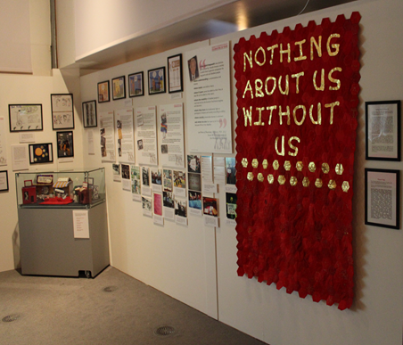

The Disability Discrimination Act, Celebrating 20 Years exhibition, 2015.

Alt text: Photograph of an L shaped exhibition wall covered with images and text panels. At the right end of the wall is a red banner made up of small hexagons of material with gold lettering that reads ‘Nothing About Us Without Us’. At the left end of the wall is a glass case containing small objects.

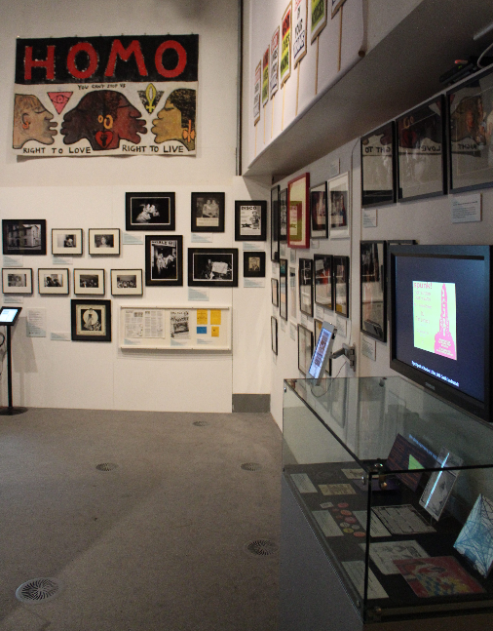

Queer Noise exhibition, 2017.

Alt text: Photograph of the corner of an L shaped exhibition wall covered with framed photographs, images and a television monitor. At the top of the far wall is a large painted paper banner which includes the profiles of four kissing faces, each is a different colour. The banner reads ‘HOMO - You Can’t Stop Us - Right To Love - Right To Live’.

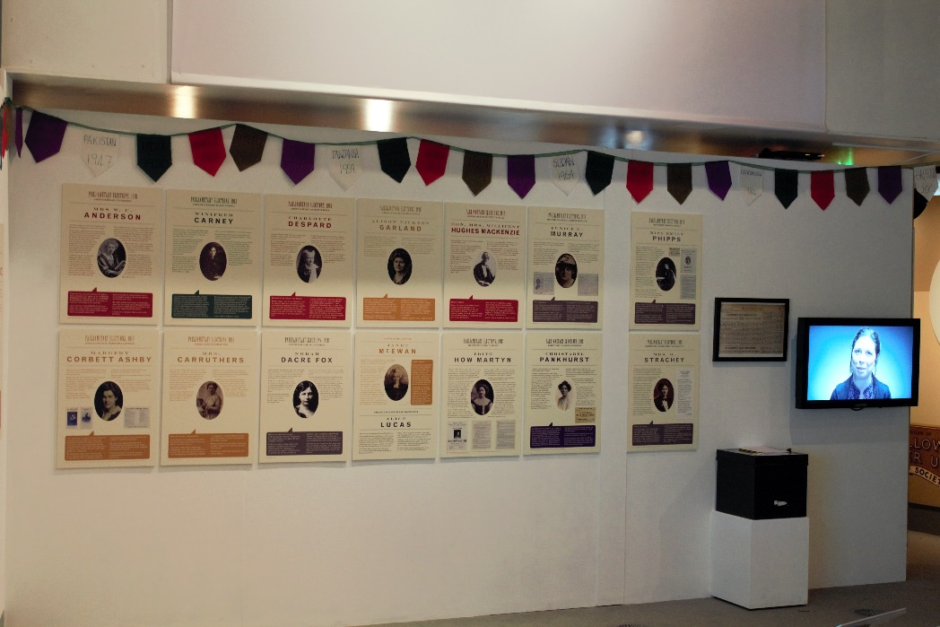

The women who said 'yes'! exhibition, 2018.

Alt text: Photograph of a long exhibition wall with 14 large panels that have text and images on. At the right end of the wall there is a television monitor and a framed document. The top of the wall is decorated with colourful triangular bunting.

Wall dimensions of the space:
- Wall 1: 3,130mm wide x 2,300mm high
- Wall 2: 4,795mm wide x 2,300mm high

Available for use in the exhibition space are a number of plinths, museum cases, and AV equipment.

How does PHM support community exhibitions?

- PHM provides dedicated support to community exhibitions through professional staff input, heating, lighting, and staffing the building during opening hours, and providing display equipment. Although PHM is unable to fully fund large scale community projects, we have a small budget available to help support the delivery of community exhibitions.
- PHM is committed to paying professional artists. If you are a professional artist, please make this clear when you get in touch.
- PHM can provide the services of a member of museum staff to advise on display methods, assist with installation, and manage production of exhibition materials according to an agreed plan.

Sending us your idea

If you are a community group or individual with an idea for a small exhibition, or already have a small display exploring disability, please send a short email, video message, or sound recording for the attention of Mark Wilson, Exhibitions Officer to exhibitions@phm.org.uk, answering these questions:

- Who are you?
- What is your exhibition about? (Include supporting images if you have them)
- Does your idea need money to do it and if so, roughly how much?

If you are unable to put your idea into an email, video message, or sound recording, you can phone the museum on 0161 838 9190 and ask to discuss your idea with Mark Wilson or a member of the Programme Team.

You can also send your idea by post to:

Mark Wilson, Exhibitions Officer

People’s History Museum

Left Bank

Spinningfields

Manchester

M3 3ER

All ideas or proposals must be received by 5.00pm on Monday 29 May 2023.

The successful exhibitions will be selected by a panel of museum staff and members of the Nothing About Us Without Us programme steering group. If your exhibition is selected for display, we will be in touch in the week commencing Monday 5 June 2023.

If you would like to discuss your idea or view the exhibition space, please contact Mark Wilson to arrange.

