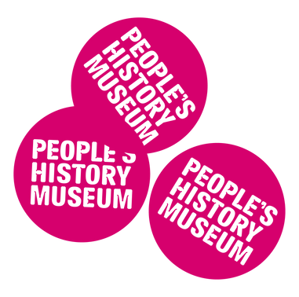
Welcome to
People's History Museum (PHM)

Visual Story
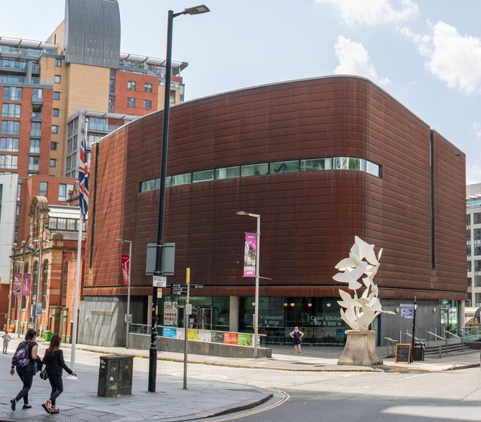
The museum building has a statue of doves of peace outside.

Page 1 of 16

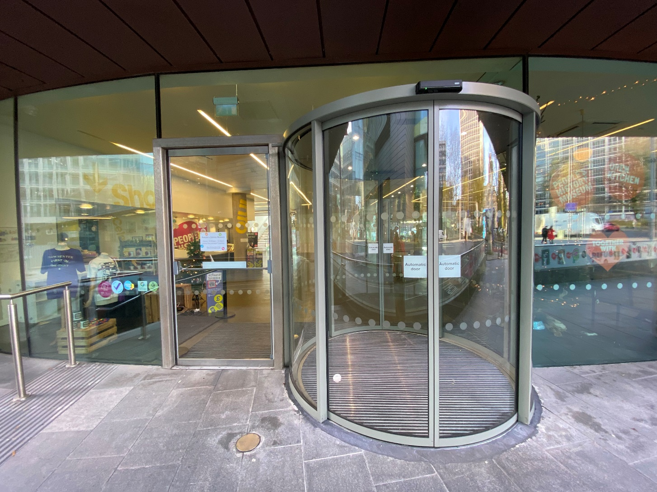

The entrance has sliding glass doors which open automatically.

Page 2 of 16

Our friendly staff will welcome you at
the Info Desk.

Page 3 of 16

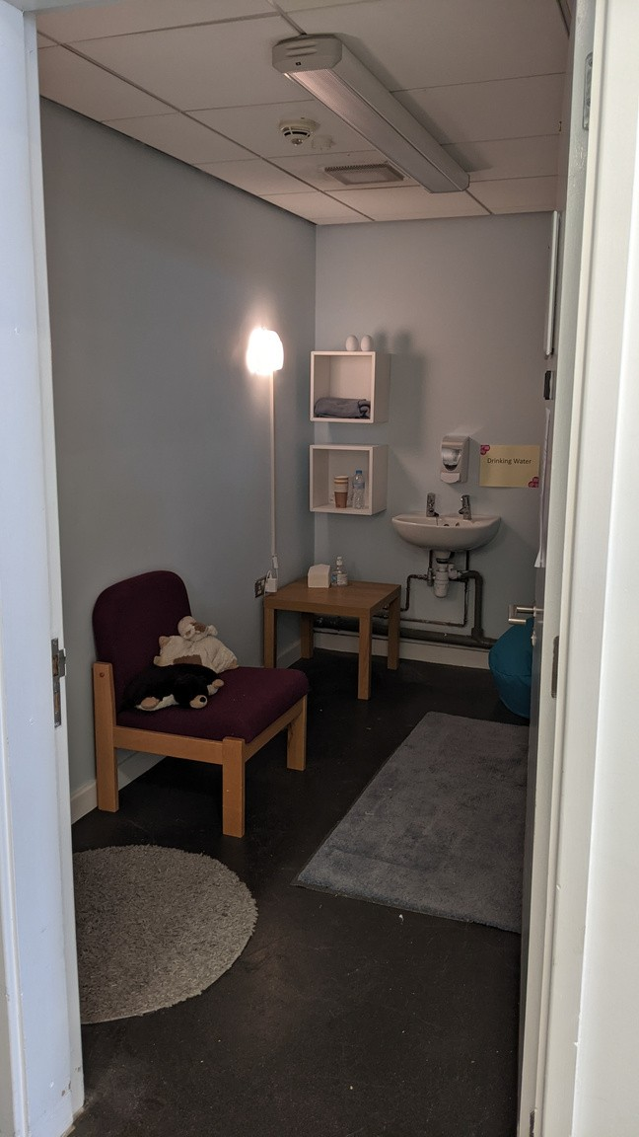

The museum has a Quiet Room
you can use during your visit.

Location: ground floor.

Page 4 of 16

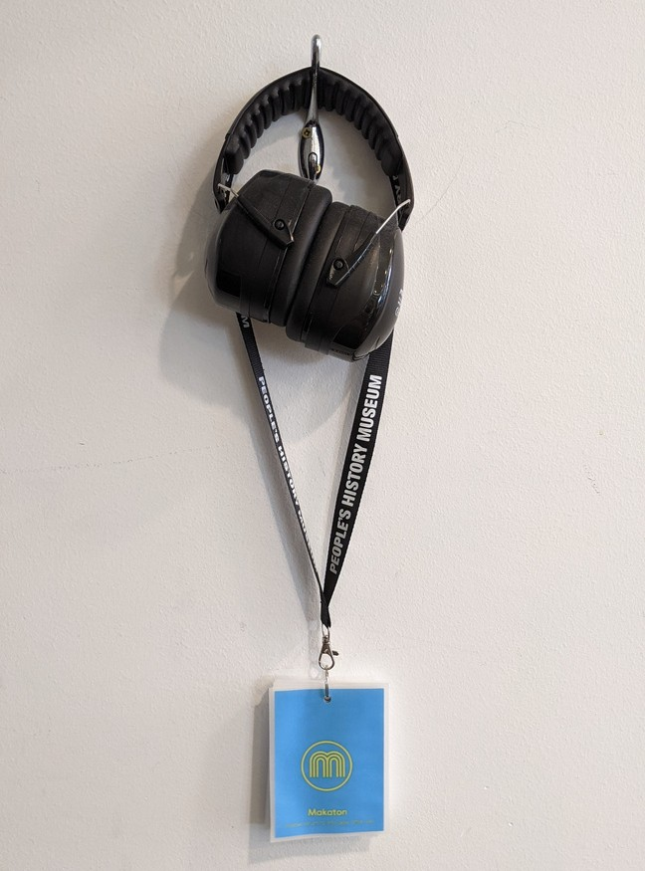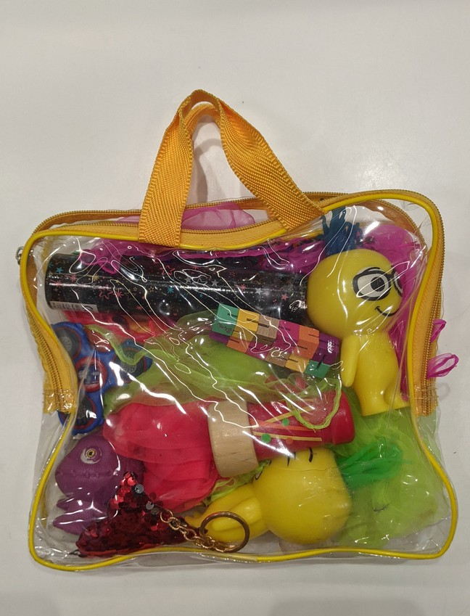

You can borrow ear defenders, a
Makaton lanyard, and a sensory bag from the Info Desk.

Location: ground floor.

Page 5 of 16

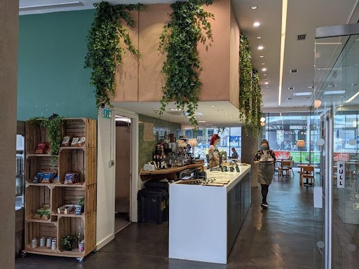

You can buy refreshments from
Open Kitchen Cafe & Bar at PHM.

Location: ground floor.

Page 6 of 16

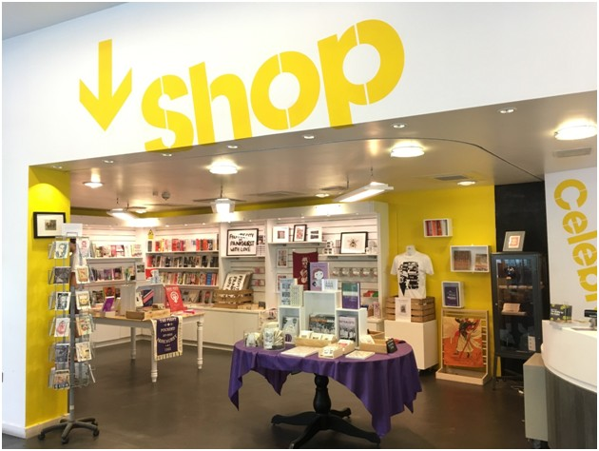

Visit the museum's gift shop.

Location: ground floor.

Page 7 of 16

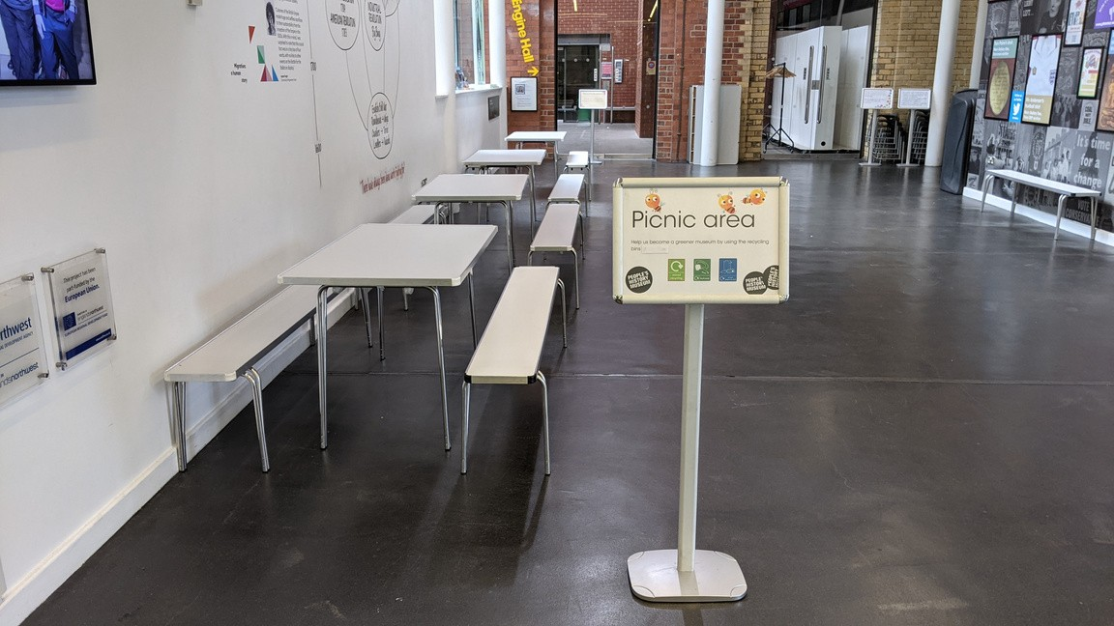

You can eat a packed lunch in the
picnic area.

Location: ground floor.

Page 8 of 16

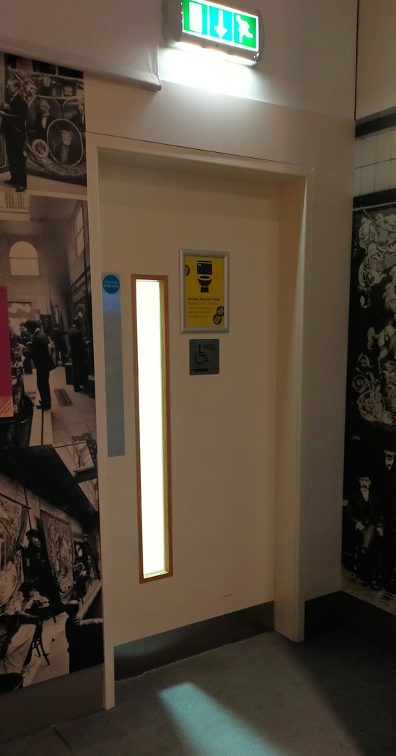
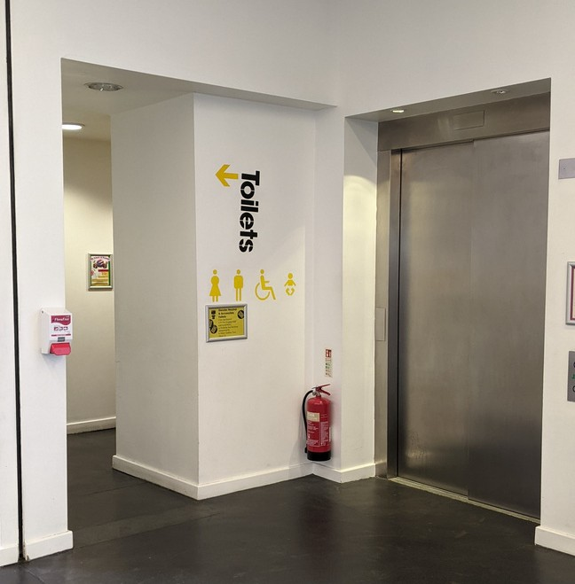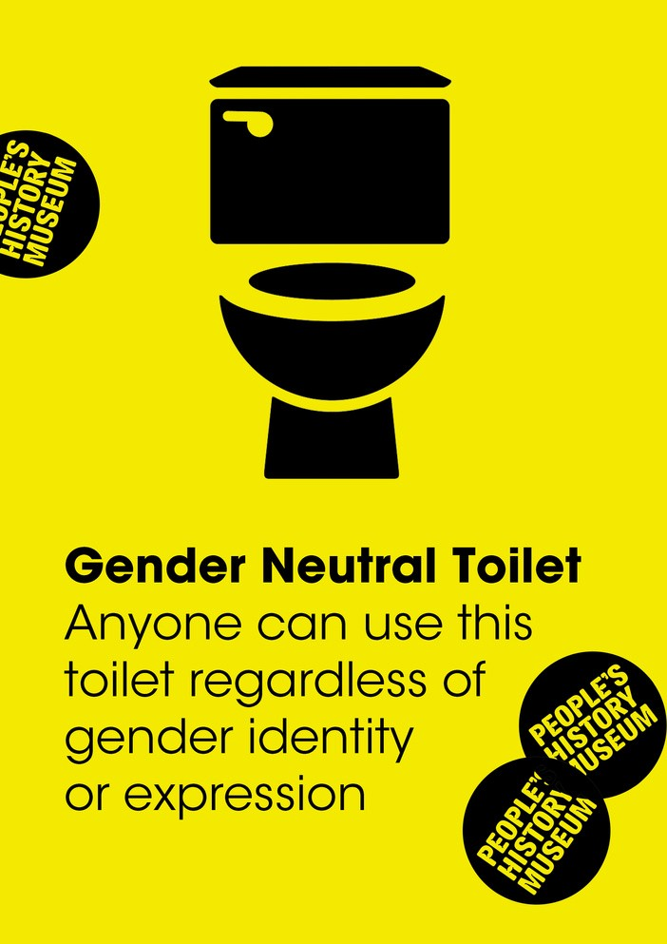

Ground floor

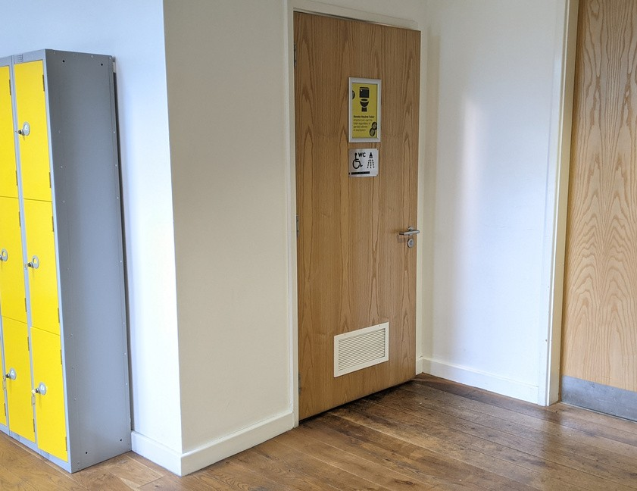
Lower ground floor

Second floor

There are toilets on the lower ground floor,
on the ground floor, and on the second floor.

There is a gender neutral, accessible toilet on each of these floors.

Page 9 of 16

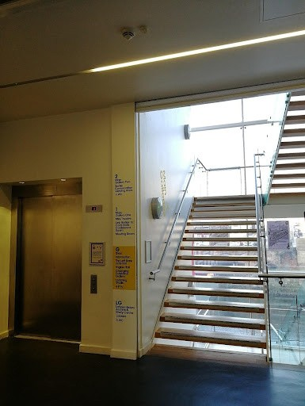

The lift and stairs lead up to
Gallery One and Gallery Two.

Page 10 of 16

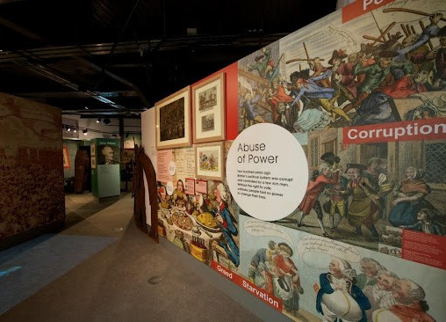

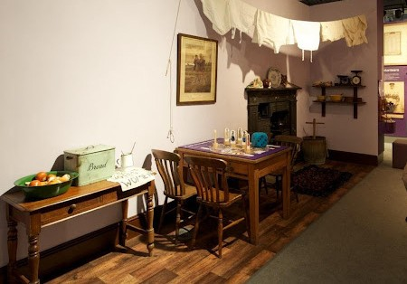

Gallery One.

Location: first floor.

Page 11 of 16

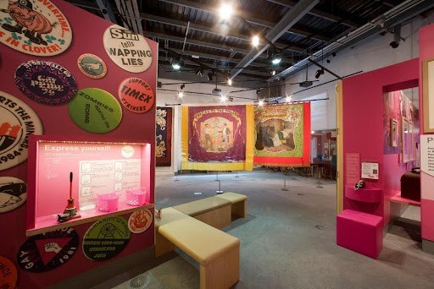

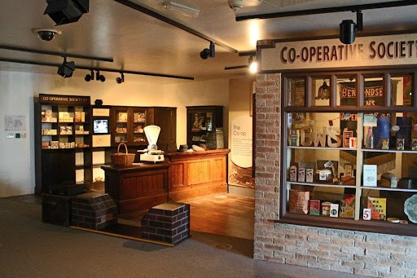

Gallery Two.

Location: second floor.

Page 12 of 16

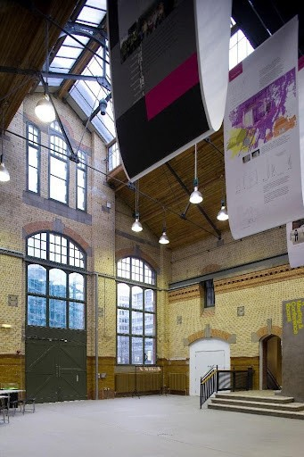

The Engine Hall is sometimes used for
events and exhibitions.

Location: ground floor.

Page 13 of 16

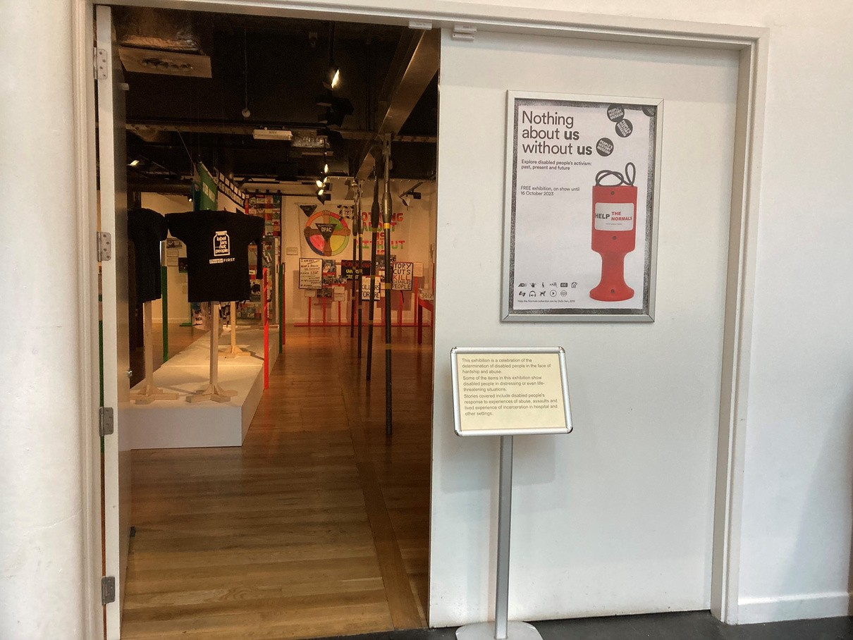
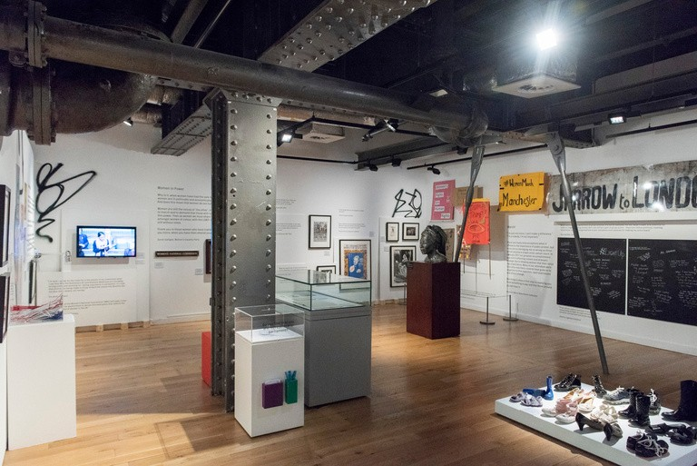

The exhibitions in Gallery Three
change a few times a year.

Location: ground floor.

Page 14 of 16

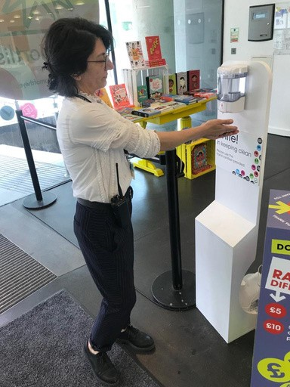

Covid-19 safety measures at the
museum:

We respect your decision to
continue to wear a face covering.

We provide hand sanitiser at regular
points throughout the building.

Spaces are cleaned daily.

Page 15 of 16

Please talk to us if you have queries or
require any assistance in advance of your
visit by phoning 0161 838 9190, or by
emailing access@phm.org.uk.

Emails will be answered
Monday to Friday, 10.00am to 5.00pm.

On the day of your visit, our Visitor
Experience Team will be available to help.

You can also give us a call on the day of
your planned visit if you require assistance.

Page 16 of 16

