People’s

History

Museum

# Director of Finance & Resources

Finance and Operations

Job Pack

April 2025

# About the role

This is an exciting opportunity for a highly motivated, dynamic and commercially minded individual

to join the Senior Management Team of one of the UK’s leading museums. Working alongside the

Director and Board of Trustees, the Director of Finance and Resources will oversee the financial management of the organisation.

The successful candidate will be a qualified Accountant with a proven track record of operating at a senior level. They will have the ability to offer insight and challenge for future development, whilst ensuring the financial sustainability and growth.

The Director of Finance & Resources is responsible driving the quality and transparency of financial management and reporting, ensuring robust financial controls and the smooth running and management of Museum and Trading finances.

With experience at Board level, they must be comfortable with presenting to Boards, have the

ability to develop strategy and present business plans.

# About People’s History Museum

**People’s History Museum** is the **national museum of democracy**, telling the story of its development in

Britain: past, present, and future. PHM invites people to explore the radical stories of people coming together to champion **ideas worth fighting for**, and to be empowered by the past to make a change for the future. **We are all together in the fight for a fairer world**.

PHM currently welcomes a local, national and international audience, attracting around 100,000 visitors annually, as well as reaching people online through digital activities. The museum involves audiences and communities in all aspects of its work, using models of co-curation, collaboration, and crowd-sourcing when developing and delivering programmes of activity. Engaging people directly in the work of the museum helps to build a passionate and committed audience who become supporters and advocates for PHM, while ensuring we are shaping authentic content representative of diverse audiences, providing an inclusive space for their voices, stories and ideas. PHM’s innovative approach explores important subjects and issues relevant to us all today.

PHM has an annual turnover of around £1.5 million, with a skilled team of staff, freelance experts and volunteers. PHM is funded by Arts Council England (ACE) as a National Portfolio Organisation (NPO) and by Greater Manchester Combined Authority (GMCA) Culture and Social Impact Fund. PHM is an independent museum, charitable trust, and company limited by guarantee, with a Board of Trustees, a Trading Company Board, and an Audit and Risk Committee.

# Staff structure

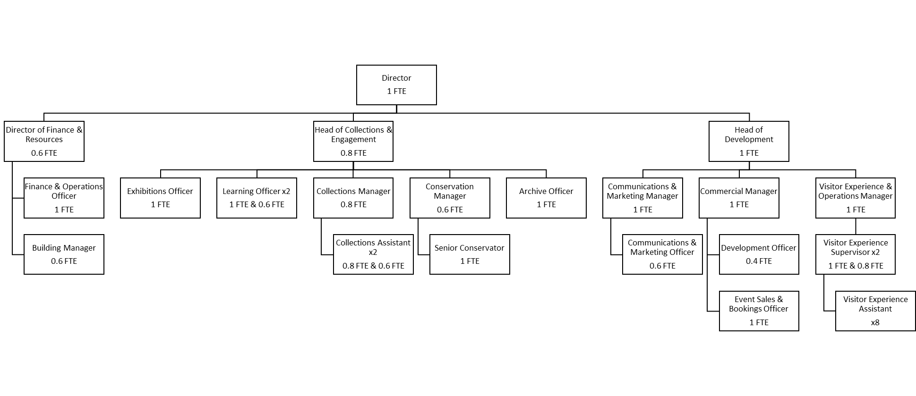

# Job Description

**Finance Director**

**Salary**: £42,000 - £58,000 FTE (offered as £25,200 - £34,800 pro rata) plus 10% employer pension contribution

**Hours**: Part time role. The role is envisioned as a 0.6 FTE with flexible working and working from home arrangements in line with People’s History Museum (PHM) policy

**Annual leave:**  24 days pro rata plus bank holidays

**Responsible to:**  Director

**Responsible for:**  Finance & Operations Officer and Building Manager

**Location:**  Based at People’s History Museum with the opportunity for agile working in line with PHM’s flexible working policy

**Purpose of the role**

The Director of Finance & Resources will oversee and optimize People’s History Museum’s financial and operational resources to support its strategic vision. As a senior leadership team (SLT) member, they will work closely with the Director, ensuring effective day-to-day management of core functions and contributing to long-term planning.

Responsibilities will include:

1. Leading the museum’s financial planning and reporting cycle
2. Supporting a sustainable business model with data-driven insights and analysis
3. Overseeing a high-performing finance function within the organisation, including team management and management of contractors and external service providers
4. Ensuring compliance with relevant regulatory bodies
5. Actively contributing to strategic discussions, impact evaluations, and cross-organisational projects.

This role will provide leadership across Finance and outsourced services including Audit. Across all aspects of the role, we are seeking someone who will help us to plan strategically for the future, drive operational excellence and work collaboratively across teams to ensure the long-term financial sustainability of the museum.

#### **Financial management and planning:**

* To work with the Director and SLT on the development of the museum’s annual and multi-year business plans. Lead on ensuring a sustainable financial model for both the Museum and its trading subsidiary
* To provide regular, clear financial updates to SLT, managers, and wider organisation, helping inform decision-making and programme delivery
* To ensure the museum’s financial operations are transparent, effective, and in line with best practices, including overseeing long and short-term cash flow, reserves forecasting, and financial planning
* To present clear and comprehensive financial reports to the Trustees, ensuring strategic priorities, risks, and financial health are accurately monitored
* To review and ensure the museum’s financial sustainability, especially on cash flow, going concern, and reserves policy
* To work across the organisation to build financial literacy and embed good financial processes and practices
* To represent SLT at the museum’s Finance and Audit Committee and lead on the planning of these meetings with the committee chair.

**Operations and risk management:**

* To oversee the museum’s financial processes, policies, and legal requirements, ensuring all operations are compliant with statutory guidelines
* To lead the financial management of project funds, capital budgets, and restricted funds, including the preparation of grant income and expenditure reports
* To oversee compliance with Companies House, Charity Commission regulations, VAT, corporation tax, and other financial laws
* To manage the annual audit process, liaising with external auditors to implement system improvements and file necessary reports
* To lead on the financial aspects of business continuity planning, ensuring robust procedures are in place and tested regularly.

#### **Building and asset management:**

* To collaborate with the Director, SLT and other stakeholders to manage leases, business rates, and legal matters concerning the main PHM building and offsite storage.
* To arrange insurance, including public liability insurance, to protect the workforce, visitors, and museum assets
* To oversee supplier management, contract renewals, procurement and negotiations in collaboration with the Operations team.

#### **Resources management:**

* The management of external contracts to provide key professional services to the museum
* To work together with the Director and SLT, to ensure all HR documentation and policies are up to date, including contracts, policy handbooks, recruitment packs, and onboarding materials
* To work flexibly within SLT, leading and contributing to projects and other areas of shared strategic planning as needed.

**Experience, knowledge and skills**

### **Essential:**

* Fully qualified accountant and current member of a recognized UK accounting body (e.g., ICAEW, CIMA, ACCA, CIPFA)
* Strong financial acumen with expertise in budgeting, forecasting, and financial reporting
* In-depth knowledge of charity financial regulations, including Companies House, Charity Commission, VAT, and Tax Law
* Proven experience in working across multidisciplinary teams and collaborating with senior management and Trustees. Able to communicate clearly and effectively with non-specialists
* Strong problem solving ability and adaptability to evolving challenges
* Familiarity with legal and governance frameworks, including SORP and best practices for charities
* Solid understanding of the charity, arts, heritage and museum sector in the UK
* Proactive and strategic mindset, balancing long term vision with day-to-day operations
* Experience of building strong relationships with Boards, management, and colleagues, offering advice and inspiring confidence
* Highly organised, adaptable, self-motivated and effective in managing a varied workload
* Commitment to diversity and understanding of working in a values-based organisation.

### **Desirable:**

* Experience working with Xero or similar accounting software
* Experience in the museum/heritage sector.

# How to apply

Please send your CV and cover letter to [hr@phm.org.uk](mailto:hr@phm.org.uk)

Please outline in your cover letter how your experience, skills and knowledge meet the job description. Your CV and cover letter will be assessed and scored against the job description using the information provided above.

**Deadline for applications:**  23:59 on Monday 19 May 2025

**Interviews:**  Thursday 29 May 2025 in person at the museum

If you have any questions or would like to arrange to discuss the role please contact Jackie Royle, Finance & Operations Officer at [hr@phm.org.uk](mailto:hr@phm.org.uk)

## **Equity**

PHM prides itself on being a welcoming and inclusive organisation, profoundly committed to advancing equality and diversity in the broadest sense. We highly value the benefits that diverse perspectives bring to PHM’s mission.

We recognise the museum currently underrepresents people of colour, disabled people, LGBTQI+ people and those with intersecting identities in our workforce; PHM is actively working to address this and encourages applications from these backgrounds. While the successful candidate will be selected purely on merit, in the event of a tie between two candidates with equal experience, we may select a candidate who helps us better represent the communities the museum serves.