People’s

History

Museum

# Collections Manager

Collections & Engagement

Job Pack

May 2025

# About the role

People’s History Museum (PHM) is looking for a dedicated professional to lead the care and management of PHM’s collection. The ideal candidate will understand current issues and best practice within collections management and curation and will have strong IT skills to lead the ongoing development of our digital collections management systems. This includes our collections management system, EMu, and our new digital asset management system, Axiell DAMS – Powered by Piction.

The Collections Manager will oversee the final stages of a John Ellerman Foundation funded project (until mid-March 2026) to improve cataloguing and digitisation, which forms the vital building blocks to improving collections management and future engagement with the museum’s collection. They will be responsible for the management of two fixed-term Collections Assistants currently undertaking digitisation and cataloguing work as part of this project.

Developing the museum collection and leading on all processes related to new acquisitions is a key aspect of the Collections Manager’s role. They will also contribute to exhibitions development, supporting the Exhibitions Officer to identifying suitable objects for display in exhibitions as well as creating smaller displays to respond to anniversaries and showcase new acquisitions.

Another key area of responsibility will be to lead on plans relating to the potential relocation of PHM’s object store, collaborating with colleagues to deliver this project.

The successful applicant will work closely with the Engagement, Archive, Conservation, and Communications & Marketing teams on current and upcoming projects, including future exhibition development, digitisation, and sharing our stories with our audiences.

The role would be ideal for someone with experience in collections management and curation, and with strong experience of working with collections management systems. Direct experience with EMu would be an advantage, as would knowledge of managing the intellectual property (IP) and copyright of collections.

PHM’s collection of over 60,000 objects showcases ideas worth fighting for, including democracy, gender equality, votes for all, co-operation, social justice, disabled people’s rights, and LGBTQIA+ rights.   Our vision is of a fairer society where people’s voices and actions make a difference. We are seeking an individual with a strong commitment to equality, diversity and social justice to care for and democratise this nationally recognised collection.

# About People’s History Museum

People’s History Museum is the national museum of democracy, telling the story of its development in Britain: past, present, and future. PHM invites people to explore the radical stories of people coming together to champion ideas worth fighting for, and to be empowered by the past to make a change for the future. We are all together in the fight for a fairer world.

PHM currently welcomes a local, national and international audience, attracting 80,000 visitors annually. The museum involves audiences and communities in many aspects of its work, using models of co-curation, collaboration and crowd-sourcing when developing and delivering programmes of activity. Engaging people directly in the work of the museum helps to build a passionate and committed audience who become supporters and advocates for PHM, while ensuring we are shaping authentic content representative of diverse audiences, providing an inclusive space for their voices, stories and ideas. PHM’s innovative approach explores important subjects and issues relevant to us all today.

PHM has an annual turnover of around £1.5 million, with a skilled team of staff, freelance experts and volunteers. PHM is funded by Arts Council England (ACE) as a National Portfolio Organisation (NPO) and by Greater Manchester Combined Authority (GMCA) Culture and Social Impact Fund. PHM is an independent museum, charitable trust, and company limited by guarantee, with a Board of Trustees, a Trading Company Board, and an Audit and Risk Committee.

# Staff structure

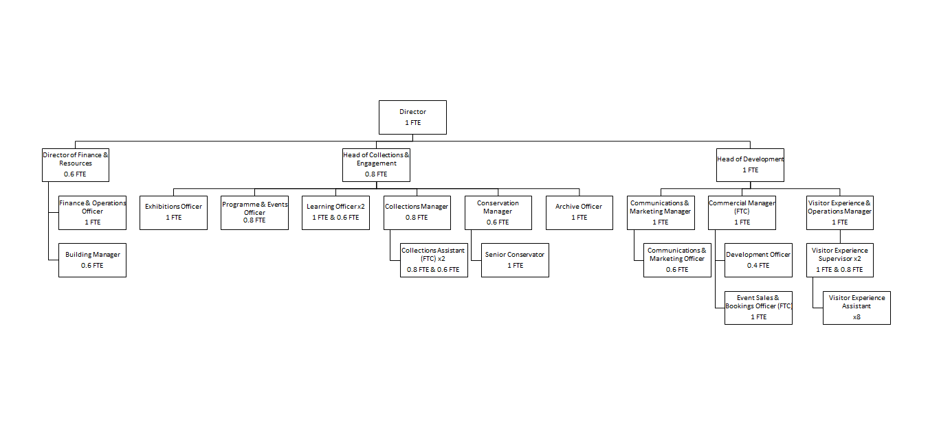

# Job description

**Collections Manager**

**Salary**: £32,115 offered as 0.8 role at £25,692 (plus 10% employer pension contribution).

**Hours**: Part time role (28 hours per week) with flexi-time and some working from home arrangements in line with PHM policy

**Annual leave:**  24 days pro rata plus bank holidays

**Contract:** Permanent

**Responsible to:**  Head of Collections & Engagement

**Responsible for:**  Collections Assistants x 2 (currently fixed-term project funded)

**Location:**  Based at People’s History Museum with the opportunity for agile working in line with the museum’s flexible working policy. Will involve roughly a day per week spent at PHM’s off-site store

**Key responsibilities**

* Lead on all aspects of collections management, including cataloguing, collections development, loans, acquisitions, review, and rationalisation.
* Lead the museum’s acquisitions panel.
* Ensure the collection is cared for to accreditation, Spectrum 5.1 and other best practice standards. Develop, maintain and adhere to collections policies and procedures. Lead on the museum’s periodic reapplication for accreditation.
* Manage the digital collections management systems, including the EMu collections management system and digital asset management system, Axiell DAMS – powered by Piction, including administration and data maintenance.
* Manage intellectual property (IP) of the collections, including gaining and granting copyright licences or assignment for non-commercial and commercial uses.
* Work with colleagues across the organisation to ensure opportunities for income generation are identified, developed and maximised by, for example, developing funding bids. Manage any collections projects and carry out any funder reporting.
* Plan and monitor the collections budget and project budgets to ensure effective use of resources.
* Lead on plans relating to the potential relocation of PHM’s object store, collaborating with colleagues to deliver this project.
* Collaborate effectively with Engagement, Archive, Conservation and Communications & Marketing teams to develop and plan exhibitions, temporary displays, learning materials and other related content, including marketing materials. Help to develop and refine relevant object lists.
* Answer public enquiries and, together with other team members, help to develop collections-related texts such as exhibition interpretation.
* Provide strategic direction, line management, development and support to the Collections team.
* Contribute flexibly to the work of the Collections & Engagement team.

**Experience, knowledge and skills**

* Experience of managing museum collections, including acquisitions, loans programmes, documentation, cataloguing, intellectual property (IP) and copyright, digitisation and storage - in line with Accreditation and Spectrum 5.1 standards. Experience of addressing backlogs in documentation an advantage.
* Strong knowledge and understanding of digital collections management systems, with specific knowledge of EMu an advantage. IT skills and knowledge of working with Microsoft365 and Sharepoint.
* Experience of managing, supporting and developing individuals and teams, alongside strong collaboration skills - ideally with experiences of working collaboratively on exhibitions and displays.
* Experience of effectively managing projects, workflows and resources (including budget management, evaluation and reporting to funders).
* High standards of written and verbal communication. Awareness of the needs of museum audiences and experience of communicating information about objects to the general public and balancing preservation with public access.
* A demonstrable commitment to diversity and inclusion and interest in areas relevant to the museum’s collections (e.g. social history, political history, the struggle for human rights). Interest in current affairs to aid contemporary collecting would be an advantage.

# How to apply

Please outline how your experience, skills and knowledge meet the job description and provide details via our online application form. Your application will be assessed and scored against the job description using the information provided.

**Deadline for applications:**  Sunday 9 June at 11pm

**Interviews:**  Thursday 19 June in person at the museum

If you have any questions or would like to arrange to discuss the role please contact Jackie Royle, Finance & Operations Officer at [hr@phm.org.uk](mailto:hr@phm.org.uk)

## **Equity**

PHM prides itself on being a welcoming and inclusive organisation, profoundly committed to advancing equality and diversity in the broadest sense. We highly value the benefits that diverse perspectives bring to our mission.

We recognise the museum sector currently underrepresents global majority, disabled, LGBTQIA+ people, different socio-economic backgrounds and those with intersecting identities in our workforce; PHM is actively working to address this and encourages applications from these backgrounds. While the successful candidate will be selected purely on merit, in the event of a tie between two candidates with equal experience, we may select a candidate who helps us better represent the communities the museum serves.

including members of the Global Majority, d/Deaf and disabled applicants and individuals from lower socio-economic backgrounds