People’s

History

Museum

# Programme & Events Officer

Collections & Engagement

Job Pack

May 2025

# About the role

We are seeking a dynamic, creative, and audience-focused Programme & Events Officer to design and deliver compelling public programmes that engage diverse communities and grow our museum’s audience. This role plays a vital part in bringing our collections, exhibitions, and mission to life through innovative, inclusive, and high-impact events and activities.

The Programme & Events Officer will lead the conception, planning, and execution of public programmes that drive attendance, deepen community relationships, and expand access to the museum. With a keen understanding of cultural trends and audience behaviours, the ideal candidate will create experiences that are both mission-aligned and audience-driven.

We are looking for someone with experience of designing and delivering successful programmes of events and activities and meeting audience targets to reach underrepresented audiences (LGBTQIA+, global majority and disabled people), grow new audiences, attract families and cultivate repeat visits. You will need experience of managing budgets and meeting income targets, and have strong teamwork, organisational and communication skills.

People’s History Museum (PHM’s) collection of over 60,000 objects showcases ideas worth fighting for, including democracy, gender equality, votes for all, co-operation, social justice, disabled people’s rights, and LGBTQIA+ rights.   Our vision is of a fairer society where people’s voices and actions make a difference. We are seeking an individual with a strong commitment to equality, diversity and social justice to bring these themes to life through events and activities.

# About People’s History Museum

People’s History Museum is the national museum of democracy, telling the story of its development in Britain: past, present, and future. PHM invites people to explore the radical stories of people coming together to champion ideas worth fighting for, and to be empowered by the past to make a change for the future. We are all together in the fight for a fairer world.

PHM currently welcomes a local, national and international audience, attracting 80,000 visitors annually. The museum involves audiences and communities in many aspects of its work, using models of co-curation, collaboration and crowd-sourcing when developing and delivering programmes of activity. Engaging people directly in the work of the museum helps to build a passionate and committed audience who become supporters and advocates for PHM, while ensuring we are shaping authentic content representative of diverse audiences, providing an inclusive space for their voices, stories and ideas. PHM’s innovative approach explores important subjects and issues relevant to us all today.

PHM has an annual turnover of around £1.5 million, with a skilled team of staff, freelance experts and volunteers. PHM is funded by Arts Council England (ACE) as a National Portfolio Organisation (NPO) and by Greater Manchester Combined Authority (GMCA) Culture and Social Impact Fund. PHM is an independent museum, charitable trust, and company limited by guarantee, with a Board of Trustees, a Trading Company Board, and an Audit and Risk Committee.

# Staff structure

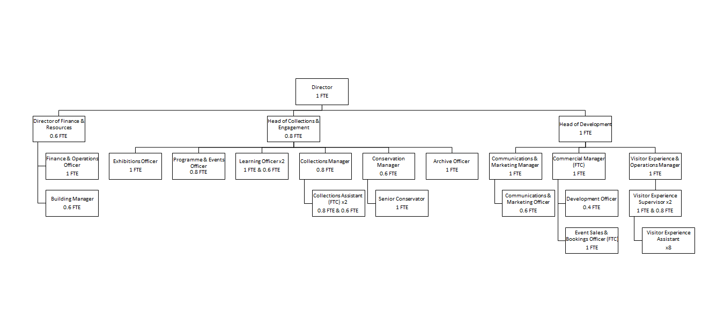

# Job description

**Programme & Events Officer**

**Salary**: £28,163 offered as 0.8 role at £22,530 (plus 10% employer pension contribution). Consideration will be given to candidates who would wish to take the role on a 0.6 basis - please state in your application if this is your preference

**Hours:**  Part time role (28 hours a week) with flexi-time and working from home arrangements in line with PHM policy. Some evening and weekend work will be needed to meet the needs of the programme, particularly on Thursday evenings and Saturdays which may be claimed back as toil.

**Annual leave:**  24 days pro rata plus bank holidays

**Contract:** Fixed Term for two years (with opportunity for extension)

**Responsible to:**  Head of Collections & Engagement

**Location:**  Based at People’s History Museum with the opportunity for agile working in line with the museum’s flexible working policy.

**Key responsibilities**

* **Design and deliver** a vibrant calendar of public events including talks, performances, workshops, festivals, and participatory experiences — that attract and engage a broad audience with a focus on our target segments.
* **Develop strategies** to grow museum attendance and participation, particularly from underrepresented audiences, new audiences, families and repeat visits.
* **Collaborate across departments** to align programming with key dates from the collection and museum priorities.
* **Cultivate and manage partnerships** with artists and freelancers, community groups, and cultural partners to co-create engaging events and broaden reach.
* **Evaluate programme impact** using audience feedback and data to refine offerings and inform future programming.
* **Manage event logistics**, including budgeting, budget monitoring, assessing commercial viability and meeting income targets, ticketing, contracts, health & safety, staffing, and implementing access standards. Ensuring high-quality, accessible, and inclusive experiences.
* **Stay current on cultural trends**, audience insights, and innovations in museum and cultural programming, test and innovate new programme ideas.
* Willingness to **work flexibility** and to vary responsibilities where needed, to support the goals of the Collections and Engagement team.

**Experience, knowledge and skills**

* Experience of designing and delivering successful programmes of events and activities e.g. talks, performances, workshops, festivals, and participatory experiences, to meet current trends and audience expectations, ideally in a museum setting.
* Experience of managing creative professionals and other stakeholders to deliver events on time and on budget.
* Experience of using audience segmentations as part of the programme design process and of setting and meeting targets to grow audiences, reach underrepresented communities (e.g. LGBTQIA+, global majority and disabled people), attract families and cultivate repeat visits. Experience of carrying audience evaluation and acting on its insights.
* Experience of budgeting and budget monitoring, including meeting income targets for events and delivering activity to budget.
* Strong teamwork and communication skills with experience of collaborating with colleagues (e.g. learning, exhibitions, collections, archive, conservation, marketing and visitor experience), and maximising relationship with community groups and individuals, programme partners, artists, creatives, speakers, and other freelancers.
* A demonstrable commitment to diversity and inclusion and interest in topics relevant to the Museum’s Collections (e.g. social history, political history, the fight for equality and social justice).
* Strong organisational, communication and IT skills to effectively manage event planning logistics including writing event descriptions for marketing, developing risk assessments, planning staffing, scheduling, and ensuring high quality access provision. Confident in using Microsoft packages.

# How to apply

Please outline how your experience, skills and knowledge meet the job description and provide details via our online application form. Your application will be assessed and scored against the job description using the information provided.

**Deadline for applications:**  Thursday 11 June at 11pm

**Interviews:**  Thursday 26 June in person at the museum

If you have any questions or would like to arrange to discuss the role please contact Jackie Royle, Finance & Operations Officer at [hr@phm.org.uk](mailto:hr@phm.org.uk)

# **Equity**

## PHM prides itself on being a welcoming and inclusive organisation, profoundly committed to advancing equality and diversity in the broadest sense. We highly value the benefits that diverse perspectives bring to PHM’s mission.

We recognise the museum sector currently underrepresents global majority, disabled, LGBTQIA+ people, different socio-economic backgrounds and those with intersecting identities in our workforce; PHM is actively working to address this and encourages applications from these backgrounds. While the successful candidate will be selected purely on merit, in the event of a tie between two candidates with equal experience, we may select a candidate who helps us better represent the communities the museum serves.