People’s

History

Museum

Visitor Experience & Operations Assistant

Job Pack
May 2025

About the role

At People’s History Museum (PHM) we welcome a diverse range of visitors from local, national, and international backgrounds, placing them at the heart of everything we do. We take pride in the role our Visitor Experience team plays in ensuring every visitor has an interesting, stimulating and engaging experience that encourages them to explore and get involved with ideas worth fighting for. This is a fantastic opportunity to join a dynamic team and gain hands-on experience across various aspects of front-of-house operations, including visitor engagement, operations, event coordination, learning support, and retail.
The team, currently consisting of ten members plus the Visitor Experience & Operations Manager, is central to the museum's daily public-facing activities. Responsibilities include maintaining the museum’s building and collections, assisting the Venue Hire team with set-ups and event operations, supporting the Engagement team with learning activities and tours and working alongside the Commercial Manager to run the museum shop. This role is perfect for someone reliable, enthusiastic, approachable, and eager to gain practical experience in a lively cultural setting, particularly in front-of-house roles within museums or heritage institutions.

About People’s History Museum

People’s History Museum is the national museum of democracy, telling the story of its development in Britain: past, present, and future. PHM invites people to explore the radical stories of people coming together to champion ideas worth fighting for, and to be empowered by the past to make a change for the future. We are all together in the fight for a fairer world.

PHM currently welcomes a local, national and international audience, attracting 80,000 visitors annually. The museum involves audiences and communities in many aspects of its work, using models of co-curation, collaboration, and crowd-sourcing when developing and delivering programmes of activity. Engaging people directly in the work of the museum helps to build a passionate and committed audience who become supporters and advocates for PHM, while ensuring we are shaping authentic content representative of diverse audiences, providing an inclusive space for their voices, stories and ideas. PHM’s innovative approach explores important subjects and issues relevant to us all today.

PHM has an annual turnover of around £1.5 million, with a skilled team of staff, freelance experts and volunteers. PHM is funded by Arts Council England (ACE) as a National Portfolio Organisation (NPO) and by Greater Manchester Combined Authority (GMCA) Culture and Social Impact Fund. PHM is an independent museum, charitable trust, and company limited by guarantee, with a Board of Trustees, a Trading Company Board, and an Audit and Risk Committee.

Staff structure

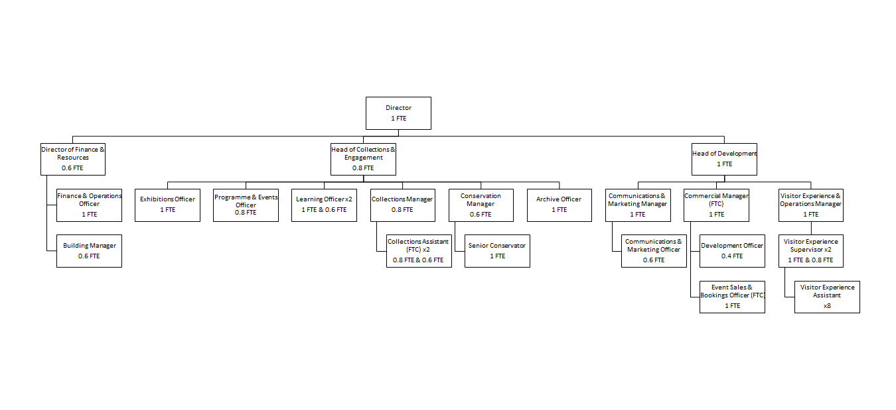

Job description

Visitor Experience & Operations Assistant

Salary: £24,027 pro rata (plus 10% pension contribution)
Hours: Part time (7 hours (Sunday) or 14 hours (Saturday & Sunday))

Annual leave: 24 days plus bank holidays (pro rata)

Contract: Permanent

Responsible to: Visitor Experience & Operations Manager

Location: Based at People’s History Museum

Key responsibilities

As part of the Visitor Experience team, alongside Assistants and Supervisors, your public-facing role plays an important part in supporting PHM’s ambition to be the go-to destination for learning about, exploring, and being inspired by ideas worth fighting for. You will deliver a welcoming and engaging experience for all visitors, while also contributing to the museum’s commercial success through support for fundraising, retail, and venue hire, as well as helping to maintain the overall upkeep and presentation of the building.

This role will include:

Supporting visitor experience and engagement with the museum’s collections and exhibitions, learning activities and events through:
  - Providing an informed and engaged welcome as the first point of contact for visitors.
  - Confidently promoting the museums donation schemes to support overall targets.
  - Responding confidently and appropriately to visitor enquiries, comments, access requirements and complaints.
  - Reception, shop and telephone duties, including till, credit card machine and cash handling.
  - Having up-to-date knowledge of the museum’s mission, values and programme of activity, and being pro-active in sharing this information with visitors.
  - Carrying out routine patrols of galleries, regularly checking radios, monitors and reporting problems.
  - Delivering gallery tours and welcoming groups.
  - Assisting with educational visits and school bookings as well as public events.
  - Proactively seeking visitor feedback by promoting our visitor survey and encouraging online reviews.
  - Reporting visitor feedback as required, both formally - through the museum’s impact and evaluation activities - and informally.

Supporting the venue hire team with events for clients, including weddings, conferences, markets and other activities

  - Assisting with event set up and room preparation, including PA technology set up.
  - Welcoming clients to the museum.
  - Cleaning and housekeeping tasks before and after events.
  - Supporting clients with queries and resolving issues throughout the course of the event.
  - Assisting with museum opening and closing procedures prior to and post events (this will include early starts and late event cover).

Monitoring and managing visitor facilities

- Cleaning and housekeeping tasks - ensuring galleries, toilets, venue hire spaces, and all other public areas are cleaned and tidy in preparation for opening and are regularly checked throughout the day.
- Keeping offices and external areas clean and tidy.
- Maintaining the highest standards of security and safety of the museum building and contents, and reporting problems with displays and facilities, potential security threats, and any suspicious activity. This also includes secure opening and closing of the building itself.
- Keeping up to date with current health and safety procedures including fire evacuation.

Experience, knowledge and skills

We are looking for a candidate who can demonstrate experience, knowledge and skills across the following criteria, with the opportunity for ongoing training and development to support the successful candidate once in post.

Experience, knowledge and skills | Application/interview/task
Commitment to and enthusiasm for the organisational priorities, collection and work of People’s History Museum | Application and interview
Capacity to communicate clearly and confidently with visitors and colleagues | Application and interview
Good attention to detail, timekeeping and problem solving skills | Interview
Enthusiasm for working as part of a team | Application and interview
Confidence approaching and speaking with visitors | Application and Interview
Ability to follow processes and procedures to ensure visitor comfort and safety | Application and interview

How to apply

Please outline how your experience, knowledge and skills meet the job description and provide details via our online application form. Your application will be assessed and scored against the job description using the information provided.

Deadline for applications: 23.00 on Friday 30 May

Interviews: Thursday 12 June, in person at People’s History Museum

If you have any questions or would like to arrange to discuss the role please contact Jackie Royle, Finance & Operations Officer at hr@phm.org.uk.

Equity

PHM prides itself on being a welcoming and inclusive organisation, profoundly committed to advancing equality and diversity in the broadest sense. We highly value the benefits that diverse perspectives bring to our mission.

We recognise the museum sector currently underrepresents global majority, disabled, LGBTQIA+ people, different socio-economic backgrounds and those with intersecting identities in our workforce; PHM is actively working to address this and encourages applications from these backgrounds. While the successful candidate will be selected purely on merit, in the event of a tie between two candidates with equal experience, we may select a candidate who helps us better represent the communities the museum serves.

