People’s

History

Museum

# Visitor Experience & Operations Assistant (Casual)

Job Pack

May 2025

About the role

At People’s History Museum (PHM) we welcome a wide range of visitors from all backgrounds and place them at the heart of everything we do. We take pride in the role our Visitor Experience team plays in ensuring every visitor has an interesting, stimulating, engaging experience that encourages them to explore and get involved with ideas worth fighting for. As a Casual Visitor Experience Assistant, you’ll support the team on an as-needed basis, helping with front-of-house duties such as greeting visitors, supporting learning sessions, working in the shop, and providing excellent customer service during busy periods and special events.

You’ll also help with the delivery of venue hire events, including setting up spaces, liaising with clients, and making sure everything runs to plan all while keeping the space welcoming and professional. This flexible role is perfect for someone reliable, enthusiastic, and proactive, with a genuine interest in working with the public. It’s a great opportunity to gain hands-on experience in a museum or visitor attraction setting, especially if you’re looking for occasional work that fits around other commitments.

# About People’s History Museum

**People’s History Museum** is the **national museum of democracy**, telling the story of its development in Britain: past, present, and future. PHM invites people to explore the radical stories of people coming together to champion **ideas worth fighting for,** and to be empowered by the past to make a change for the future. We are all together in the fight for a fairer world.

PHM currently welcomes a local, national and international audience, attracting 80,000 visitors annually. The museum involves audiences and communities in many aspects of its work, using models of co-curation, collaboration and crowd-sourcing when developing and delivering programmes of activity. Engaging people directly in the work of the museum helps to build a passionate and committed audience who become supporters and advocates for PHM, while ensuring we are shaping authentic content representative of diverse audiences, providing an inclusive space for their voices, stories and ideas. PHM’s innovative approach explores important subjects and issues relevant to us all today.

PHM has an annual turnover of around £1.5 million, with a skilled team of staff, freelance experts and volunteers. PHM is funded by Arts Council England (ACE) as a National Portfolio Organisation (NPO) and by Greater Manchester Combined Authority (GMCA) Culture and Social Impact Fund. PHM is an independent museum, charitable trust, and company limited by guarantee, with a Board of Trustees, a Trading Company Board, and an Audit and Risk Committee.

# Staff structure

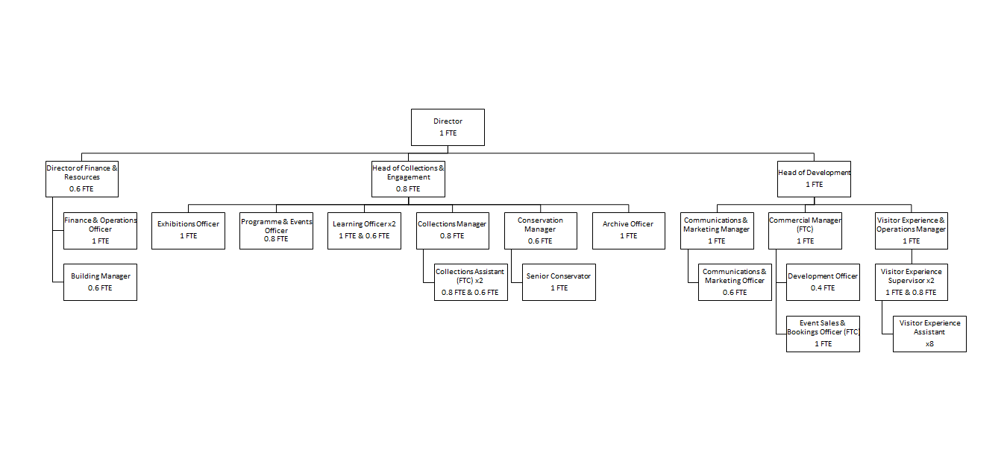

# Job description

**Visitor Experience & Operations Assistant (Casual)**

**Hourly rate**: £13.17 (plus option for 10% pension)

**Hours**: Casual basis – no fixed hours. You will be offered hours on an ad hoc basis which you can accept or decline as convenient. Evening and weekend availability essential. Weekday shifts may be offered if available.

**Contract**: Permanent

**Responsible to:** Visitor Experience & Operations Manager

**Location:** Based at People’s History Museum

**Key responsibilities**

As part of the Visitor Experience team your public-facing role plays an important part in supporting PHM’s ambition to be the go-to destination for learning about, exploring, and being inspired by ideas worth fighting for. You will deliver a welcoming and engaging experience for all visitors, while also contributing to the museum’s commercial success through support for fundraising, retail, and venue hire, as well as helping to maintain the overall upkeep and presentation of the building.

This will include:

**Supporting visitor experience and engagement with the museum’s collections and exhibitions, learning activities and events through:**

* + Providing an informed and engaged welcome as the first point of contact for visitors.
  + Confidently promoting the museum’s donation schemes to support overall targets.
  + Responding confidently and appropriately to visitor enquiries, comments, access requirements and complaints.
  + Reception, shop and telephone duties, including till, credit card machine and cash handling.
  + Having up-to-date knowledge of the museum’s mission, values and programme of activity, and being pro-active in sharing this information with visitors.
  + Carrying out routine patrols of galleries, regularly checking radios, monitors and reporting problems.
  + Delivering gallery tours and welcoming groups.
  + Assisting with educational visits and school bookings as well as public events.
  + Proactively seeking visitor feedback by promoting our visitor survey.
  + Reporting visitor feedback as required, both formally through the museum’s impact and evaluation activities and informally.

**Supporting the venue hire team with events for clients, including weddings, conferences, markets and other activities**

* + Assisting with event set up and room preparation, including PA technology set up.
  + Welcoming clients to the venue.
  + Cleaning and housekeeping tasks before and after events.
  + Supporting clients with queries and resolving issues throughout the course of the event.
  + Assisting with museum opening and closing procedures prior to and post events (this will include early starts and late event cover).

**Monitoring and managing visitor facilities**

* Cleaning and housekeeping tasks - ensuring galleries, toilets, venue hire spaces and all other public areas are cleaned and tidy in preparation for opening and are regularly checked throughout the day.
* Keeping offices and external areas clean and tidy.
* Maintaining the highest standards of security and safety of the museum building and contents, and reporting problems with displays and facilities, potential security threats, and suspicious activity. This also includes secure opening and closing of the building itself.

**Experience, knowledge and skills**

We are looking for a candidate who can demonstrate experience, knowledge and skills across the following criteria, with the opportunity for ongoing training and development to support the successful candidate once in post.

|  |  |
| --- | --- |
| **Experience, knowledge and skills** | **Application/interview/task** |
| Commitment to and enthusiasm for the organisational priorities, collection and work of People’s History Museum | Application and interview |
| Capacity to communicate clearly and confidently with visitors and colleagues | Interview |
| Good attention to detail, timekeeping and problem solving skills | Application and interview |
| Enthusiasm for working as part of a team | Application and interview |
| Confidence approaching and speaking with visitors | Interview |
| Ability to follow processes and procedures to ensure visitor comfort and safety | Application and interview |

# How to apply

Please outline how your experience, knowledge and skills meet the job description and provide details via our online application form. Your application will be assessed and scored against the job description using the information provided.

**Deadline for applications:**  23.00 on **Friday 30 May 2025**

**Interviews:**   **Thursday 19 June**,in person at People’s History Museum

If you have any questions or would like to arrange to discuss the role please contact Jackie Royle, Finance & Operations Officer at [hr@phm.org.uk](mailto:hr@phm.org.uk).

## **Equity**

PHM prides itself on being a welcoming and inclusive organisation, profoundly committed to advancing equality and diversity in the broadest sense. We highly value the benefits that diverse perspectives bring to PHM’s mission.

We recognise the museum sector currently underrepresents global majority, disabled, LGBTQIA+ people, different socio-economic backgrounds and those with intersecting identities in our workforce; PHM is actively working to address this and encourages applications from these backgrounds. While the successful candidate will be selected purely on merit, in the event of a tie between two candidates with equal experience, we may select a candidate who helps us better represent the communities the museum serves.