Welcome to
People's History Museum (PHM)

Visual Story
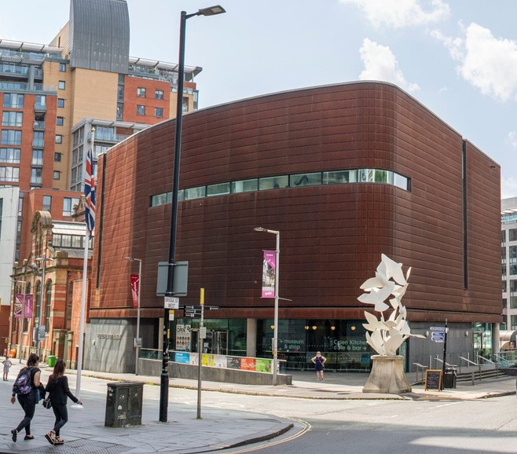
The museum building has a statue of doves of peace outside.

Page 1 of 18

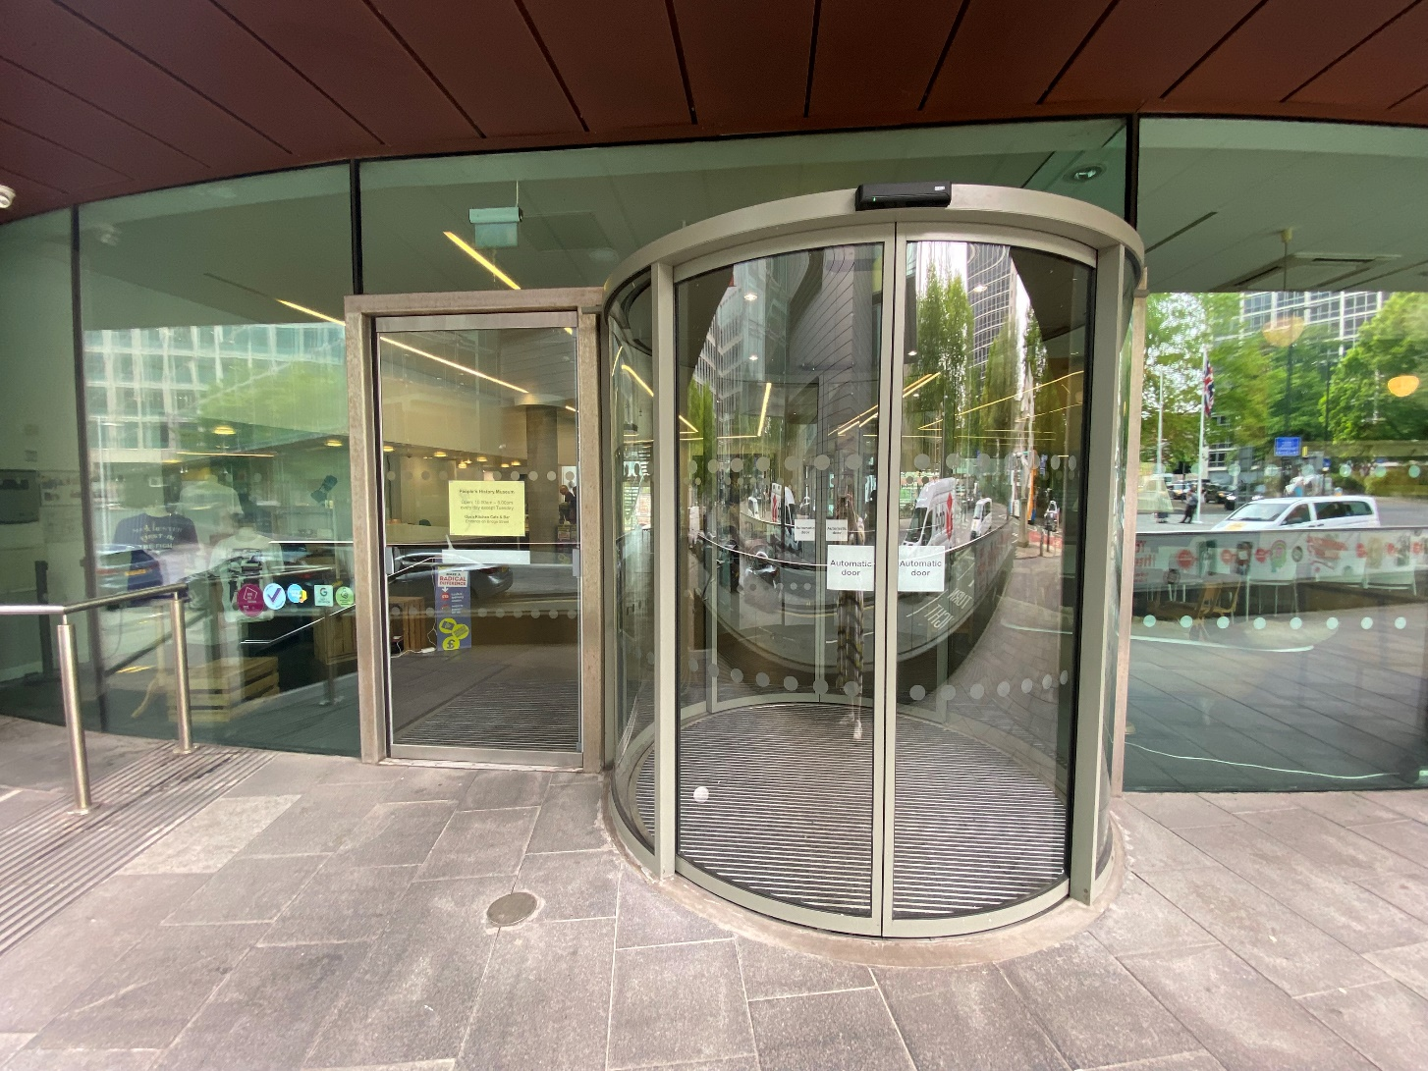

The entrance has sliding glass doors which open automatically.

Page 2 of 18

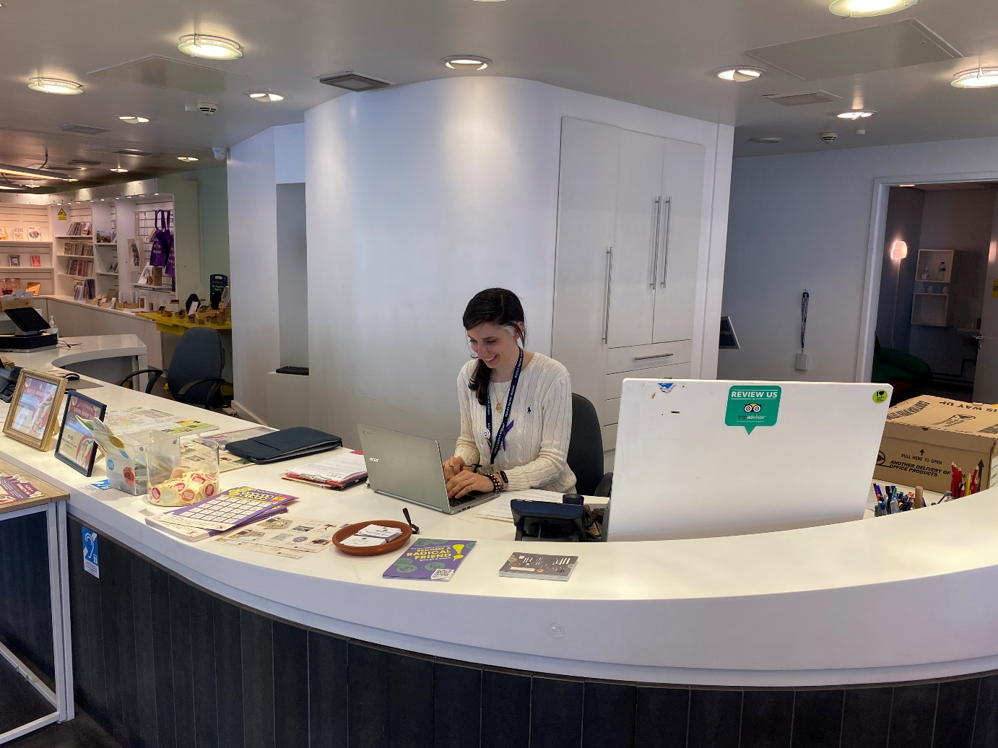

Our friendly staff will welcome you at
the welcome desk.

Location: ground floor.

Page 3 of 18

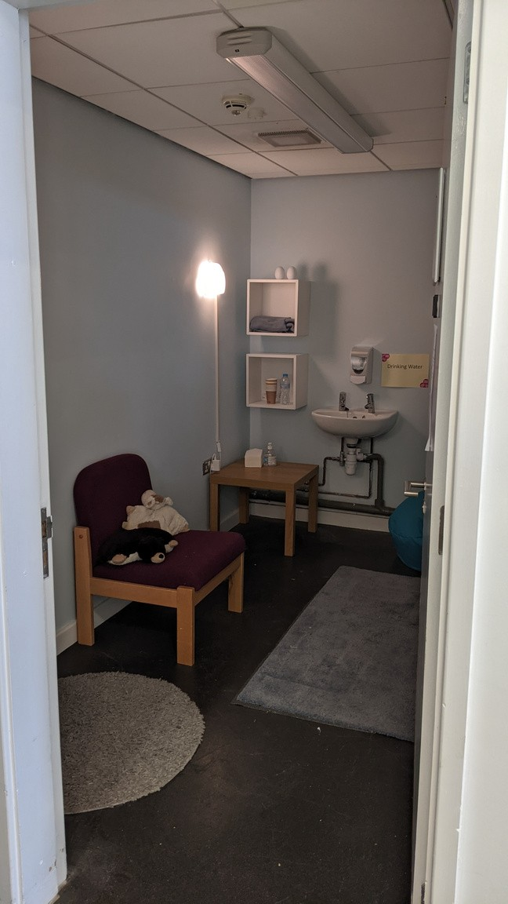

The museum has a Quiet Room
you can use during your visit.

Location: ground floor.

Page 4 of 18

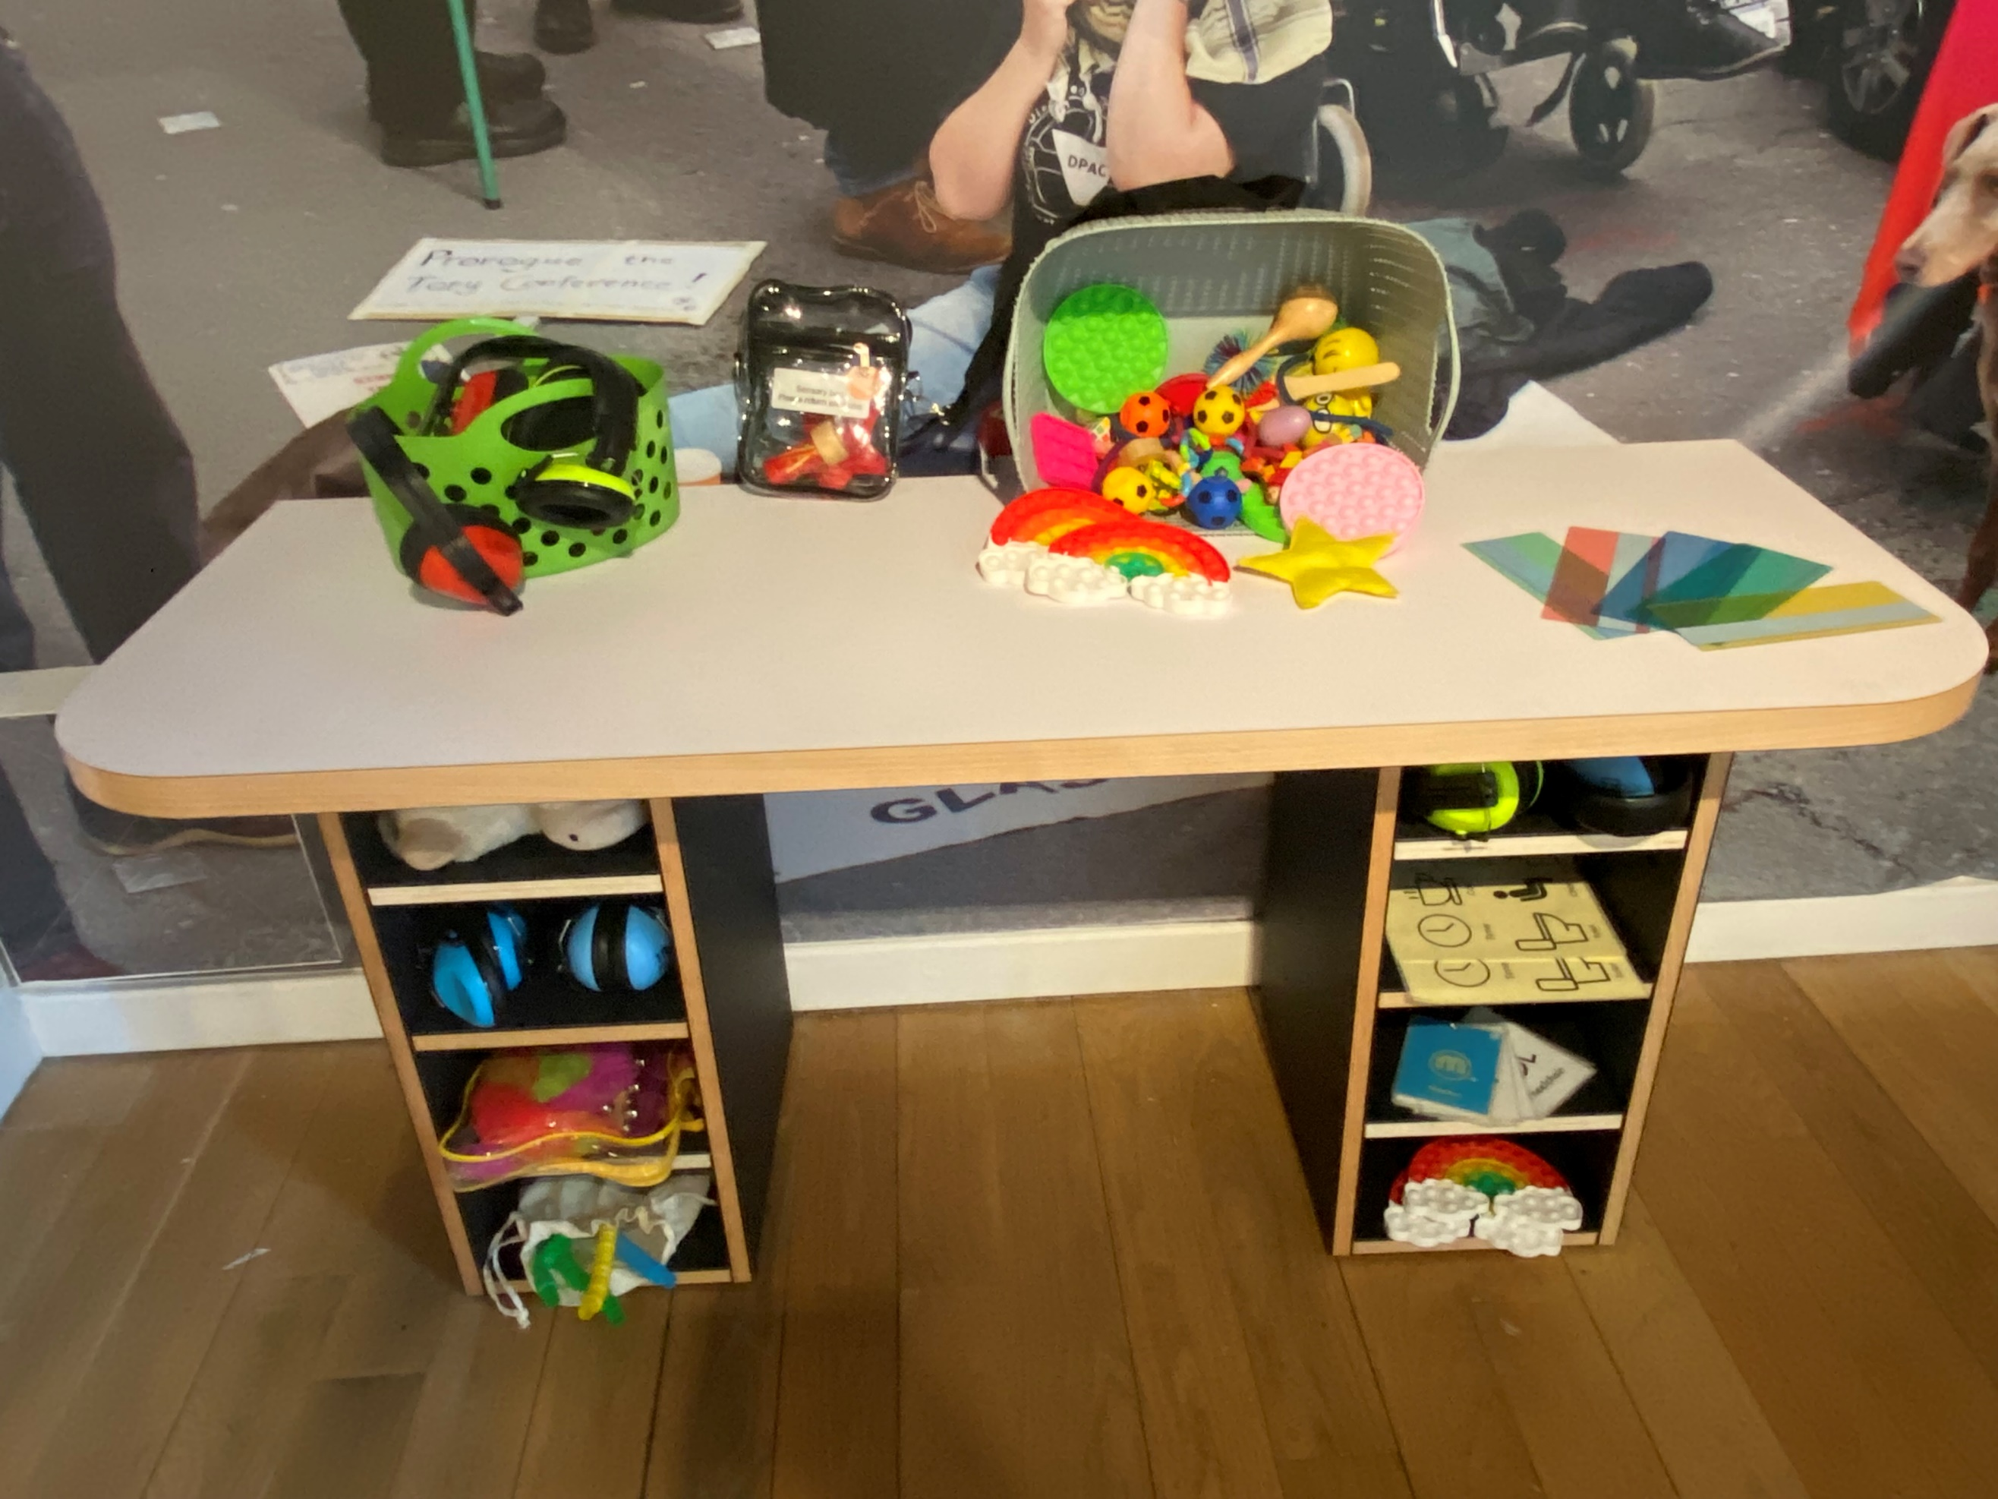

Sensory tools can be borrowed from access stations throughout the museum.

Locations: outside Gallery One, first floor,
outside Gallery Two, second floor,
inside Gallery Three, ground floor.

Page 5 of 18

Page 5 of 18

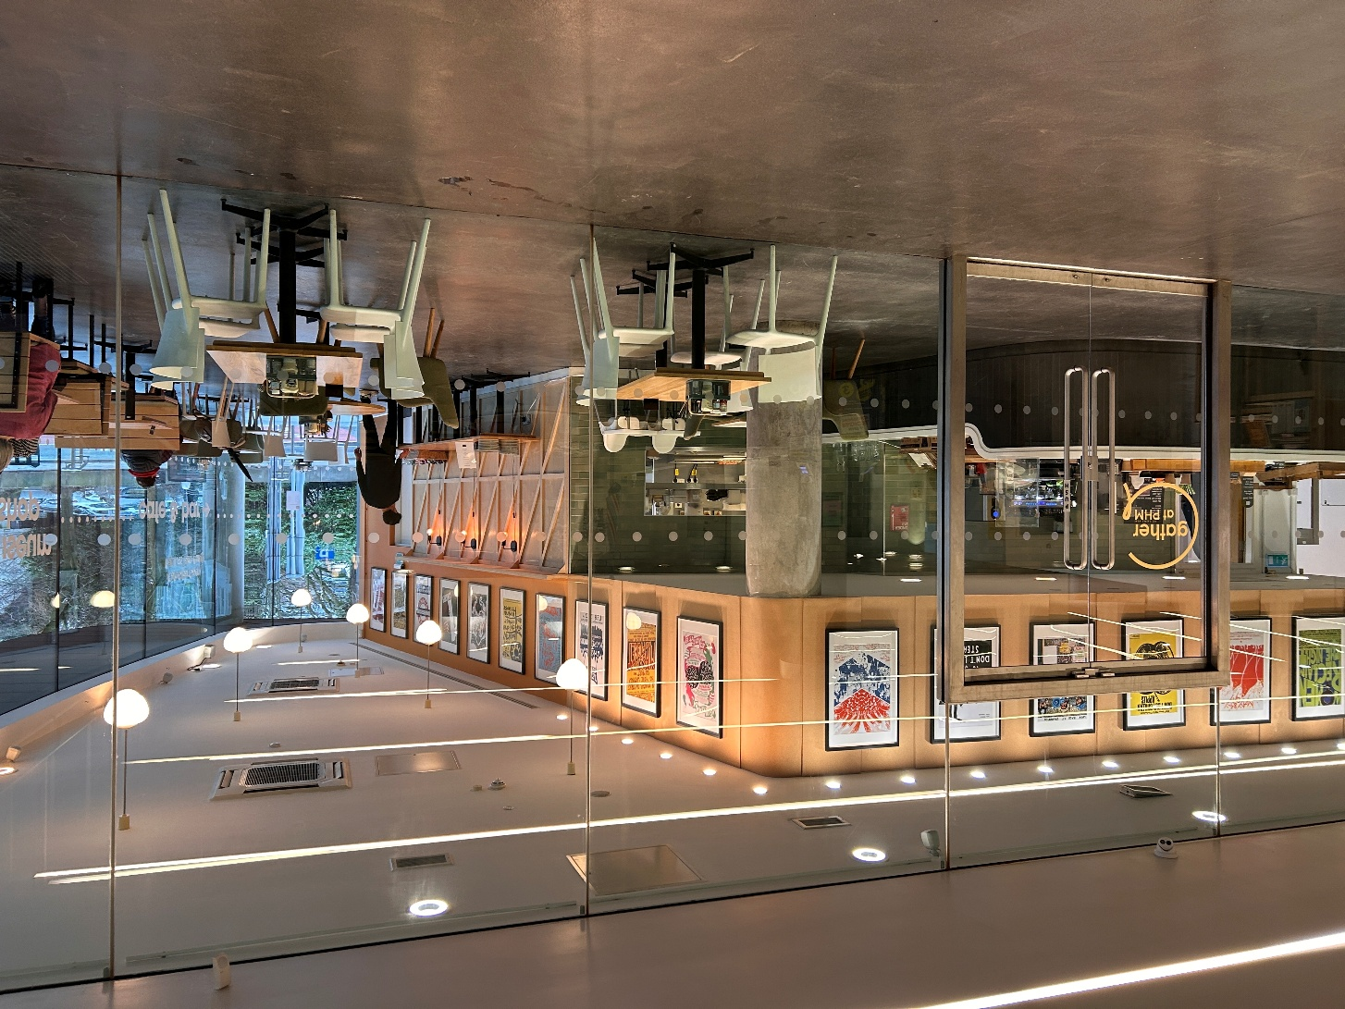

You can buy refreshments from
Gather café at
People’s History Museum.

Location: ground floor.

Page 6 of 18

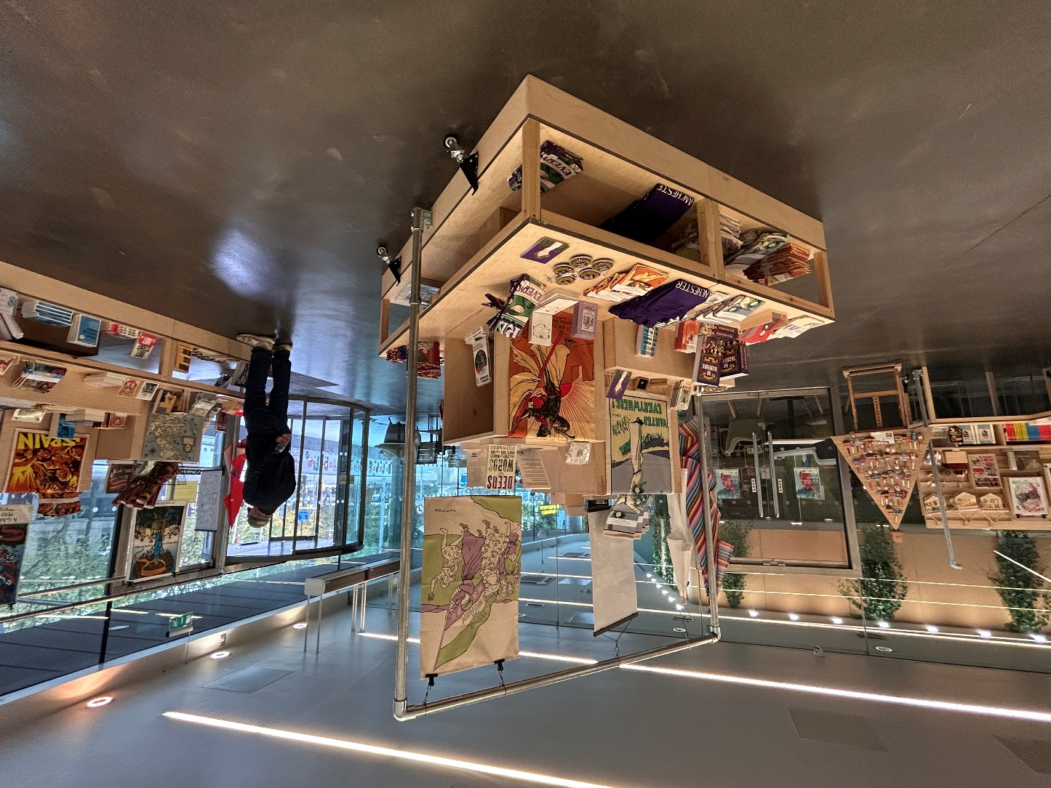

You can visit the museum's gift shop.

Location: ground floor.

Page 7 of 18

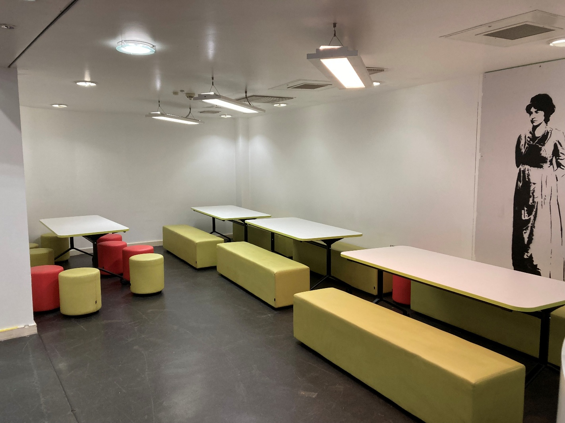

You can eat a packed lunch in the
picnic area.

Location: ground floor.

Page 8 of 18

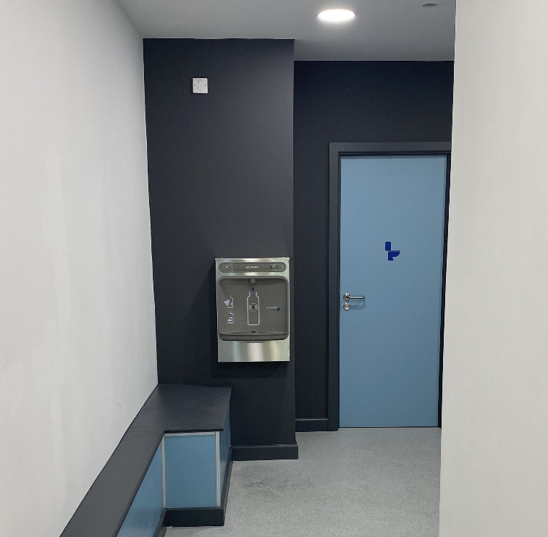
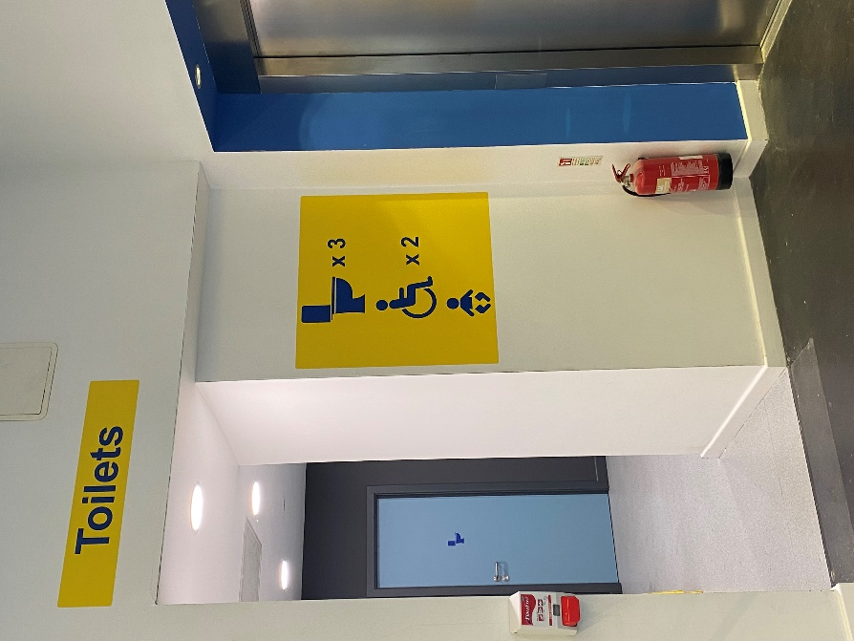

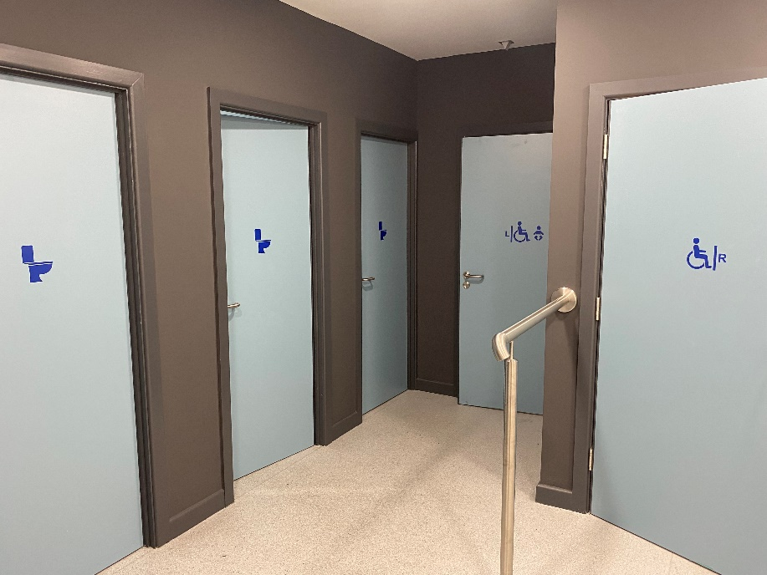

There are gender neutral and left and right transfer accessible toilets, baby changing facilities, and a bottle filling station.

Location: ground floor.

Page 9 of 18
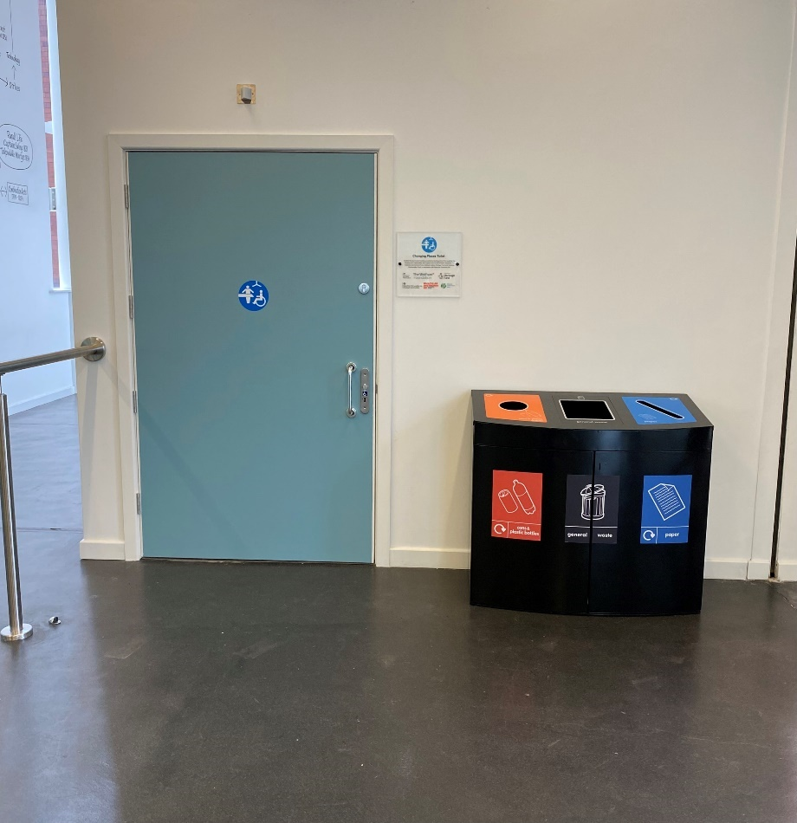

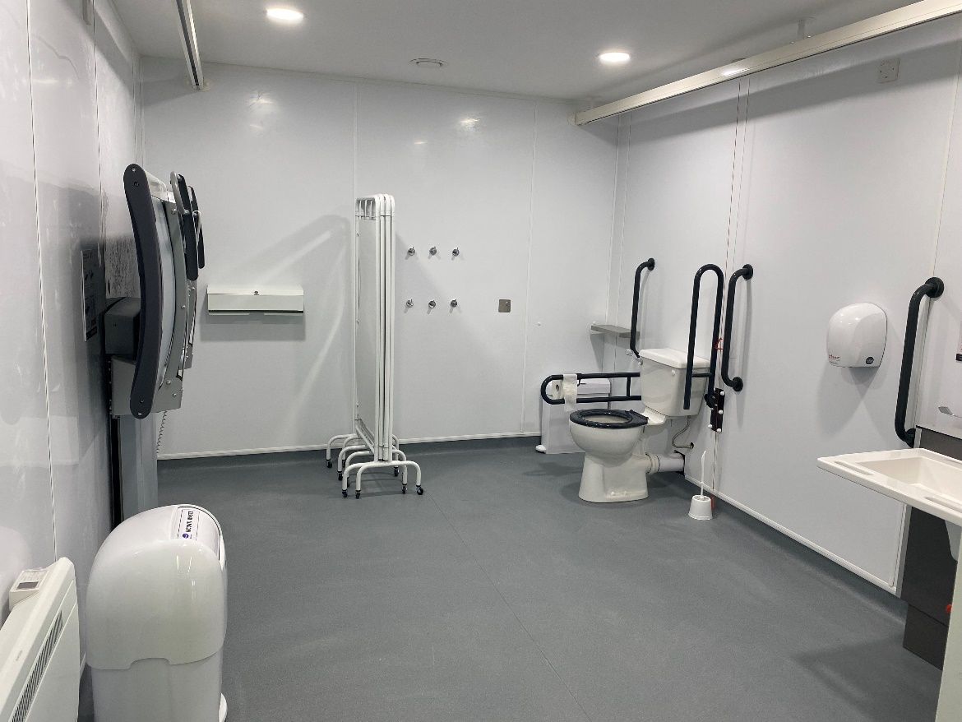

There is a Changing Places toilet.

Location: ground floor.

Page 10 of 18

Ground floor gendered toilets.

Second floor gender neutral
left transfer accessible toilet.

Lower ground floor gender neutral
left transfer accessible toilet.

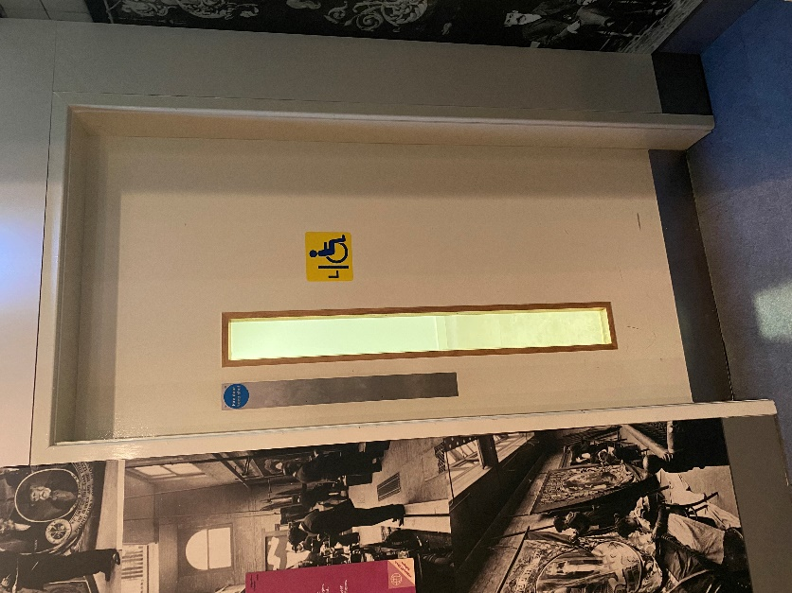
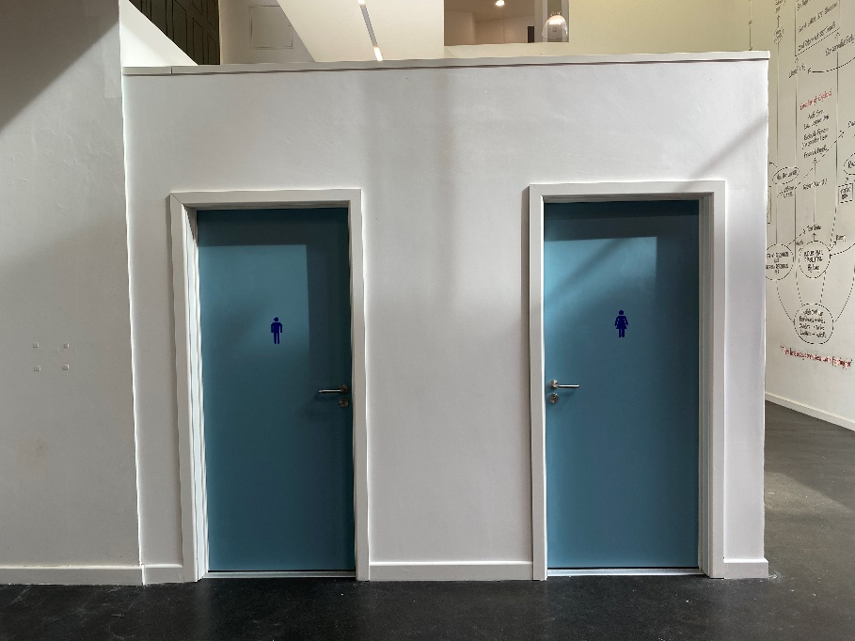

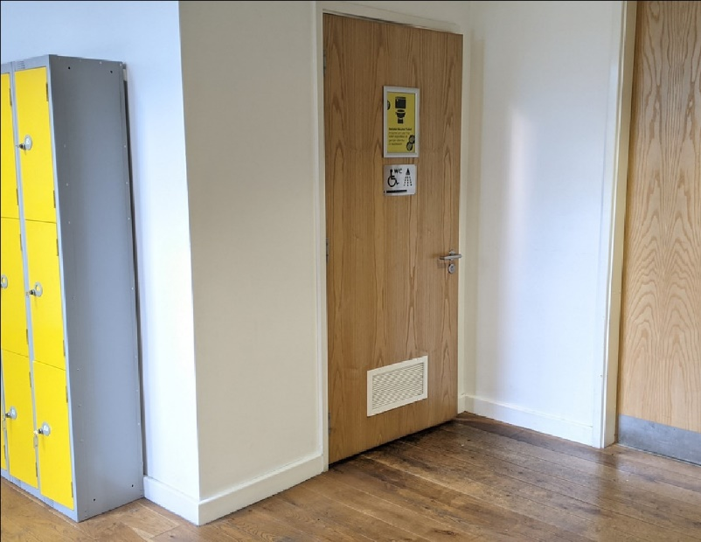

There are gendered toilets on the ground floor.

There is one gender neutral left transfer
accessible toilet on the lower ground floor
and one on the second floor.
Page 11 of 18

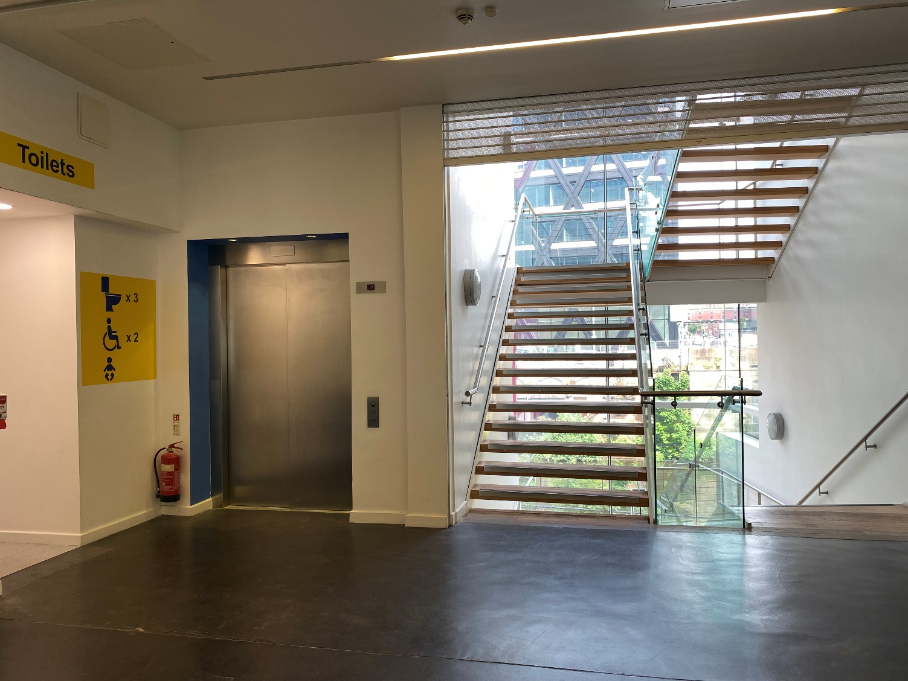

The lift and stairs lead up to
Gallery One and Gallery Two.

Page 12 of 18

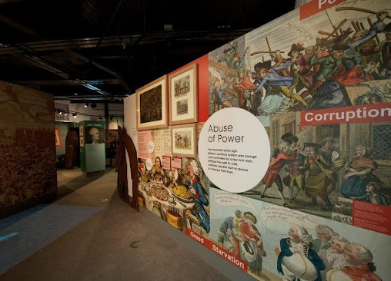

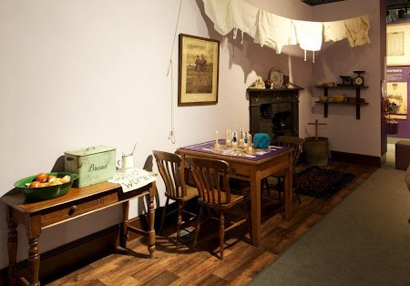

Gallery One.

Location: first floor.

Page 13 of 18

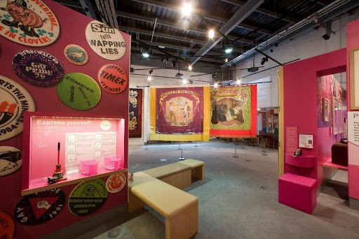

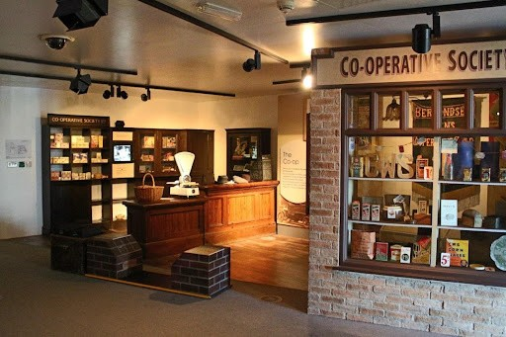

Gallery Two.

Location: second floor.

Page 14 of 18

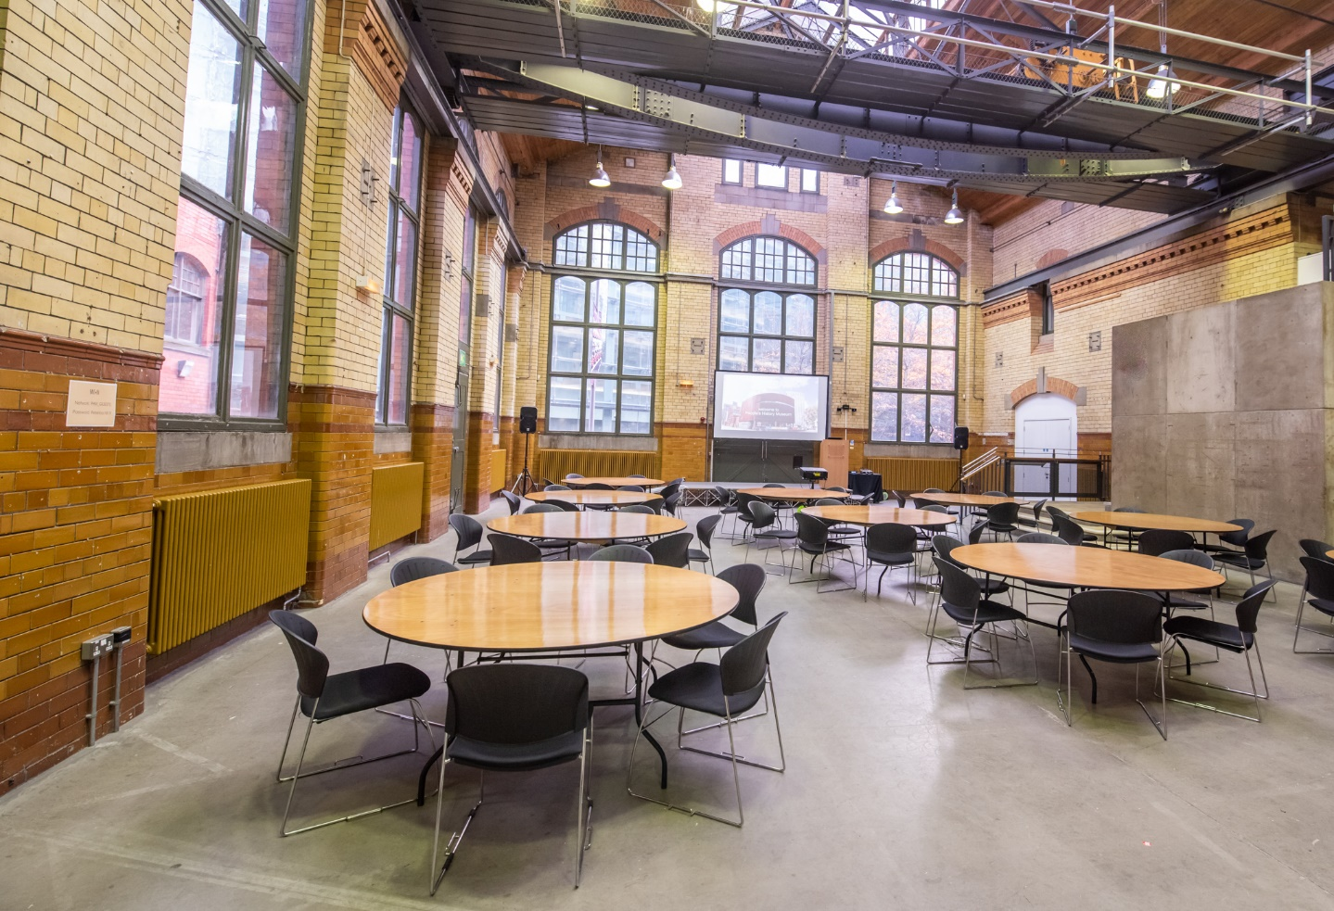

The Engine Hall is used for Venue Hire events.

Location: ground floor.

Page 15 of 18

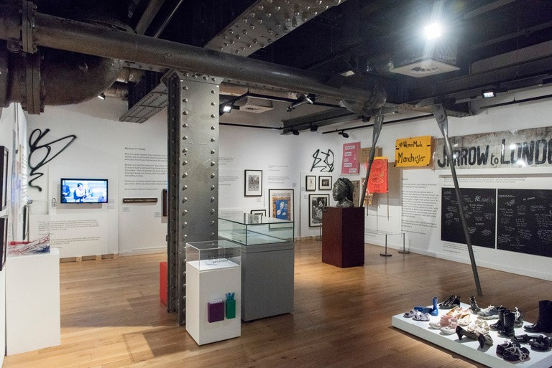
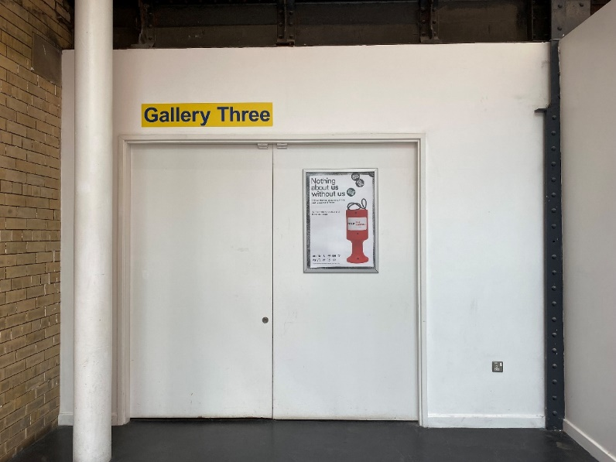
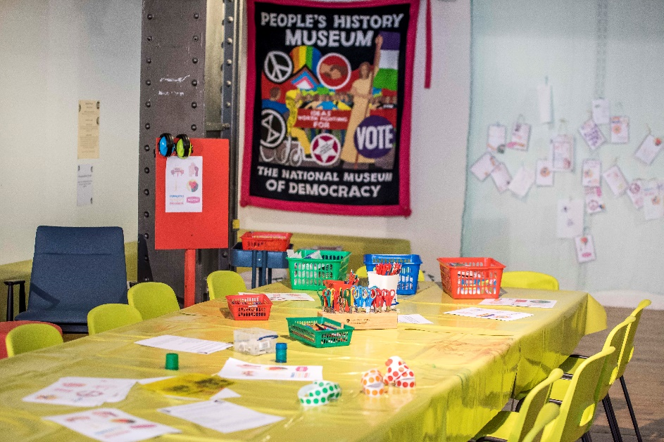

Exhibitions and activities in Gallery Three
change a few times a year.

Location: ground floor.

Page 16 of 18

Health and safety measures at the museum:

- Staff are trained to assist with evacuation of the building in case of an emergency.

- We respect your decision to continue to wear a face covering.

- Hand washing and hand sanitiser stations are located throughout the museum.

- Spaces are cleaned daily.

Page 17 of 18

Please talk to us if you have queries or
require any assistance in advance of your
visit by phoning 0161 838 9190, or by
emailing access@phm.org.uk.

Emails will be answered
Monday to Friday, 10.00am to 5.00pm.

On the day of your visit, our Visitor
Experience Team will be available to help.

You can also give us a call on the day of
your planned visit if you require assistance.

Page 18 of 18

