People’s

History

Museum

Collections Assistant
Collections & Engagement Team

Job Pack
May 2026

About the role

This is an exciting opportunity to join People’s History Museum’s (PHM) Collections & Engagement Team at a time of key development for the museum and the collection. The Collections Team are currently exploring the practicalities of relocating the object store. As well as providing improved conditions for our objects, we hope that this new building will be safe and accessible to the public; allowing for more onsite engagement. A move of this size and scale is a huge task, and the Collections Assistant will be pivotal in helping the museum to prepare the collection for this move by developing an inventory of objects at the store, documenting and cataloguing objects to reduce any backlog, and repacking objects to approved standards. This work will give the museum a better understanding of the collection and will contribute to our core engagement, exhibitions, and learning programme.

We are looking for an enthusiastic and organised colleague, who is interested in discovering, documenting, and sharing untold stories of the past from PHM’s collection of over 60,000 objects. This role will report to the Collections Manager and will play a vital role in documenting the museum’s collection, researching and photographing new acquisitions and collection highlights, and supporting ongoing collection projects. The post holder will help to put into practice the inventory procedure and will work with the Collections Manager to improve documentation about objects in the store. They will also support with logging and answering museum collection enquiries, helping to provide information and supervision for researchers, as well as advising colleagues in the museum on key resources, objects, and stories for use in upcoming programmes of events, engagement and exhibitions, social media, website content, and PR and press opportunities.

The successful applicant will work closely with the Collections Manager to care for, curate, and manage the museum’s collection, and will collaborate with our Conservation, Communications & Marketing, and Engagement Teams to share stories with our audiences.

The role would be ideal for someone looking to start their career within museum collections, with strong problem solving, organisational, and communication skills.

You do not need to have any previous experience of working with museum collections as full training will be given.

The majority of this role is based at our offsite collection store which has no step free access or step free routes around the building.
The job will require working at height, manual handling, and is likely to include lone working, in line with the museum’s policies.
We are an equal opportunities employer and are fully committed to providing opportunities to all. Please do contact us if you would like to discuss any adjustments you may need or would like more information about the accessibility issues.
Please note, this role is not available for job share.

About People’s History Museum
People’s History Museum is the national museum of democracy, telling the story of its development in Britain: past, present, and future. PHM invites people to explore the radical stories of people coming together to champion ideas worth fighting for, and to be empowered by the past to make a change for the future. We are all together in the fight for a fairer world. PHM currently welcomes a local, national and international audience, attracting 85,000 visitors annually.

The museum involves audiences and communities in many aspects of its work, using models of co-curation, collaboration, and crowdsourcing when developing and delivering programmes of activity. Engaging people directly in the work of the museum helps to build a passionate and committed audience who become supporters and advocates for PHM, while ensuring we are shaping authentic content representative of diverse audiences, providing an inclusive space for their voices, stories and ideas. PHM’s innovative approach explores important subjects and issues relevant to us all today.

PHM has an annual turnover of around £1.5 million, with a skilled team of staff, freelance experts, and volunteers. PHM is funded by Arts Council England (ACE) as a National Portfolio Organisation (NPO) and by Greater Manchester Combined Authority (GMCA) Culture and Social Impact Fund. PHM is an independent museum, charitable trust, and company limited by guarantee, with a Board of Trustees, a Trading Company Board, and an Audit and Risk Committee.

The Collections Team is responsible for managing and caring for the museum’s object collection of over 60,000 objects, working in close collaboration with the Conservation and Engagement Teams to care for and share our objects with our audiences.

The museum’s collection covers wide topics and themes around the fight for rights, equality, and justice in the UK. The museum is renowned for holding the largest collection of political and trade union banners in the world, and also holds thousands of political and grassroots posters, badges, and placards, alongside 3-dimensional social history objects, fine and decorative art, textile and furniture collections. Key themes within the museum collection include: early radicalism and reform; enfranchisement and suffrage; workers’ rights, trade unionism and strikes; migrant rights; disabled people’s rights and activism; women’s rights; LGBTQIA+ rights; peace and anti-nuclear campaigns; and British politics from the 19th to the 21st centuries.

Staff structure

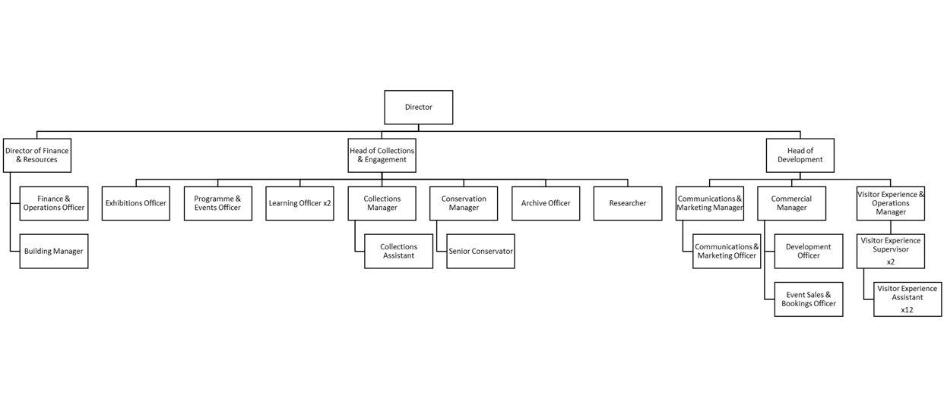

Job Description
Collections Assistant

Salary: £25,185 (£20,140 pro rata) (plus 10% pension contribution)
Hours: Part time (28 hours a week)

Annual leave: 24 days plus bank holidays (19.5 days pro rata)

Contract: Fixed Term for 18 months

Responsible to: Collections Manager

Responsible for: None

Location: Based at the museum’s offsite store (in Manchester city centre) and at People’s History Museum with occasional opportunity for agile working in line with PHM’s flexible working policy

Key responsibilities

- Developing an inventory of the museum’s collection
- Using the inventory, and the museum’s policies and historic documentation to reduce our collections backlog
- Creating and updating digital and paper records for objects
- Conducting research about the objects and their histories
- Labelling and packing objects
- Photographing objects and editing image files for use by the museum
- Responding to telephone and email enquiries about the collection
- Writing physical and online object labels
- Supporting work placements at offsite store
- Collaborating with other PHM teams, for example Communications & Marketing, to share the museum’s collections with our audiences
- Providing administrative support for the Collections Team where appropriate, such as taking minutes in meetings

Knowledge, experience, and skills

Knowledge
- A basic understanding of and interest in British social and political history from 1700 onwards
- An interest in one or more of the following areas: the history of trade unionism; LGBTQIA+ history; the history of ethnically minoritised communities; disabled people’s history; women’s history
- An interest in current affairs
Experience
- Experience of using a digital camera and using photo editing software to carry out basic tasks e.g. image cropping
Skills
- High level of attention to detail including with respect to carrying out repetitive tasks
- Excellent written communication skills
- Highly organised
- Able to progress multiple projects concurrently and in accordance with multiple deadlines
- Able to work methodically through tasks
- Able to carry out research about objects using online and hard copy resources
- Enthusiasm for discovering and sharing stories
- Able to work independently with strong problem solving skills
- Able to collaborate and work as part of a team
Values
- A strong commitment to the equitable treatment of staff, audiences, and community partners
- A strong commitment to improving the diversity of stories told by the museum in its permanent and changing exhibitions, in its collection, and in its online content
- A strong commitment to improving access to the museum and its collection
Please note
The majority of this role is based at our offsite collection store which has no step free access or step free routes around the building.
The job will require working at height, manual handling, and is likely to include lone working, in line with the museum’s policies.
We are an equal opportunities employer and are fully committed to providing opportunities to all. Please do contact us if you would like to discuss any adjustments you may need or would like more information about the accessibility issues.
How to apply
Please outline how your knowledge, experience, and skills meet the job description and provide details via our online application form. Your application will be assessed and scored against the job description using the information provided.

Deadline for applications: 5.00pm on Sunday 21 June 2026

Interviews: Wednesday 15 July 2026 (in person)

If you have any questions or would like to arrange to discuss the role please contact Jackie Royle, Finance & Operations Officer at hr@phm.org.uk.

Equity
PHM prides itself on being a welcoming and inclusive organisation, profoundly committed to advancing equality and diversity in the broadest sense. We highly value the benefits that diverse perspectives bring to PHM’s mission.

We recognise the museum currently underrepresents people of colour, disabled people, LGBTQIA+ people and those with intersecting identities in our workforce; PHM is actively working to address this and encourages applications from these backgrounds. While the successful candidate will be selected purely on merit, in the event of a tie between two candidates with equal experience, we may select a candidate who helps us better represent the communities the museum serves.

