People’s

History

Museum

Event Sales & Bookings Officer (Commercial)
Development Team

Fixed Term contract 6 months

Job Pack
May 2026

About the role

This is an exciting opportunity to join People’s History Museum’s (PHM) Commercial Team. Driving commercial income is a vital source of funds for PHM and our approach to generating profit for purpose. The museum’s Business Plan sets out our ambition to grow commercial income streams, with Venue Hire being one of our strongest opportunities to achieve this. We want our building to be a hotspot for all kinds of events including corporate conferences, meetings and workshops, weddings, marketplace events, and much more. Reinforcing our reputation as a leading heritage meeting and events space in Manchester.

We are looking for an organised, customer focussed sales professional to join our team, concentrating on increasing event sales and delivering high quality events for paying clients. The role will be responsible for meeting income targets, attracting and retaining clients, and upselling add on services.

Strong co-ordination and customer service skills are vital. This role involves co-ordinating and delivering event specifications for a wide range of conference and social events and managing a varied portfolio at any one time. The successful applicant will work closely with the museum’s Operations Team and wider network of suppliers to ensure all events exceed client expectations.

The role would be ideal for someone with experience in event sales, delivering events, or managing bookings in a comparable industry. Ability to follow processes and use a CRM system is essential.

About People’s History Museum

People’s History Museum is the national museum of democracy, telling the story of its development in
Britain: past, present, and future. PHM invites people to explore the radical stories of people coming together to champion ideas worth fighting for, and to be empowered by the past to make a change for the future. We are all together in the fight for a fairer world. PHM currently welcomes a local, national and international audience, attracting 85,000 visitors annually.

The museum involves audiences and communities in all aspects of its work, using models of co-curation, collaboration, and crowdsourcing when developing and delivering programmes of activity. Engaging people directly in the work of the museum helps to build a passionate and committed audience who become supporters and advocates for PHM, while ensuring we are shaping authentic content representative of diverse audiences, providing an inclusive space for their voices, stories and ideas. PHM’s innovative approach explores important subjects and issues relevant to us all today.

PHM has an annual turnover of around £1.5 million, with a skilled team of staff, freelance experts and volunteers. PHM is funded by Arts Council England (ACE) as a National Portfolio Organisation (NPO) and by Greater Manchester Combined Authority (GMCA) Culture and Social Impact Fund. PHM is an independent museum, charitable trust, and company limited by guarantee, with a Board of Trustees, a Trading Company Board, and an Audit and Risk Committee.

Staff structure
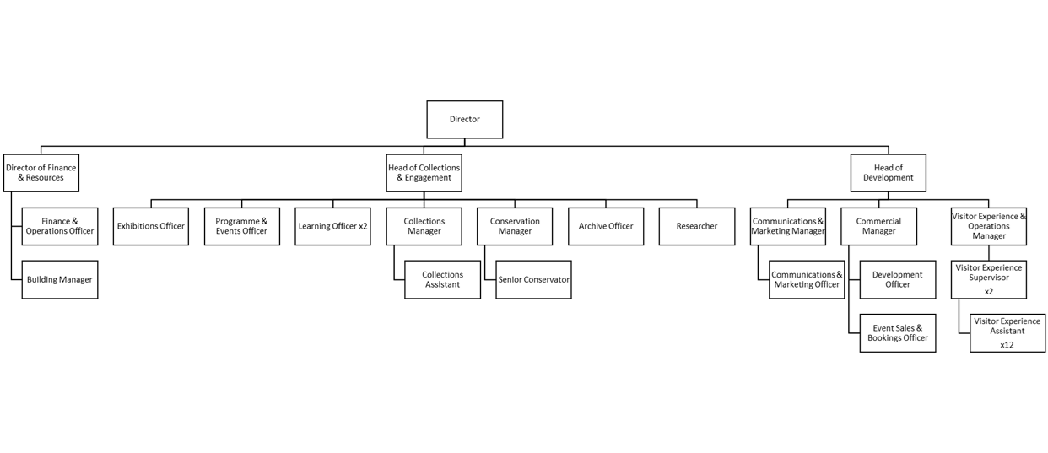

Job Description
Event Sales & Bookings Officer

Salary: £29,064 per annum (plus 10% pension contributions)

Hours: Full time (35 hours per week)

Annual leave: 24 days plus bank holidays

Contract: Fixed Term for 6 months

Responsible to: Commercial Manager

Responsible for: None

Location: Based at People’s History Museum with the opportunity for agile working in line with PHM’s flexible working policy

Role purpose

The Event Sales & Bookings Officer will be responsible for achieving the Venue Hire income targets through reactive and proactive sales.

The Event Sales & Bookings Officer will lead on event sales, developing proposals for prospective clients, liaising with clients to confirm arrangements, preparing event specifications, and collating client feedback.

This role is responsible for liaising with potential and confirmed clients to finalise bookings, prepare event specifications, liaising with other PHM teams, and external suppliers to ensure all elements are in place.

The Event Sales & Bookings Officer will work with the museum’s CRM system to manage bookings, and event specifications, and to produce monthly performance reports and financial spreadsheets.

Main responsibilities

- To lead on all sales enquiries, developing proposals for prospective clients, showing clients the venue, and preparing booking agreements.

- To achieve a 48-hour (within working days) response rate to all customer enquiries and achieve the conversion rate target.

- To maximise income through add on sales, liaising with PHM’s wider event supplier network to book add ons as required, including equipment and related technical support.

- Deliver client aftercare including collating and acting on client feedback and including findings in monthly reports with any improvements to be taken.

- To support the future development of the service through data collection, market research, and feedback.

- To act as the main point of contact for confirmed bookings, and to liaise and co-ordinate with clients to confirm arrangements for events by providing excellent customer service. This includes welcoming clients and acting as an onsite presence during events as required.

- To co-ordinate event requirements within PHM and the museum’s onsite event caterers to ensure events run smoothly with correct catering, level of staffing, and set up of spaces and equipment. This includes preparation of the detailed events schedule, co-ordinating communications and meetings for involved staff, and checking quality of spaces during the event set up on the day.

- To maintain efficient and accurate administration around all events, utilising our CRM system, SharePoint database, and Profit & Loss spreadsheet. This includes liaison with the Finance Team regarding invoices and submitting purchase orders.

- To prepare monthly reports of events data, including the number of enquiries, income, and visitor figures using the CRM reporting functions and financial spreadsheets.

Person specification
- Experience of event sales or sales in a similar hospitality environment.

- Excellent customer services skills, confident in speaking to clients in person, via phone, and on email.

- Experience of bookings and events.

- Strong administration skills, able to take pieces of information from a range of inputs (phone calls, emails, etc) and turn them into efficient booking specifications, across multiple upcoming events.

- Excellent communication skills, ability to negotiate and communicate with a wide range of clients, stakeholders and staff.

- Strong IT skills, confident in using Microsoft packages.

- Good problem-solving skills.

- Ability to follow established processes.

- Experience of using a CRM or events management database.

- Experience of organising events on behalf of external clients/stakeholders.

How to apply

Please outline how your experience, skills, and knowledge meet the job description and provide details via our online application form. Your application will be assessed and scored against the job description using the information provided.

Deadline for applications: Wednesday 10 June 2026 at 23:00

Interviews: Thursday 18 June 2026 in person at PHM

If you have any questions or would like to arrange to discuss the role please contact Jackie Royle, Finance & Operations Officer at hr@phm.org.uk.

Equity
PHM prides itself on being a welcoming and inclusive organisation, committed to advancing equality and diversity in the broadest sense. We highly value the benefits that diverse perspectives bring to PHM’s mission.

We recognise the museum currently underrepresents people of colour, disabled people, LGBTQIA+ people and those with intersecting identities in our workforce; PHM is actively working to address this and encourages applications from these backgrounds. While the successful candidate will be selected purely on merit, in the event of a tie between two candidates with equal experience, we may select a candidate who helps us better represent the communities the museum serves.

